(Insert Building Name)
Emergency Action Plan (EAP)

(Insert Month 20XX)

(Note: To insert your building’s image above, right-click the image, click Format Shape, click Fill Paint Can, click Fill, click Picture or texture fill, click Insert picture from File, then select a jpeg or png image file of the desired building. Delete these instructions before publishing final plan.)

Old Dominion University
(Insert Building Address)
Norfolk, Virginia 23529

This document contains sensitive and confidential information that is not subject to FOIA under Code of Virginia §2.2-3705.2.

This page is intentionally blank.

Security and Privacy Statement

Public disclosure of this document would have a reasonable likelihood of threatening public safety by exposing vulnerabilities. It contains sensitive and confidential information that is not subject to FOIA under Code of Virginia §2.2-3705.2. Accordingly, Old Dominion University is withholding this plan from full public disclosure. Refer any request for a copy of this document to Old Dominion University legal counsel or the Virginia Attorney General’s office.

This page is intentionally blank.

Table of Contents

Security and Privacy Statement iii
Table of Contents v
Record of Changes vii
Building Emergency Action Plan 1
BUILDING ADDRESS 1
BUILDING EMERGENCY COORDINATOR 1
FLOOR/AREA MONITORS (delete this section if not applicable) 1
BUILDING EMERGENCY PREPAREDNESS COMMITTEE 2
EMERGENCY CONTACT NUMBERS 2
ODU RESOURCE CONTACT NUMBERS 3
INTERNAL ASSEMBLY AREAS 5
EVACUATION ROUTE MAPS 7
EMERGENCY ASSEMBLY AREAS 9
EVACUATION ACCOUNTABILITY SHEET 11
FIRST AID KIT/AUTOMATED EXTERNAL DEFIBRILLATOR LOCATIONS 13
EMERGENCY KIT LOCATIONS 13
UNIQUE HAZARDS 13
BUILDING FIRE ALARMS 14
PANIC BUTTONS 14
VISITORS 15
AFTER-HOURS CONSIDERATIONS 15
Annex A: Departmental Key Personnel & Notification Protocol – (Insert Department/ Unit Name) 17
DEPARTMENT LOCATION 17
DEPARTMENTAL OVERVIEW 17
DEPARTMENTAL KEY PERSONNEL INFORMATION 18
DEPARTMENTAL NOTIFICATION PROTOCOL 18
Annex B: Emergency Procedures 19
ACTIVE THREAT: SECURE-IN-PLACE 19
BOMB THREAT 21
BOMB THREAT CHECKLIST 23
EARTHQUAKE 25
EVACUATION 26
EVACUATION OF PERSONS WITH DISABILITIES 27
PERSONS REQUIRING ASSISTANCE DURING EMERGENCIES TRACKING FORM 29
EXPLOSION 32
FIRE 33
FLOODING 35
HAZARDOUS MATERIALS 36
HURRICANE, TROPICAL STORM, and NOR’EASTER: SHELTER-IN-PLACE 37
MEDICAL EMERGENCY 38
POWER OUTAGE 39
SEVERE THUNDERSTORM/LIGHTNING: SHELTER-IN-PLACE 40
SUSPICIOUS PACKAGE/MAIL 41
SUSPICIOUS PERSON 42
TORNADO: SHELTER-IN-PLACE 43
WINTER STORM AND EXTREME COLD: SHELTER-IN-PLACE 44
WORKPLACE VIOLENCE 46
Annex C: Emergency Information for the Classroom 47
Emergency Guide for Faculty and Instructors in the Classroom 49
Annex D: Emergency Kits 51
DEPARTMENT/UNIT EMERGENCY KIT SUGGESTED CONTENTS 51
PERSONAL EMERGENCY KIT SUGGESTED CONTENTS 51
Annex E: EAP Reference Information and Instructions 52
EMERGENCY PLANNING AT OLD DOMINION UNIVERSITY 52
EMERGENCY ACTION PLAN OVERVIEW 52
THE BUILDING EMERGENCY PREPAREDNESS COMMITTEE AND THE BUILDING EMERGENCY COORDINATOR 53
TRAINING AND EXERCISES 55
EAP DEVELOPMENT AND MAINTENANCE 56

Record of Changes

(Changes made to the Emergency Action Plan between official approvals should be documented in the Record of Changes table below. The Record of Changes will contain, at a minimum, a change number, the section and/or page number of the change, a description of the change, the date of the change, and the initials of the person who made the change. Minor plan changes (such as grammatical or phone number changes) which do not affect the implementation of the plan do not need to be captured in the Record of Changes table. A new Record of Changes table should be used whenever the plan is re-approved by the department head or designee.)

Submit recommended changes to this document to (insert name of Building Emergency Coordinator and email address).

Change Number | Section and/or Page Number | Description of Change | Date of Change | Posted By
1 | Building EAP, Annex A | Updated Primary BEC contact info, updated departmental notification protocol | 6/1/19 | Marvin The Martian

This page is intentionally blank.

Building Emergency Action Plan

BUILDING ADDRESS

(Provide street address or physical location)

BUILDING EMERGENCY COORDINATOR

(Building Emergency Coordinators (BECs) and Alternate BECs should provide contact information which enables officials to make contact at any time.)

Primary Building Emergency Coordinator
Name
Title
Office Address
Office Phone
Cell Phone
Home Phone
Email Address

Alternate Building Emergency Coordinator
Name
Title
Office Address
Office Phone
Cell Phone
Home Phone
Email Address

FLOOR/AREA MONITORS (delete this section if not applicable)

(Add tables for additional floor/area monitors as necessary.)

Floor/Area Monitor – (Insert floor/area responsible)
Name
Title
Office Address
Office Phone
Cell Phone
Email Address

BUILDING EMERGENCY PREPAREDNESS COMMITTEE

(The building Emergency Preparedness Committee (EPC) should consist of one representative from each department/unit occupying the building. There is no set number of representatives that can serve on an EPC. Through the EPC, the Building Emergency Coordinator (BEC) and Alternate BEC is selected. List members of the EPC, the department/unit they represent, and their contact information in the table below. Add/delete rows to fit the size of the EPC.)

Name | Department/Unit | Office Phone | Email  (sans @odu.edu)

EMERGENCY CONTACT NUMBERS

Department/Agency | Phone Number | Website
Life Threatening Emergencies
Police/Fire/Emergency Medical Services (EMS) | 757-683-4000 or 911
Non-Life Threatening Emergencies
ODU Police Department (ODUPD) | 757-683-4000 | www.odu.edu/police
Norfolk Police Department (NPD) | 757-441-5610 | www.norfolk.gov/police
Norfolk Fire-Rescue (NFR) | 757-441-5610 | www.norfolk.gov/index.aspx?nid=596
ODU Office of Emergency Management (OEM) | 757-683-5116 | www.odu.edu/emergency
ODU Environmental Health and Safety (EHS) | 757-683-4495 | www.odu.edu/ehs
ODU Facilities Management (FM) | 757-683-4600 | www.odu.edu/facilitiesmgmt
ODU Fire Prevention | 757-683-5166 | www.odu.edu/fireprevention
ODU Student Health Services (SHS) | 757-683-3132 | www.odu.edu/studenthealth
ODU Counseling Services | 757-683-4401 | www.odu.edu/counselingservices

All campus telephones and emergency call boxes will connect you directly to the ODUPD Communications Center. When dialing 911 from a cellular phone on campus, your call may go to another area law enforcement agency. If/when this occurs, tell the dispatcher that you are on the ODU campus and ask to be transferred to ODUPD.

Call from a safe location and remember to stay calm, be prepared to answer questions, and do not hang up until the dispatcher instructs you to do so. If possible, attempt to gather some information that will be helpful for emergency responders such as approximate number of injuries, rooms that are involved, and how to best access the location of the incident/emergency/event.

ODU RESOURCE CONTACT NUMBERS

Department | Phone Number | Website
ODU Educational Accessibility | 757-683-4655 | www.odu.edu/educationalaccessibility
ODU Human Resources | 757-683-3042 | www.odu.edu/humanresources
ODU ITS Helpdesk | 757-683-3192 | www.odu.edu/ts/helpdesk
ODU Police Department (non-emergency) | 757-683-5665 | www.odu.edu/police
ODU Safe Ride and Escort Services | 757-683-3477 | www.odu.edu/life/health-safety/safety/saferide
ODU Switchboard | 757-683-3000 | www.odu.edu/about/contact
ODU Transportation and Parking Services | 757-683-4004 | www.odu.edu/parkingservices
ODU Women’s Center | 757-683-4109 | www.odu.edu/life/support/womenscenter
(Add additional numbers as appropriate.)

This page is intentionally blank.

INTERNAL ASSEMBLY AREAS

Figure A-1: Internal Assembly Areas – (Insert Building Name and Floor Number)

(Contact the Office of Emergency Management at 757-683-5116 or oem@odu.edu to have an Internal Assembly Area map(s) created. Using floor plans for each floor of the building, the IAA map(s) will designate safe interior locations where building occupants should gather for accountability while sheltering in place.)

(Insert map here)

Building Name and Number Floor Internal Assembly Areas
- The (locations) are the best locations to shelter-in-place during a weather emergency.
- During an active threat or workplace violence incident, internal locked rooms are the best locations to secure-in-place.
- Roll Taker: (Insert name of designated person)

This page is intentionally blank.

EVACUATION ROUTE MAPS

Figure A-2: Evacuation Route Map – (Insert Building Name and Floor Number)

(Contact the Office of Emergency Management at 757-683-5116 or oem@odu.edu to have an Evacuation Route Map map(s) created. Using floor plans for each floor of the building, the Evacuation Route Map(s) will show primary and secondary routes of evacuation; exit locations; the placement of fire extinguishers, fire alarm pull stations, and automated external defibrillators (AEDs, if applicable), and areas of rescue (if applicable)).

(Insert map here)

This page is intentionally blank.

EMERGENCY ASSEMBLY AREAS

Figure A-3: Emergency Assembly Areas – (Insert Building Name)

(Contact the Office of Emergency Management at 757-683-5116 or oem@odu.edu to have an Emergency Assembly Area map created. Using an aerial image of the building and vicinity, EAA maps will contain primary and secondary evacuation routes from the building and will designate primary and secondary EAAs for building occupants to gather for accountability. EAA maps are intended to serve as guidance only and should be considered flexible to change as events warrant, e.g., nearby construction, temporary inaccessibility, etc. Using the EAP and EAA maps as a guide, the BEC is responsible for determining the best location for building occupants to gather outside the building during an incident/ emergency/event.)

(Insert map here)

Building Name Primary Emergency Assembly Area
- Using the closest available exits, building occupants are to evacuate the building and report to EAA 1 located at (describe location).
- Roll Taker: (Insert name of designated person)

Building Name Secondary Emergency Assembly Area
- Using the closest available exits, building occupants are to evacuate the building and report to EAA 2 located at (describe location).
- Roll Taker: (Insert name of designated person)

This page is intentionally blank.

EVACUATION ACCOUNTABILITY SHEET

Directions: Use this form to account for personnel at the building’s Emergency/Internal Assembly Area (EAA/IAA) when a prepopulated roster is otherwise unavailable.

Building: _____________________________________________________________________________

Department/Unit: ______________________________________________________________________

Name | ODU UIN | Department/Unit
Please Print or Type

This page is intentionally blank.

FIRST AID KIT/AUTOMATED EXTERNAL DEFIBRILLATOR LOCATIONS

(Each building should have at least one first aid kit available to building occupants. For guidance on what should be stocked in first aid kits and how these kits are to be maintained, visit https://www.osha.gov/Publications/OSHA3317first-aid.pdf. Many buildings have been equipped with one or more automated external defibrillators (AEDs) courtesy of department purchase. Indicate specific locations of first aid kits and AEDs in the table below. If no AED has been installed in your building, contact OEM at oem@odu.edu or 757-683-5116 so that the nearest installed AED to your building can be identified for inclusion in the table below. Add/delete rows/columns as needed.)

First Aid Kit Location(s)
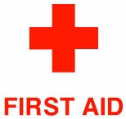

AED Location(s)


Report any use of AEDs to the Office of Fire Prevention at 757-683-5166 or firesafety@odu.edu.

EMERGENCY KIT LOCATIONS

(See Annex D: Emergency Kits for recommendations on outfitting personal/departmental kits.)

Kit Description | Location | Date Last Checked

UNIQUE HAZARDS

(In the table below, list any unique hazards located in the building. Unique hazards may include gas cylinders, chemicals, combustibles, research activities, biological agents, etc. Add/delete rows as needed.)

Description  of Hazard | Location | Contact Person | Office Phone | Cell Phone
Acetylene Gas | Auto Shop | Wile E. Coyote | 757-683-1234 | 757-123-4567

BUILDING FIRE ALARMS

With very limited exceptions (e.g., sheds, outbuildings, etc.), all regularly-occupied campus buildings are equipped with a centralized, monitored fire alarm system.

Procedures

- The fire/evacuation alarm is a high-pitched annunciator. When fire/evacuation alarm sounds, stop all activities and immediately leave the building. Follow evacuation procedures located in this plan.
- Special attention should be given to persons with hearing/visual/mobility impairments during the notification and evacuation.
- Procedures which may be hazardous if left unattended (e.g., welding, research using flammable materials, etc.) should be shut down prior to evacuation, if safe to do so.
- Verify that doors are closed to reduce the spread of fire and smoke.
- In cases where fire alarm systems are offline and a fire or smoke is observed, building occupants must attempt to make other occupants aware of an emergency by knocking on doors and shouting “FIRE!”, sounding air horns, or using similar other means.

PANIC BUTTONS (delete this section if not applicable)

Panic buttons are devices used to immediately and discretely notify ODUPD in the event of an emergency. These devices are generally mounted under desks/tabletops and require depressing one or more buttons to activate the alarm. To avoid accidental activation of panic alarms, departmental/unit supervisors should educate staff on their placement and, if possible, arrange furniture such that contact with arm rests/extremities can be avoided.

(Indicate specific locations of panic buttons in the table below. Add/delete rows/columns as needed.)

Panic Button Location(s)

Procedures

- Activate the alarm to notify ODUPD by depressing the button(s) if you feel threatened or see another person in need of assistance.
- Secure-in-place if possible until help arrives.
- Alarms must be reset by ODUPD.

VISITORS

Visitors present a unique challenge to buildings as they are not generally familiar with building emergency procedures. During an incident/emergency/event, visitors should be given special care to ensure that they follow the building emergency procedures within this plan.

(Insert special details regarding visitors and emergency procedures, e.g., accountability protocol, credentialing, escorts, etc.)

AFTER-HOURS CONSIDERATIONS

The potential exists that an incident/emergency/event may occur before or after regular office hours, or on a holiday or weekend when offices are closed. The BEC or Alternate BEC may be unavailable or off duty, and faculty/staff of highest authority who are available at the time of the incident/emergency/event may need to manage the situation. These individuals should seek to follow the guidelines in this plan, while simultaneously making an effort to notify supervisors of the situation. Attempts to reach key personnel in this EAP should be made via phone and email using the protocols provided in Annex A: Departmental Key Personnel and Notification Protocol.

(Insert special after-hours information/provisions here, if needed)

This page is intentionally blank.

Annex A: Departmental Key Personnel & Notification Protocol – (Insert Department/ Unit Name)

(For buildings with multiple departments/units, create identical annexes for each department/unit using the following format: Annex A-1, Annex A-2, and so on.)

DEPARTMENT LOCATION

Building Floor(s) Occupied | Rooms/Suites Occupied

DEPARTMENTAL OVERVIEW

(List the following information below (as applicable) in narrative or bulleted format: description of department, activities performed (e.g., teaching, research, etc.), and approximate number of faculty/ staff/students.)

DEPARTMENTAL KEY PERSONNEL INFORMATION

Name | Title | Dept./Unit | Office Address | Office Phone | Cell Phone | Email (sans @odu.edu)
Bugs Bunny | Dept. Head | Emergency Mgmt. | 131A Public Safety | 3-1234 | 757-123-4567 | bbunny
Road Runner | Office Manager | Fire Prevention | 132 Public Safety | 3-5678 | 757-765-4321 | rrunner
Yosemite Sam | Daytime Supervisor | Risk Management | 133 Public Safety | 3-9012 | 757-757-7577 | yosam

DEPARTMENTAL NOTIFICATION PROTOCOL

(Insert departmental tiered notification tree or text explanation here. A sample table is below. Regardless of format, this protocol should include first contact, second contact, and third contact names/cell phone numbers/email addresses. If after-hours or weekend notifications vary from normal business hour protocol, add additional columns/information as needed.)

Contact Order | Name | Title | Program/Unit | Cell Phone | Email (sans @odu.edu)
1 | Emergency Cell Phone | N/A | N/A | 757-999-9999 | N/A
2 | Yosemite Sam | Daytime Supervisor | EHS | 757-123-4567 | yosam
3 | Bugs Bunny | Department Head | OEM | 757-765-4321 | bbunny

Annex B: Emergency Procedures

ACTIVE THREAT: SECURE-IN-PLACE

Follow Run-Hide-Fight procedures in the event of an active threat incident.

RUN and escape, if possible.
- Getting away from the threat is the top priority.
- Leave your belongings behind and get away.
- Help others escape, if possible, but evacuate regardless of whether others agree to follow.
- Warn and prevent individuals from entering an area where the active shooter may be.
- Call ODUPD at 757-683-4000 or 911. Report the following to law enforcement:
  - What is happening.
  - Where you are located, including building name and room number.
  - Number of people at your specific location.
  - Injuries, if any, including the number of injured and types of injuries.
  - Detailed description of the threat, including number of persons armed, clothing/equipment worn, direction of travel, and types of weapons being used.
  - Try to provide information in a calm, clear manner so that the dispatcher can quickly replay information to emergency responders.

HIDE, if escape is not possible.
- Get out of the shooter’s view and stay very quiet.
- Silence all electronic devices and make sure they won’t vibrate.
- Secure-in-place: lock and block doors, close blinds, and turn off lights.
- Don’t hide in groups- spread out along walls or hide separately to make it more difficult for the shooter.
- Try to communicate with police silently. Use text message or social media to tag your location, or put a sign in a window.
- Stay in place until law enforcement gives you the all clear.
- Your hiding place should be out of the shooter's view and provide protection if shots are fired in your direction.

FIGHT as an absolute last resort.
- Commit to your actions and act as aggressively as possible against the shooter.
- Recruit others to ambush the shooter with makeshift weapons like chairs, fire extinguishers, scissors, books, etc.
- Be prepared to cause severe or lethal injury to the shooter.
- Throw items and improvise weapons to distract and disarm the shooter.

After the Incident
- Keep hands visible and empty.
- Know that law enforcement’s first task is to end the incident, and they may have to pass injured along the way.
- Officers may be armed with rifles, shotguns, and/or handguns and may use pepper spray or tear gas to control the situation.
- Officers will shout commands and may push individuals to the ground for their safety.
- Follow law enforcement instructions and evacuate in the direction they come from, unless otherwise instructed.
- Take care of yourself first, and then you may be able to help the wounded before first responders arrive.
- If the injured are in immediate danger, help get them to safety.
- While you wait for first responders to arrive, provide first aid. Apply direct pressure to wounded areas and use tourniquets if you have been trained to do so.
- Turn wounded people onto their sides if they are unconscious and keep them warm.
- Consider seeking professional help for you and your family to cope with the long-term effects of the trauma.
- Seek updated information and further instructions.
  - Online, visit ODU home page at www.odu.edu.
  - By phone, call the ODU Switchboard at 757-683-3000.
  - Watch or listen to local media outlets.

BOMB THREAT

Bomb threats are assumed to be real and considered a threat to the University and its operations. Bomb threats are usually received by telephone, sometimes by note or letter. Most bomb threats are made by callers who aim to create an atmosphere of anxiety and panic – but all calls must be taken seriously.

Threatening Call Procedures

- Remain calm.
- Keep the caller on line as long as possible to learn as much as you can. Have a coworker call ODUPD at 757-683-4000 or 911 while you continue to speak with the caller.
- If you can, activate caller ID and note whatever the telephone displays.
- Make a detailed, written record of the call. Refer to the Bomb Threat Checklist on the following pages.
- Notify your supervisor.
- If the threat was left on voice mail, do NOT erase it.
- DO NOT activate the building alarm system to evacuate.

Threatening Email/Written Threat Procedures

- Immediately call ODUPD at 757-683-4000 or 911.
- DO NOT delete the e-mail or destroy the written threat.
- DO NOT activate the building alarm system to evacuate.
- Forward the e-mail as directed by law enforcement.
- The threat should never be ignored. Once a threat is recognized, unnecessary handling should be avoided so as to preserve evidence for law enforcement investigation.

In the event of a campus bomb threat, check ODU Alerts and University email; follow instructions provided by University leadership.

This page is intentionally blank.

BOMB THREAT CHECKLIST

Telephoned Threat
As soon as a telephoned bomb threat is received, the person answering the telephone should signal a coworker to inform the ODU Police Department by calling 757-683-4000 or 911. The person receiving the call should be guided by the following instructions:
Remain calm and try to hold the caller on the phone as long as possible.
- Record exact time and date of call. | Date: | Time:
- Record the exact words of the caller.
- If the caller is interested in talking, encourage him or her to do so by asking questions.
When possible, ask caller:
- What time will the bomb go off?
- Where (exact location) is the bomb? Why was it placed there?
- What kind of explosive material is in the bomb (dynamite, black powder, TNT)?
- How will the device be detonated (timing mechanism, heat, radio, etc.)?
- Is there any special way to identify the bomb?
From the voice of the caller, try to determine:
- Sex:
- Age (child, teenager, adult):
- Race:
- Accent:
- Any speech defects or peculiarities (lisp, stutter, slurred, etc.):
- What is the manner of the caller (calm, angry, emotional, etc.)?
- Is the caller drunk or on drugs?
- Is the caller calm, excited, in a hurry?
- Does the caller seem educated or uneducated (speech habits word use, language, etc.)?
- Does the caller repeat words or phrases?
- Does the caller emphasize certain words?
Note any background noises that might help determine the origin of the call, such as:
- Silence
- Animals (dogs barking, farm noise, etc.)
- Street noises
- Airplanes (jet overhead, plane taking off, etc.)
- Motor running
- Office machines
- Music, television, or radio program
- Dishes rattling
- Baby crying, or
- People laughing, partying, etc.
When call is complete, notify the ODU Police Department by calling 757-683-4000 or 911 if not already contacted. Write down everything about the call while it is fresh in your memory. DO NOT discuss the call with anyone unless authorized to do so. The police department will respond immediately. Contact your supervisor and the Building Emergency Coordinator and have them meet the police at a pre-determined location at the building.
Follow instructions from emergency responders.

Written Threat
If a written threat of an explosive device or other danger is received, contact the ODU Police Department immediately at 757-683-4000 or 911. The threat should never be ignored. Save all materials, including any envelope or container. Once the message is recognized as a threat, further unnecessary handling should be avoided so as to preserve evidence for police investigation
Suspicious Device or Package
If you receive or observe a suspicious letter or package that is unexpected or unknown with the following characteristics…
- Excessive postage  - Misspellings of common words  - Excessive weight  - Rigid envelope  - Foreign mail, airmail, or special delivery  - Hand written or poorly-typed address  - Excessive securing with tape, twine, etc.  - Restrictive markings (“confidential”) | - No return address  - Oily stains or discoloration  - Visual distractions  - Lopsided or uneven  - Titles but no names  - Protruding wires or tinfoil  - A package or container found in an unusual area  - Incorrect titles
…then, from a safe location, notify the ODU Police Department by calling 757-683-4000 or 911 and follow the below procedures:
- Move people away from the package
- DO NOT move or open the package
- DO NOT investigate too closely
- DO NOT cover, insulate, or place the package in a cabinet or drawer
- Clear the area and report to the building’s Emergency Assembly Area

EARTHQUAKE

If you feel the ground begin to shake, follow the DROP, COVER, and HOLD ON! procedure.

- DROP to the ground,
- Take COVER by getting under a sturdy table or other piece of furniture; and
- HOLD ON until the shaking stops. If there isn’t a table or desk near you, cover your face and head with your arms and crouch in an inside corner of the building.

- Stay away from glass, windows, outside doors and walls, and anything that could fall, such as lighting fixtures or furniture.
- Use a doorway for shelter only if it is nearby and if you know it is a strongly supported, load-bearing doorway.
- Stay inside until the shaking stops and it is safe to move about. Injuries most often occur when people inside buildings attempt to move during the earthquake.
- DO NOT use elevators.
- Beware of aftershocks.
- If you are outdoors, stay there. Move away from buildings, street lights, and utility wires.
- Seek updated information and further instructions.
  - Online, visit ODU home page at www.odu.edu.
  - By phone, call the ODU Switchboard at 757-683-3000.
  - Watch or listen to local media outlets.

Figure B-1: Drop, Cover, and Hold On Earthquake Graphic
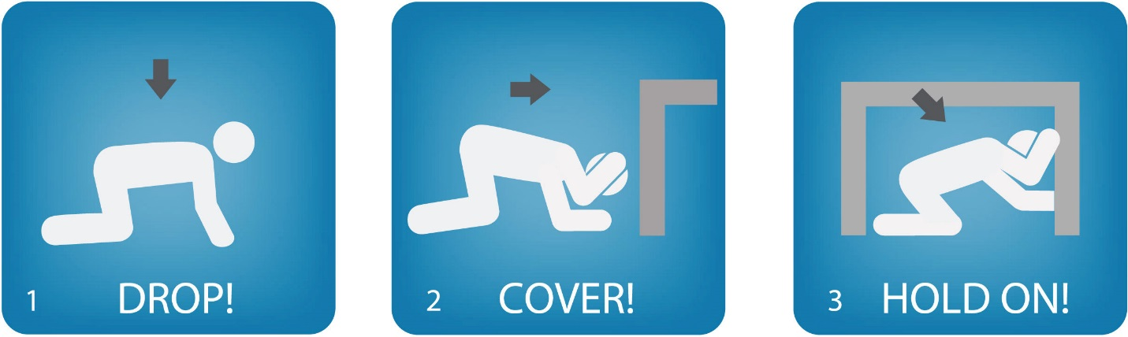

EVACUATION

All building occupants are required to exit the building when the fire alarm sounds.

If a building is evacuated in response to a fire or similar emergency, all personnel are to report to the pre-designated primary or secondary Emergency Assembly Area(s) (EAA).

Evacuation Procedures

- Remain calm.
- Stop what you are doing and do not rush or panic.
- Gather personal belongings if it is safe to do so.
- Close (don’t lock) doors and windows as you exit.
- Use the nearest safe stairway (do not use elevators) and proceed to the nearest safe exit.
- Proceed to the pre-designated EAA and report to the roll taker (if available).
- Await instructions from emergency responders and/or the BEC.
- DO NOT re-enter the building unless authorized by emergency responders.

Floor/Area Monitor Responsibilities (delete this section if not applicable)

- DO NOT place yourself in necessary danger to conduct sweeps of your assigned floor or area.
- Take note of unusual circumstances or non-compliance of personnel to evacuate.
- Knock loudly on doors and announce the need to evacuate. Close any open doors.
- Instruct any lingering occupants to evacuate the building. If persons refuse to exist, emergency responders and the BEC should be notified once outside the building.
- Report any pertinent emergency information to emergency responders and/or the BEC at the EAA.

EVACUATION OF PERSONS WITH DISABILITIES

The following guidelines apply to assisting persons with disabilities during an evacuation situation.

In all emergencies

- Evacuate persons with disabilities if possible.
- DO NOT use elevators unless authorized to do so by the fire department.
- Check on persons with disabilities during an evacuation. Verify that they have been notified of the emergency.
- Attempt a rescue ONLY if the person is in imminent danger and cannot wait for emergency responders.
- Always ASK a person with a disability how you can help before giving assistance. Ask how he/she can be best assisted or moved and whether there are any special considerations that you should be made aware.

Procedures for persons with a visual impairment

- Give verbal instructions to advise the safest route to evacuate. Use estimated distances and directional terms to assist the person.
- DO NOT automatically grasp a visually impaired person’s arm. ASK if he/she desires assistance and offer to allow them to hold your arm while exiting.

Procedures for persons with a hearing impairment

- Get the person’s attention by touch and eye contact. Clearly state the emergency and necessary next actions. Gestures and pointing are helpful, but be prepared to write instructions.
- Offer visual instructions to advise the safest route or direction by pointing toward exits or evacuation maps.

Procedures for persons with a mobility impairment

- It may be necessary to help clear the exit route.
- If persons with mobility impairments cannot exit the building, they should move to safer locations such as Areas of Rescue Assistance, stairwells, or rooms with closing doors away from the hazard.
- Notify emergency responders immediately about any persons remaining in the building with mobility impairments.
- If persons are in imminent danger, it may be necessary to carry them if safe to do so. Always ASK how best to move the person before trying any lifting assistance.

Figure B-2: Two-Handed Carry | Figure B-3: Seated Carry
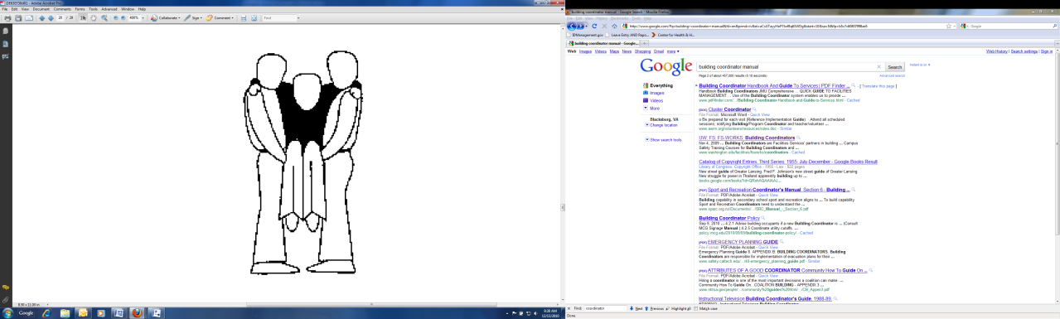 | 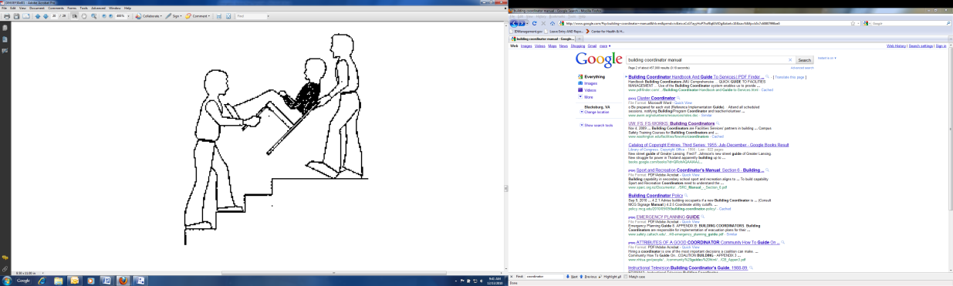

This page is intentionally blank.

PERSONS REQUIRING ASSISTANCE DURING EMERGENCIES TRACKING FORM

List all self-identified persons with disabilities who request evacuation assistance during an emergency.*

Name
Room/Building
Phone
Assistance Needed

Name
Room/Building
Phone
Assistance Needed

Name
Room/Building
Phone
Assistance Needed

Name
Room/Building
Phone
Assistance Needed

Name
Room/Building
Phone
Assistance Needed

*DO NOT include this completed list when distributing the EAP. This information is to be maintained by the Building Emergency Coordinator and should not be shared except with those that have been assigned to assist persons with disabilities during a building emergency.

This page is intentionally blank.

EXTREME HEAT

National Weather Service Definitions
Heat Advisory | Issued when maximum heat index expected >105°F for at least 3 hours
Excessive Heat Warning | Issued when maximum heat index expected >110°F for at least 3 hours

Extreme Heat Procedures

- Monitor local weather conditions with an AM/FM or NOAA All-Hazards Weather Radio, the official www.weather.gov website, and/or cell phone app. Heed warnings and follow instructions accordingly.
- Slow down by reducing, eliminating, or rescheduling strenuous activities until the coolest time of day. Children, seniors, and anyone with health problems should stay in the coolest available place, not necessarily indoors.
- Dress for the weather. Wear lightweight, loose fitting, light colored clothing.
- Eat light, cool, easily digestible foods such as fruit and salads.
- Drink plenty of water, non-alcoholic and decaffeinated fluids, even if you don’t feel thirsty.
- Use air conditioners and electric fans to exhaust hot air from rooms or draw in cooler air.
- Minimize direct exposure to the sun to minimize sunburn potential.
- Check on older, sick, or frail people who may need assistance.
- Monitor persons for heat exhaustion or heat stroke. If signs/symptoms of either present (confusion, headache, dizziness, fainting, cessation of sweating, hot/dry skin, weakness/cramps, nausea/ vomiting, rapid heartbeat, rapid/shallow breathing) seek medical attention right away.

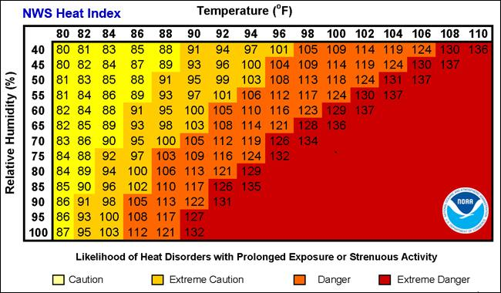
Figure B-4: National Weather Service Heat Index Table

EXPLOSION

Explosion Procedures

- Remain calm.
- Get out of the building as quickly and calmly as possible.
- Call ODUPD at 757-683-4000 or 911.
- If items are falling off bookshelves or from the ceiling, get under a sturdy table or desk.
- If there is a fire, stay low to the floor and exit the building as quickly as possible.
- DO NOT use elevators. Use handrails in stairwells; stay to the right.
- Assist others in exiting the building and move to the building Emergency Assembly Area (EAA).
- If you are outside, you should stay outside. Move quickly to the building EAA.
- Wait for and follow instructions from emergency personnel. Keep streets and walkways clear for emergency vehicles and crews.
- If you are trapped in debris, tap on a pipe or wall so rescuers can hear where you are.
- Persons without proper training should not attempt to rescue people who are inside a collapsed building. Wait for emergency personnel to arrive.
- Seek updated information and further instructions.
  - Online, visit ODU home page at www.odu.edu.
  - By phone, call the ODU Switchboard at 757-683-3000.
  - Watch or listen to local media outlets.

FIRE

Fire/Fire Alarm Response Procedures

- NEVER IGNORE A FIRE ALARM! Your first reaction should be to alert the people around you. Immediately evacuate, and if safe to do so/time allows, bring readily accessible personal items with you.
  - Act immediately but remain calm.
  - Stay low in case of smoke or fumes.
  - DO NOT attempt to extinguish a fire unless you are trained to do so.
- Feel the doorknob or higher on the door with the back of your hand. If it feels hot, fire may be on the other side of the door, so keep it closed. Stuff clothing, towels, etc. (preferably wet) in the door’s cracks to keep smoke out.
  - Even if the door is cool, open it slowly. Stand low and to one side of the door, in case smoke or fumes seep around it.
  - If heat and smoke come in, slam the door tightly, stuff clothing, towels, etc. (preferably wet) in the door’s cracks to keep smoke out, and use your alternate exit.
- If the hallway is clear of smoke, walk in a calm manner to the nearest fire exit and evacuate the building.
  - Use the stairs – NEVER use elevators.
  - Stay low to avoid smoke, fumes, and gases that may have entered.
  - Close doors as you leave to confine fire as much as possible. Do NOT lock doors.
  - If the alarm is not already sounding, pull the fire alarm on your way out.
  - Move quickly to the building Emergency Assembly Area.
- If trapped in a room:
  - Retreat. Close as many doors as possible between you and the fire.
  - Stuff clothing, towels, etc. (preferably wet) in the door’s cracks to keep smoke out.
  - Open the window a few inches for fresh air and hang a brightly colored cloth or bed sheet out the window if possible to alert the fire department to your location.
- If caught in smoke:
  - Drop to hands and knees and crawl or crouch low, watching the base of the wall as you go.
- If forced to advance through flames:
  - Hold your breath. Move quickly, covering head and hair. Keep head down and close your eyes as often as possible.
- If clothing catches fire, stop where you are. Drop to the ground, and cover your mouth and face with your hands to protect them from the flames. Then roll over and over to smother the fire. Remember: STOP…DROP…ROLL
- If you encounter a small fire (wastebasket-size or smaller):
  - Under certain conditions, small fires can be extinguished before there is a full evacuation. The fire must be truly small and controllable and you need both the correct fire extinguisher and knowledge of how to use it. NEVER ENTER A SMOKE-FILLED ROOM. In any case, constantly evaluate and be ready to evacuate if the fire cannot be easily controlled. Under all circumstances:
    - Alert people in the area.
    - Activate the fire alarm.
    - Maintain an accessible exit.
    - Avoid smoke and fumes.
    - Smother the fire or use the correct fire extinguisher.
    - If using an appropriate fire extinguisher, use the PASS method:

Fire Extinguisher Use Procedure

      - P – PULL safety pin from handle.
      - A – AIM (nozzle, cone, horn) at base of the fire.
      - S – SQUEEZE the trigger handle.
      - S – SWEEP from side to side (watch for re-flash).

Figure B-5: PASS Firefighting Method
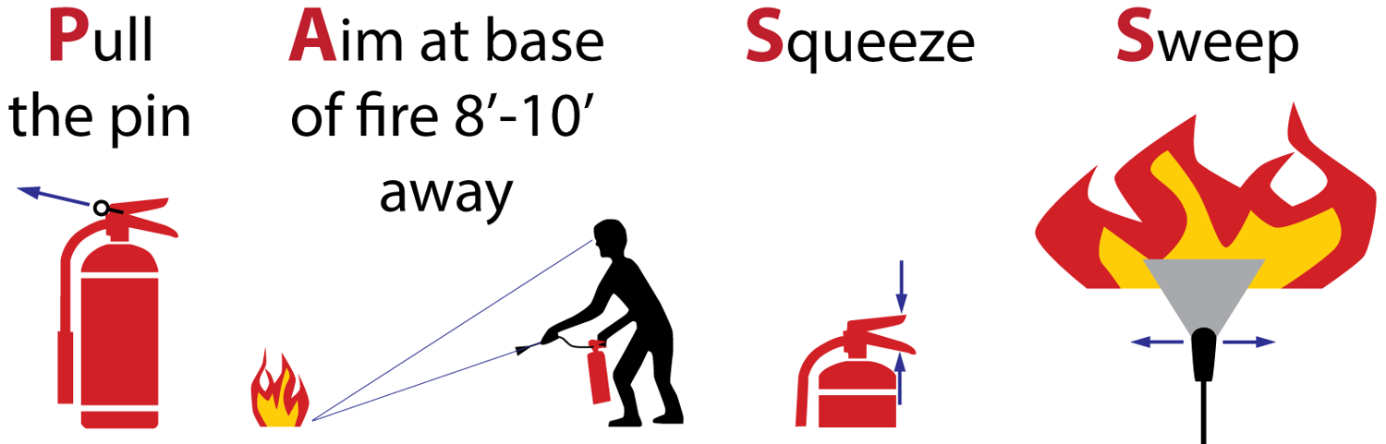

- Seek updated information and further instructions.
  - Online, visit ODU home page at www.odu.edu.
  - By phone, call the ODU Switchboard at 757-683-3000.
  - Watch or listen to local media outlets.

FLOODING

National Weather Service Definitions
Flood Watch | Issued to inform the public and cooperating agencies that current and developing hydrometeorological conditions are such that there is a threat of flooding, but the occurrence is neither certain nor imminent.
Flood Warning | Issued to inform the public of flooding along larger streams in which there is a serious threat to life or property. A flood warning will usually contain river stage (level) forecasts.
Flash Flood Watch | Issued to indicate current or developing hydrologic conditions that are favorable for flash flooding in and close to the watch area, but the occurrence is neither certain or imminent.
Flash Flood Warning | Issued to inform the public, emergency management, and other cooperating agencies that flash flooding is in progress, imminent, or highly likely.

Flood Response Procedures

- Be prepared to shelter-in-place or to evacuate quickly.
- Monitor local weather conditions with an AM/FM or NOAA All-Hazards Weather Radio, the official www.weather.gov website, and/or cell phone app. Heed warnings and follow instructions accordingly.
- Be aware of streams, drainage channels, and other areas known to flood suddenly. Flash floods can occur in these areas with or without warning clouds or rain.
- DO NOT drive through flood waters. Remember: TURN AROUND, DON’T DROWN!
- Seek updated information and further instructions.
  - Online, visit ODU home page at www.odu.edu.
  - By phone, call the ODU Switchboard at 757-683-3000.
  - Watch or listen to local media outlets.

HAZARDOUS MATERIALS

Hazardous Materials Spill Response Procedures

Minor spills of hazardous chemicals that pose little or no threat to the safety and health of personnel can be cleaned by competent departmental personnel by following the warning and cautions signs on the container’s label or manufacturer’s safety data sheet (SDS). A hazardous material emergency exists when cleanup of a spill of a hazardous material is beyond the level of knowledge, training, or ability of the staff in the immediate spill area or the spill creates a situation that is immediately dangerous to life and health of persons in the spill area or facility.

Hazardous spills on-campus that are beyond your capability to control or clean-up, or that present a fire, safety, or health risk are to be reported by calling ODUPD at 757-683-4000 or 911.

- Alert people in the immediate area of the spill and evacuate the room.
- Confine the hazard by closing doors and windows as you leave the room.
- If possible, shut down heating, ventilation, and air conditioning (HVAC) systems.
- Use eyewash or safety showers as needed to rinse spilled chemicals off persons.
- Evacuate any nearby rooms that may be affected. If the hazard will affect the entire building, evacuate the building. If a volatile, flammable material is spilled, immediately warn everyone, and control sources of ignition.
- Notify the ODU Police Department of the name of hazardous material, location of the spill, size of the spill, number of injured persons (if any), and any environmental concerns, such as location of storm drains or streams by calling 757-683-4000 or 911. You will need to provide your name and a telephone number and be prepared to spell the name(s) of the hazardous materials involved. Always call from a safe location.
- Report all spills to your supervisor and/or the Principal Investigator.

Procedures for laboratory personnel to handle chemical, biological, or radiological spills are provided in laboratory-specific documentation. Trained laboratory personnel are authorized by ODU Environmental Health and Safety (EHS, 757-683-4495, www.odu.edu/ehs) to determine appropriate emergency response measures for their areas.

HURRICANE, TROPICAL STORM, and NOR’EASTER: SHELTER-IN-PLACE

National Weather Service Definitions
Tropical Storm Watch | Issued when tropical storm conditions (sustained winds of 39 to 73 mph) are possible within the specified coastal area within 48 hours.
Tropical Storm Warning | Issued when tropical storm conditions (sustained winds of 39 to 73 mph) are expected somewhere within the specified coastal area within 36 hours.
Hurricane Watch | Issued when hurricane conditions (sustained winds of ≥74 mph) are possible within the specified coastal area. Because hurricane preparedness activities become difficult once winds reach tropical storm force, the hurricane watch is issued 48 hours in advance of the anticipated onset of tropical-storm-force winds.
Hurricane Warning | Issued when hurricane conditions (sustained winds of ≥74 mph) are expected somewhere within the specified coastal area. Because hurricane preparedness activities become difficult once winds reach tropical storm force, the hurricane warning is issued 36 hours in advance of the anticipated onset of tropical-storm-force winds. The warning can remain in effect when dangerously high water or a combination of dangerously high water and waves continue, even though winds may be less than hurricane force.

Hurricane, Tropical Storm, and Nor’easter Response Procedures

- Remain calm.
- Monitor local weather conditions with an AM/FM or NOAA All-Hazards Weather Radio, the official www.weather.gov website, and/or cell phone app. Heed warnings and follow instructions accordingly.
- Follow the instructions of University leadership and local/State emergency management personnel regarding evacuation.
- Follow the instructions of University leadership regarding continuity of University operations.
- If evacuating, shut down computers and electrical equipment. Secure workspaces and outdoor items, if applicable.
- Review/update equipment inventories in case of loss or damage during the storm.
- Review/update personnel contact lists.
- For locations subject to flooding, elevate and/or cover items with plastic sheeting to mitigate damage. As appropriate, relocate vehicles to higher ground.
- Back up data as appropriate.
- Review departmental continuity plans and develop an appropriate strategy to either continue critical operations during the event and/or resume normal operations after the storm has passed.
- Review personal and family preparedness and evacuation plans, and secure sufficient provisions to sustain family members for at least three days (preferably up to seven days).
- DO NOT call ODUPD/911 unless you are reporting a life-threatening situation.
- Seek updated information and further instructions.
  - Online, visit ODU home page at www.odu.edu.
  - By phone, call the ODU Switchboard at 757-683-3000.
  - Watch or listen to local media outlets.

MEDICAL EMERGENCY

Medical Emergency Response Procedures

- The initial minutes after an injury or medical crisis frequently are the most important. If you remain calm, you will be better able to share critical information with emergency responders.
- Immediately call ODUPD at 757-683-4000 or 911 and tell the dispatcher about the person who needs attention:
  - Gender.
  - Approximate age.
  - Nature of injury or illness.
  - Pertinent medical history (if known).
  - Precise location.
  - Do not hang up until the dispatcher instructs you to do so.
- DO NOT move an injured person – unless there is immediate danger of further harm – until emergency medical personnel arrive.
- Keep the person warm.
- If possible, designate someone to direct emergency responders from the approach to the victim.
- If trained, take prompt appropriate action by providing basic first aid until emergency medical personnel arrive and take over care of the victim.
  - Appropriate action can mean anything from waiting near the injured person to applying direct pressure to a wound, performing CPR, or splinting an injury.
  - Never perform a medical procedure if you are not sure how to do it.

POWER OUTAGE

Power Outage Procedures

- Remain calm.
- If it is an emergency, call ODUPD at 757-683-4000 or 911. Otherwise, during regular business hours (8:00am-5:00pm), notify the ODU Facilities Management Maintenance Support Center at 757-683-4600. After hours and on weekends, notify the ODU Police Department at 757-683-4000.
- Stay where you are unless there is an imminent threat to your safety (e.g., a fire). Since most power outages are relatively brief, it may be best to remain in place rather than attempt to evacuate the building.
- In many buildings, only the alarm systems and emergency lighting are connected to a backup generator. These systems may experience a brief (up to 30 seconds) interruption as power is switched to an emergency generator or when power to the building is restored.
- If you are in an unlit area, proceed with caution to an area that has emergency lighting. The backlighting on your cell phone (or a flashlight app) may help you navigate.
- Elevators will not function during a power outage. If you are trapped in an elevator, stay calm. Press the emergency call button inside the elevator or call ODUPD at 757-683-4000 or 911. When speaking with the dispatcher, identify the building, elevator number and location in the building, and floor where the car stopped.
- Protect electrical equipment and appliances.
  - To avoid damage from any surge when the power is restored, turn off and unplug non-essential electrical devices, especially voltage-sensitive equipment like computers.
  - Keep the doors to refrigerators and freezers closed as much as possible to help them stay cold.

SEVERE THUNDERSTORM/LIGHTNING: SHELTER-IN-PLACE

National Weather Service Definitions
Severe Thunderstorm Watch | Issued when conditions are favorable for the development of severe thunderstorms in and close to the watch area. A severe thunderstorm by definition is a thunderstorm that produces one inch (quarter size) hail or larger in diameter, and/or winds ≥58 miles an hour, and/or damage to trees, power lines, and/or structures is observed. The size of the watch can vary depending on the weather situation. They are usually issued for a duration of 4 to 8 hours, and are normally issued well in advance of the actual occurrence of severe weather.
Severe Thunderstorm Warning | Issued when either a severe thunderstorm is indicated by radar or a spotter reports a thunderstorm producing hail one inch or larger in diameter, and/or winds ≥58 miles an hour, and/or damage to trees, power lines, and/or structures is observed; therefore, people in the affected area should seek safe shelter immediately. Severe thunderstorms can produce tornadoes with little or no advance warning. Lightning frequency is not a criteria for issuing a severe thunderstorm warning. They are usually issued for a duration of one hour. They can be issued without a Severe Thunderstorm Watch being already in effect.

Severe Thunderstorm/Lightning Response Procedures

- Remain calm.
- Monitor local weather conditions with an AM/FM or NOAA All-Hazards Weather Radio, the official www.weather.gov website, and/or cell phone app. Heed warnings and follow instructions accordingly.
- Recognize the signs of an oncoming thunder and lightning storm: towering clouds with a cauliflower shape, dark skies and distant rumbles of thunder or flashes of lightning. If you can hear thunder, you are within lightning striking distance. Do not wait for lightning to strike nearby before taking cover. Lightning can strike as far as 10 miles from the area where it is raining, which is about the distance you can hear thunder.
- Lightning is extremely dangerous. At the first rumble of thunder, go to a large building or fully enclosed vehicle and wait 30 minutes after the last rumble of thunder before you go back outside.
Remember: WHEN THUNDER ROARS, GO INDOORS!
- Shelter-in-place: during a severe thunderstorm warning, report to the designated Internal Assembly Area (IAA) or seek indoor shelter in an interior room or hallway away from windows and doors.
- Avoid windows, corridors with windows, or large free-standing expanses (such as auditoriums and cafeterias). DO NOT use elevators during a severe thunderstorm warning!
- If you are caught outside with no shelter, lie flat in a ditch or depression and cover your head.
- Watch for flying debris.
- DO NOT call ODUPD/911 unless you are reporting a life-threatening situation.
- Seek updated information and further instructions.
  - Online, visit ODU home page at www.odu.edu.
  - By phone, call the ODU Switchboard at 757-683-3000.
  - Watch or listen to local media outlets.

SUSPICIOUS PACKAGE/MAIL

Suspicious Letter or Package Indicators

- Excessive postage.
- Misspellings of common words.
- Excessive weight.
- Rigid envelope.
- Foreign mail, airmail, or special delivery.
- Hand written or poorly-typed address.
- Restrictive markings such as “confidential,” “personal,” etc.
- Excessive securing – material such as masking tape, string, etc.
- Incorrect titles, or titles without names present.
- Oily stains or discoloration.
- Visual distractions.
- Lopsided or uneven.
- No return address.
- Protruding wires or tinfoil.

Suspicious Package Response Procedures

- Remain calm.
- From a safe location notify law enforcement immediately by calling dialing ODUPD at 757-683-4000 or 911.
- Move people away from the package and limit access to the area.
- DO NOT move or open the package.
- DO NOT investigate too closely.
- DO NOT cover, insulate, or place the package into a cabinet or drawer.
- Clear the area and report to the building’s Emergency Assembly Area.

Pranks and Hoaxes

The University and law enforcement authorities take postal threats very seriously. Pranks or hoaxes involving false threats of biological agents or terror disrupt lives and the University’s sense of normalcy, create serious safety concerns, and tax valuable University and community resources. They create illegitimate alarm in a time of legitimate concern. Any individual found responsible for such acts will be subject to University disciplinary action, up to and including separation from the University, as well as prosecution under State and Federal law.

SUSPICIOUS PERSON

If you witness a person acting in an odd or unusual manner or if a person or situation makes you feel uneasy, trust your instincts and report it.
- Remain calm.
- DO NOT physically confront the person.
- DO NOT let anyone into a locked building or office.
- DO NOT block the person’s access to an exit.
- Call ODUPD at 757-683-4000 or 911. Provide as much information as possible about the person and his or her direction of travel in your description of the person, include age, race, clothing, height, weight, sex, hair and eye color, weapons, direction of travel, and any other descriptors you noticed.

If a suspicious person is standing at your car, or near a parking spot, just keep walking. When it appears to be safe, return to your vehicle and look around and inside your vehicle before getting in.

Suspicious Vehicle Indicators

- Missing or forged license plates.
- Covered or taped windows.
- Any vehicle that appears overloaded or has any substance leaking from it.
- Any vehicle containing drums, barrels, or other bulks containers.
- Parked illegally, parked at an unusual location, or appears to be abandoned.

Suspicious Vehicle Response Procedures

If you see a vehicle that appears to be suspicious, immediately call ODUPD at 757-683-4000 or 911. Give the dispatcher the following information:
- The exact location of the vehicle in question.
- A description of the vehicle, including license plate, vehicle color, vehicle make, model, and any other distinguishing features.
- Your full name and the telephone number from which you are calling, in case you are disconnected.
- Do not hang up as additional information may be needed. Follow directions provided by emergency personnel.

TORNADO: SHELTER-IN-PLACE

National Weather Service Definitions
Tornado Watch | Issued when conditions are favorable for the development of tornadoes in and close to the watch area. Their size can vary depending on the weather situation. They are usually issued for a duration of 4 to 8 hours. They normally are issued well in advance of the actual occurrence of severe weather.
Tornado Warning | Issued when a tornado is indicated by radar and/or funnel cloud or tornado spotted. Also includes waterspout moving onshore. Persons in the affected area should seek safe shelter immediately. Tornado Warnings can be issued without a Tornado Watch being already in effect; they are usually issued for a duration of around 30 minutes.

Tornado Warning Response Procedures

- Remain calm.
- Monitor local weather conditions with an AM/FM or NOAA All-Hazards Weather Radio, the official www.weather.gov website, and/or cell phone app. Heed warnings and follow instructions accordingly.
- If you receive an ODU Alert or otherwise hear about a tornado in your area, DO NOT wait until you see it to take cover. Instructions to shelter-in-place would be issued through the ODU Alerts system along with specific precautions to take during the emergency.
- Shelter-in-place: during a tornado warning, report to the designated Internal Assembly Area (IAA) or seek indoor shelter in the lowest level possible, in an interior room or hallway away from windows and doors.
- Crouch near the floor or under heavy, well supported objects. Cover your head.
- Avoid windows, corridors with windows, or large free-standing expanses (such as auditoriums and cafeterias). DO NOT use elevators during a tornado warning!
- If you are caught outside with no shelter, lie flat in a ditch or depression and cover your head.
- Watch for flying debris.
- DO NOT call ODUPD/911 unless you are reporting a life-threatening situation.
- Seek updated information or further instructions.
  - Online, visit ODU home page at www.odu.edu.
  - By phone, call the ODU Switchboard at 757-683-3000.
  - Watch or listen to local media outlets.

WINTER STORM AND EXTREME COLD: SHELTER-IN-PLACE

National Weather Service Definitions
Winter Weather Advisory | Issued when 1”-2” snow, 0.25”-1” sleet, and/or any ice accretion on sidewalks/roadways is expected
Winter Storm Watch | Issued when there is a potential for heavy snow or significant ice accumulations, usually at least 24 to 36 hours in advance.
Winter Storm Warning | Issued when a winter storm is producing or is forecast to produce heavy snow (4” per 24 hours or 3” per 12 hours), sleet (1”+) or significant ice accumulations (1/4”+).
Blizzard Warning | Issued for winter storms with sustained wind or frequent gusts of ≥35 mph with considerable blowing/drifting of snow/falling snow that frequently reduces visibility to 1/4 of a mile or less. These conditions are expected to prevail for >3 hours.
Wind Chill Advisory | Issued when the wind chill is expected to be ≤0°F
Wind Chill Warning | Issued when the wind chill is expected to be ≤-15°F

Winter Storm/Extreme Cold Response Procedures

- Monitor local weather conditions with an AM/FM or NOAA All-Hazards Weather Radio, the official www.weather.gov website, and/or cell phone app. Heed warnings and follow instructions accordingly.
- Stay indoors during the storm or cold weather.
- If you must be outside, dress in layers.
- Walk carefully on snowy, icy, walkways.
- Avoid overexertion when shoveling snow.
- Keep dry. Change wet clothing frequently to prevent a loss of body heat.
- Drive only if it is absolutely necessary. If you must drive: travel during the day; don’t travel alone; keep others informed of your schedule; stay on main roads and avoid shortcuts.
- Monitor persons for frostbite or hypothermia. If signs/symptoms of either present (loss of feeling or white/pale appearance in extremities, uncontrollable shivering, memory loss, disorientation, incoherence, slurred speech, drowsiness, apparent exhaustion) seek medical attention right away.

Figure B-6: National Weather Service Wind Chill Table
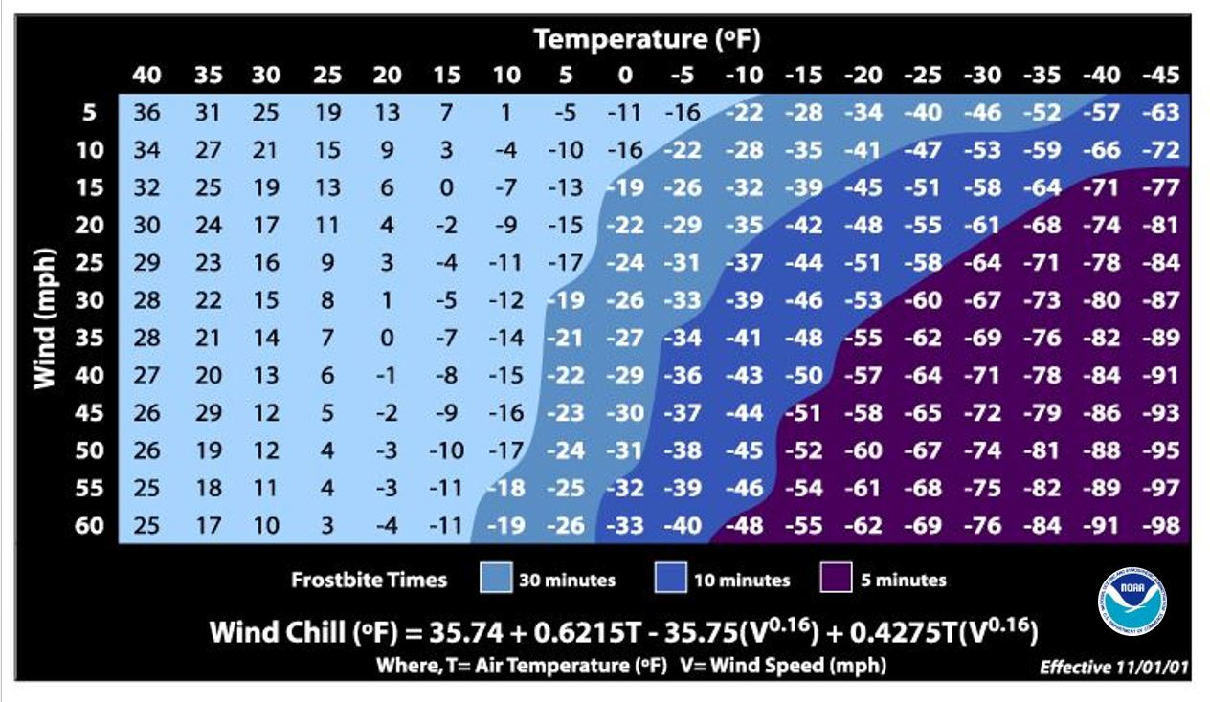

WORKPLACE VIOLENCE

Workplace Violence Procedures

- ODU Policy 6501 prohibits workplace violence. Specifically, the University will respond promptly to violence, threats of violence, harassment, intimidation, or disruptive behavior of a threatening nature towards people or property. Individuals who violate this policy may be removed from university property and are subject to disciplinary and/or personnel action up to, and including, termination and/or criminal prosecution.
- Workplace violence is defined as any actual or threatening behavior of a violent nature, as understood by a reasonable person, exhibited by faculty, staff, student employees, or others.
- Examples of workplace violence include, but are not limited to:
  - Intentional physical contact for the purpose of causing harm (such as slapping, punching, striking, shoving, or otherwise physically attacking a person).
  - Menacing or threatening behavior (such as throwing objects, waving fists, damaging property, stalking, or otherwise acting in an aggressive manner; or, using oral or written statements specifically intended to frighten, coerce, or cause distress) where such behavior would be interpreted by a reasonable person as being evidence of intent to cause physical harm to individuals or property.

- General Reporting Responsibilities
  - Any member of the university community who has been subject to workplace violence or who has witnessed workplace violence must promptly notify their supervisor, who must notify the Department of Human Resources Employee Relations Manager and/or the Director of Employee Relations and Strategic Initiatives. As appropriate, the ODU Police Department must also be notified.

- Reporting Concerning Behavior
  - Additionally, employees are encouraged to report any concerning behavior to the University's Threat Education Assessment & Management Team (T.E.A.M.). It is imperative that all university employees take this responsibility seriously.

- Reporting Imminent or Actual Violence
  - Any person experiencing or witnessing imminent or actual violence involving weapons or potential injuries should call ODUPD at 757-683-4000 or 911.

- Reporting Acts of Violence Not Involving Weapons or Injuries to Persons
  - Any person who is the subject of, or witness to, a suspected violation of this policy should report the incident to his or her supervisor or, in lieu thereof, to the Old Dominion University Department of Human Resources.

Annex C: Emergency Information for the Classroom

The importance of emergency preparedness extends into the classroom. Students, even in higher education settings, look to the instructor for guidance and definitive action during an emergency. Faculty and instructors who take a few minutes at the start of each semester to familiarize their students with basic evacuation and emergency procedures will help ensure that they and their students are better prepared for an emergency. The one-page quick reference guide on the following page titled Emergency Guide for Faculty and Instructors in the Classroom is intended to be carried by the faculty/instructor to the classroom.

This annex is optional but recommended for most buildings. For administrative buildings where no instructional activities take place, this annex can be deleted.

This page is intentionally blank.

Emergency Guide for Faculty and Instructors in the Classroom

Students look to the person at the front of the class as the leader of the group. Regardless of class size, students expect the instructor to have answers and a clear plan when an incident, emergency, or event occurs.

What are my responsibilities as the instructor?
- Most importantly: Provide leadership if an emergency arises and follow emergency procedures for all building alarms and emergencies.
- Clearly cover the basic emergency procedures for the class during the first week of class (10 minutes of pre-planning can save lives).
- Know how to report an emergency from the classroom.
- Communicate the evacuation route and Emergency Assembly Area (EAA) outside the building in case of evacuation. Also explain where the Internal Assembly Area (IAA) is and how it should be used as a shelter-in-place location.
- Evacuate the classroom if a medical emergency occurs to allow emergency responders to access the victim.
- Persons with disabilities who self-identify should be able to provide information on special assistance needs if an incident/emergency/event occurs. Persons with disabilities may need assistance leaving the building during an evacuation.

How do I report an emergency?
Report all emergencies by:
- Calling ODUPD at 757-683-4000 or 911. Save this number in your cell phone.
- Stating the nature of the emergency.
- Remaining on the line until the dispatcher hangs up.

What should I carry with me to class?
- Class roster
- Charged cell phone with battery backup/charging cable
- List of important telephone numbers (i.e. dept. leadership, supervisors, or lab managers, if applicable)

How do I evacuate the classroom?
In many buildings, evacuation routes are posted on building walls at main entrances. Know the evacuation routes for your classroom. Look for illuminated EXIT signs in larger classrooms to determine primary and secondary exits. All fire alarms require mandatory evacuations.

Where do I go after evacuation?
As your class is evacuating the classroom, ensure that everyone is leaving the building. Report to the designated building EAA. Ensure that your class knows the location and use it to account for students during an evacuation.

What about a person with a disability?
Four options are available to evacuate a person with a mobility impairment:
- Horizontal evacuation to the outside. Evacuation without using stairs.
- Stairway evacuation by assisting the person to walk or be carried.
- Stay in place unless danger is imminent. Report the location of the person once outside.
- Area of rescue/refuge or other designated location, if available.

What if there is violence or an active THREAT?
- Dial 757-683-4000 or 911 from a cell phone.
- Run: Evacuate the area if safe to do so.
- Hide: Secure the classroom by locking doors; blocking the door with desks/chairs/tables; moving persons away from windows and behind items that protect them (desks, chairs, tables). Silence devices and remain very quiet.
- Fight: Only as a last resort, attempt to incapacitate the shooter with improvised weapons.
- Treat the injured using basic first aid (apply pressure to wounds and elevate arms or legs that are bleeding).
- Cooperate with emergency responders.

This page is intentionally blank.

Annex D: Emergency Kits

DEPARTMENT/UNIT EMERGENCY KIT SUGGESTED CONTENTS

This list is meant to serve as a guide only and should be tailored to fit the needs of the department/unit. Contact the Office of Emergency Management for more information at 757-683-5116 or oem@odu.edu.

- Building EAP
- Employee roster and phone directory/tree
- First aid kit
- Dust masks
- A multi-tool
- Communications equipment (including a hand-crank/solar NOAA All-Hazards Weather Radio, portable AM/FM radios, walkie talkies, and extra batteries)
- Leather gloves
- Hard hats
- Plastic sheeting
- Sign-making supplies (including markers, thumb tacks, tape, paper, post-its)
- Duct tape/caution tape
- Flashlights and batteries
- Light sticks
- Shelf-stable/nonperishable food
- Bottled water
- Whistle
- Change of clothes for those involved in emergency response

PERSONAL EMERGENCY KIT SUGGESTED CONTENTS

In addition to Departmental/Unit Emergency Supply Kits, employees are encouraged to assemble personal emergency kits and have them accessible at all times. Additional tips for individual preparedness can be found at www.odu.edu/emergency. Suggested items include, but are not limited to:

- Water bottles/packets
- Food/wrapped snacks
- Flashlights and batteries
- Battery-operated/hand-crank/solar NOAA All-Hazards Weather Radio
- Cell phone battery pack and charging cable
- A change of clothes and sturdy, closed toe shoes
- Backup eyeglasses and prescription medications
- Emergency telephone numbers and out-of-area emergency contact numbers

Annex E: EAP Reference Information and Instructions

EMERGENCY PLANNING AT OLD DOMINION UNIVERSITY
Figure E-1:
Emergency Management Cycle
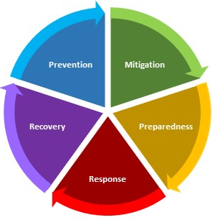
Emergency management is defined as the activities that prevent, mitigate, prepare for, respond to, and recover from incidents, emergencies, and events that may disrupt normal operations. Emergency plans and procedures are developed to be flexible, scalable, and applicable across all hazard spectra.

The Office of Emergency Management (OEM) is responsible for coordinating all emergency and continuity planning at Old Dominion University. The office provides strategic guidance and development support for several types of plans, including the ODU Crisis and Emergency Management Plan (CEMP–designed to provide overarching guidance for the University’s response to incidents/ emergencies/events), the University Continuity Plan (a recovery-focused plan designed to maintain or quickly resume the University’s chief mission during and after incidents/emergencies/ events), and department/building-centered Emergency Action Plans (EAPs–a document to provide immediately actionable guidance for life safety during an incident/emergency/ event) and Continuity Plans. Each of these plans serve as a tool to increase individual, departmental, and University preparedness and resiliency and improves the whole community’s ability to respond and recover from an incident, emergency, or event.

The development of an EAP is an integral part of the emergency management system ODU employs as the foundation for preparedness, response, and short-term recovery activities. This EAP details the actions that personnel in a building should take in response to an incident/emergency/event situation.

EMERGENCY ACTION PLAN OVERVIEW

Required University-wide by University Policy 1021: Emergency Management, the Emergency Action Plan (EAP) serves to address natural, human-caused, and technological incidents/emergencies/events that may occur in your building and could affect the campus-wide community. A workplace emergency is an unexpected incident that: threatens students, faculty, staff, and visitors; disrupts or closes all or part of the University; and/or causes physical or environmental damage.

The EAP is designed to provide immediately actionable guidance for life safety during an incident/ emergency/event that affects all or part of a building. The EAP is authorized by provisions in, but does not supersede, the University’s CEMP: i.e. an incident/emergency/event that expands beyond the scope of a department’s/building’s ability to respond in accordance with their respective EAP would defer to a University-level response as directed by the CEMP. Nothing in the EAP should be construed as limiting the use of good judgment and/or common sense in matters not foreseen or specifically addressed by the EAP.

The Building EAP is presented in the following order:
- Building Emergency Action Plan
- Annex A: Departmental Personnel and Notification Protocol
- Annex B: Emergency Procedures
- Annex C: Emergency Information for the Classroom
- Annex D: Emergency Kits
- Annex E: EAP Reference Information and Instructions

The following are key elements of the EAP:
- Evacuation routes, exit points, and pre-designated Emergency Assembly Areas (EAAs – safe locations outside the building in case of an incident/emergency/event) and Internal Assembly Areas (IAAs – safe internal spaces in case of an incident/emergency/event);
- When and how to evacuate the building;
- Procedures for notifying emergency responders of an incident/emergency/event;
- The meaning of sheltering- or securing-in-place and procedures for doing so;
- Locations of fire extinguishers, first aid kits, and automatic external defibrillators (AEDs);
- Any unique hazards located in the building where you work; and,
- Procedures for persons needing assistance.

For assistance with this document, the EAP planning or development process, or programmatic and technical questions, please contact the Office of Emergency Management at 757-683-5116 or oem@odu.edu.

THE BUILDING EMERGENCY PREPAREDNESS COMMITTEE AND THE BUILDING EMERGENCY COORDINATOR

All departments co-located in a single building will need to assign one departmental representative within the building to serve on the Building Emergency Preparedness Committee (EPC).

Duties of the Emergency Preparedness Committee

- Convene once annually, at a minimum. More frequent meetings are recommended.
- Appoint a Building Emergency Coordinator (BEC) with an assigned term as determined by the committee.
- Appoint an Alternate BEC with an assigned term as determined by the committee.
- Develop and maintain the EAP building annex in conjunction with the BEC.
- Participate in preparedness training and exercises on an annual basis.

The BEC should be a full-time faculty or staff member with at least 6 months experience in their position. The individual should have an understanding of the departments housed in their building and the activities of same. The BEC should know the building well and should keep regular office hours. The BEC should serve a term of no less than one year with no limit to the number of consecutive terms. BECs will need to provide multiple forms of contact including methods reachable outside of normal business hours.

Duties of the Building Emergency Coordinator

- Chair the Emergency Preparedness Committee.
- Serve as the point of contact for safety and preparedness information, receive and monitor emergency communications as provided, and distribute relevant information throughout the building.
- Coordinate the development and maintenance of the Building EAP in conjunction with the EPC.
- Serve as the primary contact between emergency responders and building occupants in case of an emergency.
- Coordinate fire drills and emergency exercises, as necessary, for the building with OEM.
- Train an alternate to assume BEC duties in case of absence.
- Act as a conduit to OEM and/or emergency response agencies.

The alternate BEC is responsible for maintaining awareness of the activities of the BEC in case he/she is unavailable during an emergency.

EPCs should consider assigning building primary and alternate Floor/Area Monitors as necessary. Floor/Area Monitors can be an essential part of the building evacuation process. They are assigned by floor or geographically within a building and serve to provide immediate life safety information to building occupants during an incident/emergency/event. Floor/Area Monitors may also conduct a sweep or quick check or specific spaces as they evacuate the building as long as their personnel safety is not endangered in the process.

See Figure E-2 below for a visual depiction of the relationship between the EPC and BEC.

Figure E-2: Relationship Between the Building Emergency Preparedness Committee and the Building Emergency Coordinator
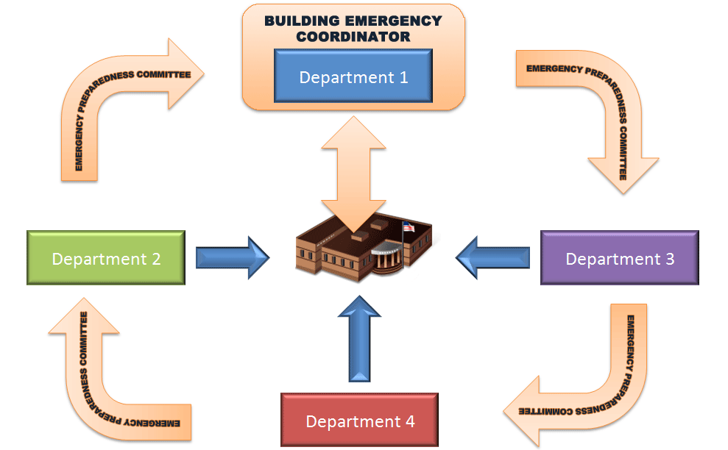

TRAINING AND EXERCISES

Training is an integral part of the safety and preparedness program for your building. Employees should be aware of emergency procedures located within this plan. There are numerous training opportunities for members of the University community to become better prepared to respond to incidents/ emergencies/events. Contact OEM at 757-683-5116 or oem@odu.edu for more information.

Employee Emergency Action Plan Awareness

It is the responsibility of the Building Emergency Preparedness Committee departmental representatives to ensure all of their employees are familiar with the EAP. This includes general plan awareness, a physical tour of evacuation routes and assembly areas, knowledge of the location(s) of first aid kits and AEDs, and any special building circumstances. Awareness training should be facilitated by departmental supervisory staff when employees (new or transferring) are assigned to a building.

Building Occupant Responsibilities

It is the responsibility of the occupant to become familiar with the EAP and refresh their knowledge periodically. Knowledge of evacuation routes, assembly areas, and notification procedures are critical to successfully manage an incident/emergency/event. Questions regarding the plan or its contents should be directed to the Building Emergency Coordinator or OEM.

Building Emergency Coordinator/Alternate BEC Orientation Training

BECs and their alternates will be provided targeted, periodic training aimed to enrich departmental EAP programs. The training will be presented primarily by members of OEM, ODUPD, EHS, and FM, as well as other stakeholders as appropriate. Contact OEM at 757-683-5116 or oem@odu.edu for more information.

OEM Training

OEM sponsors various training courses, including Incident Command System, National Incident Management System, EAP/continuity plan awareness, and others on a periodic basis. Contact OEM @ 757-683-5116 or oem@odu.edu for available training opportunities.

Building Evacuation/Fire Safety Drills

Building evacuation and/or fire drills must be conducted regularly. The number of drills that must be performed per year varies by building use and function. Please contact OEM at 757-683-5116 or oem@odu.edu to determine the drill schedule for your building and to schedule drills.

EAP/Continuity Plan Exercises

Exercises designed to test elements of departmental EAPs/continuity plans must be conducted on an annual basis. Seminars and workshops serve to orient staff to EAP contents, while tabletops, drills, and other exercise formats allow departments to refresh, retrain, and test departmental staff on plan elements and identify strengths and areas for improvement in plans/procedures. Generally, a one-hour, OEM-facilitated tabletop exercise testing EAP response procedures/protocol and Continuity Plan recovery procedures/protocol will satisfy this requirement. Contact OEM at 757-683-5116 or oem@odu.edu for more information.

EAP DEVELOPMENT AND MAINTENANCE

Development

- Sample verbiage or language is provided to assist in developing the plan. The sample language provided in the template should be replaced, expanded upon, or modified as necessary to fit the needs of the building/department using the template. This includes tables, charts, checklists or other tools within the template. However, all sections and elements outlined in the template should be included in the building’s/department’s Emergency Action Plan unless otherwise indicated.
- If your building/department has addition al information that should be added (building/department-specific plans, standard operating procedures, etc.), add those as additional annexes in the rear of the template. This document is designed to be flexible and adaptable to your needs.

Finalization

- Delete all blue italicized text instructions/explanations, or change to appropriate content.
- Make sure that all tables are completed as necessary.
- If you need assistance formatting or completing the plan or need guidance on developing certain sections, contact OEM at 757-683-5116 or oem@odu.edu.

Distribution

- In order for an emergency plan to be effective, it must be widely circulated. This document is intended for everyone in your building/department – from Deans and Department Chairs to Faculty and Staff.
- Make sure all staff has access to the plan and reviews it at least annually. It is recommended that at least one hard copy per department be stored in a red three-ring binder in an accessible location(s).

Maintenance

Buildings/departments are required to annually review and update their EAP via the Building Emergency Preparedness Committee. The following EAP sections should be reviewed and updated:
- All information in the Building Emergency Action Plan.
- All personnel and notification protocols in each departmental/unit Annex A: Departmental Key Personnel and Notification Protocol. Note: departments are encouraged to update personnel contact information more frequently.
- Any changes to the document other than minor grammatical/formatting edits should be logged in the Record of Changes found at the beginning of the plan.
- For assistance with map development or plan coordination with the EPC, contact OEM at 757-683-5116 or oem@odu.edu.

The University Audit Department will periodically review EAPs for completeness, accuracy, and compliance with University Policy 1021: Emergency Management requirements.

