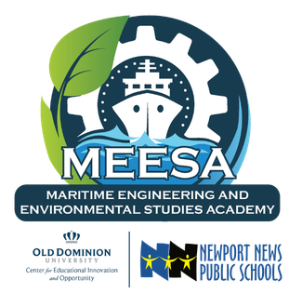

MEETING AGENDA
BOARD MEETING
July 17, 2025

1. AGENDA

1. Welcome
2. Fiscal reporting & Budget
a. Year 0 fiscal report to state
b. Year 1 proposed budget
3. By-laws introduction
4. MEESA Update - Tirzah Sarro & Kaitlyn McCoy
5. Ribbon Cutting update
6. Meetings
a. Upcoming meetings:
i. Required 50% in person
ii. Discussion & next meeting
b. Housing materials- drive versus board docs (or other similar tool)

