Using Jamf Self Service (Mac)
The Self Service portal allows you to install applications on ODU-managed Apple computers. DTT can publish applications, web links and other configurations and make them available in Self Service. This guide will show you how to access and install applications.

Accessing Self Service
- Open your Applications folder: Click on a blank area of the desktop, then click on Go > Applications. (Or press Shift + Command + A from any Finder window.)
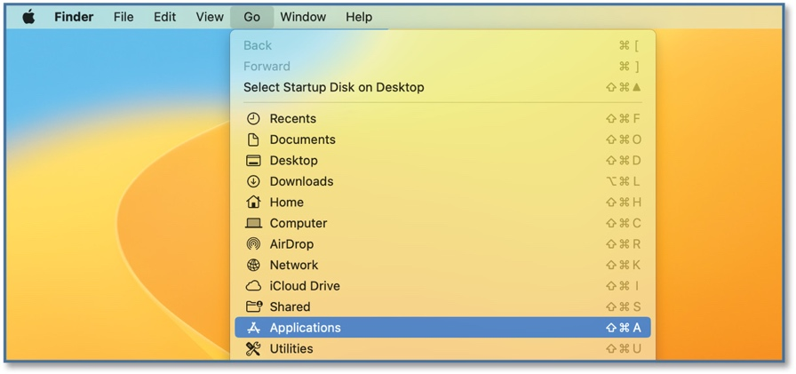
- Double-click on the Self Service application.

- When Self Service launches, log in with your MIDAS ID and password.
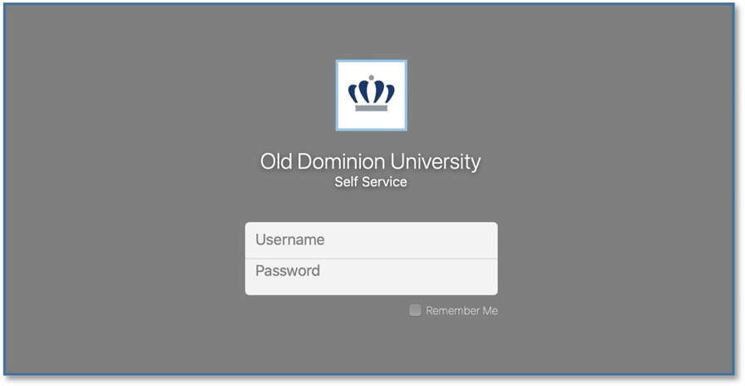

Installing Applications
- Find the application that you want to install, and click on the Install button.
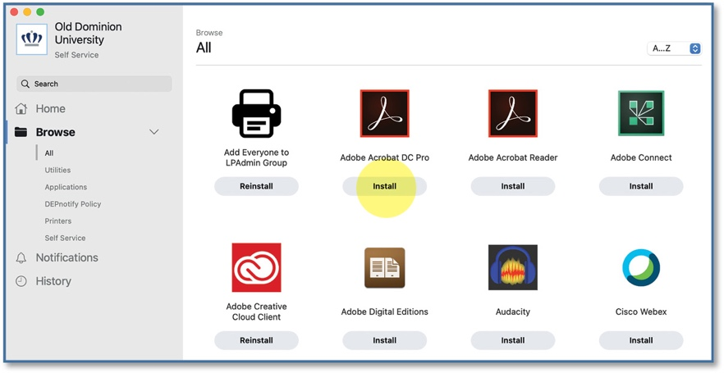
- Click Install again on the following page.
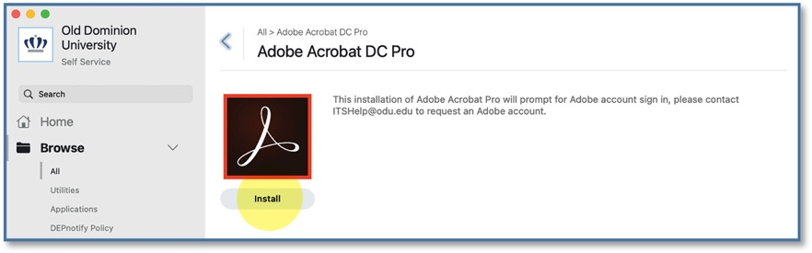
- Once the application has been installed, the button changes to Reinstall.
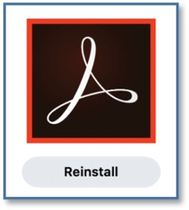
If a reboot is required after installation, you will have a couple of minutes to save your data before your computer restarts. Installation times will vary depending on the application. If an application is missing from Self Service, contact your TSP or the IT Help Desk at ithelpdesk@odu.edu.

