Using Company Portal (Windows)
The Company Portal allows you to install applications on your updated ODU-managed Windows computers. DTT can publish applications, web links and other configurations and make them available on the Company Portal. This guide will show you how to access and install applications.
- Click on the Start Menu > All Programs > Company Portal
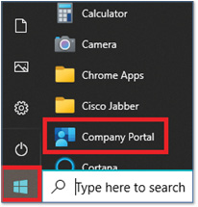
- In the Company Portal, you will see a list of Featured apps (applications commonly used on campus) and a list of Recently published apps (newest applications to the Company Portal).
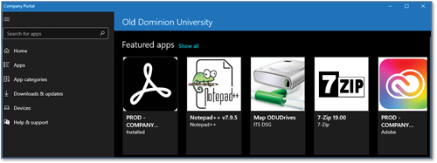
- On the left menu bar, click on Apps and you will see a list of all applications available to install. (Note: You can also Search for apps by using the search bar at the top left, or you can Refine or filter the apps by categories on the right.)
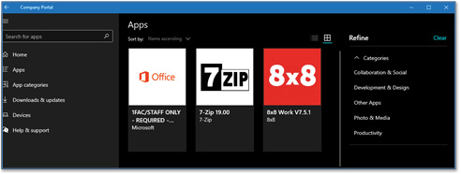
- Select the application you wish to install, and it will open a window showing a description of the application. Click on Install.
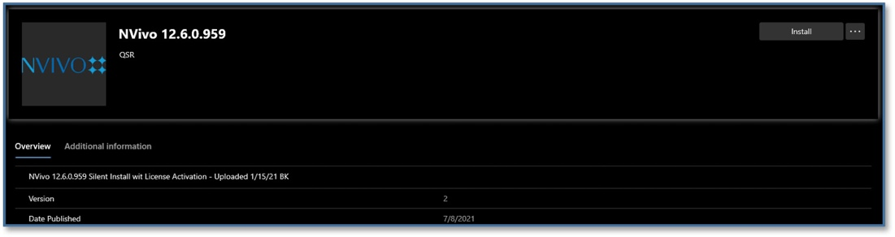
- You will see a message about your device syncing before downloading the installation files.
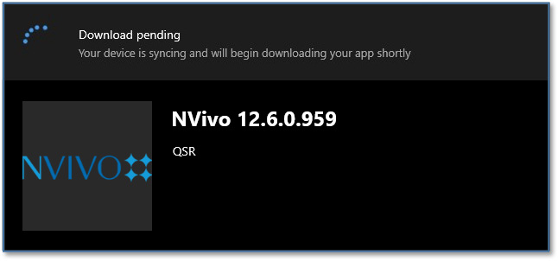
- Once syncing is complete, the download will begin.
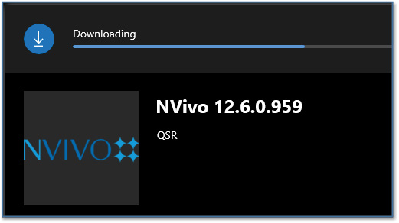
(You may also see a notification in your task bar about the download.)
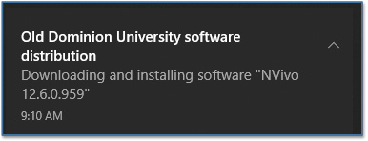
- Installation can take several minutes to an hour, depending on the software. You can close Company Portal and continue to work on your device. The install will continue in the background.
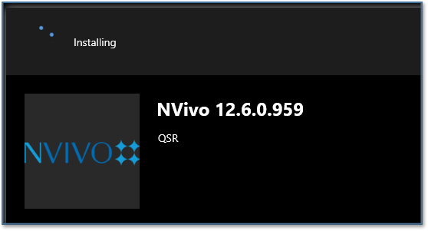
- When the installation is complete, you will see another notification in your task bar.
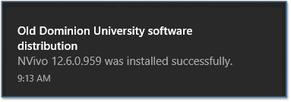
- Company Portal will also show that the software has been installed.
