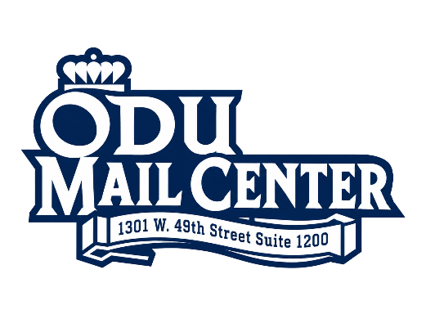
POSTAGE CHARGE
AUTHORIZATION FORM
NAME:
DEPARTMENT:
BUDGET CODE:
DATE:
PHONE:
EMAIL:

MAIL CLASS: | TOTAL PIECES:
☐ First Class Letters
☐ First Class Large Envelopes
☐ Post Cards* |  | *Post Card maximum dimensions are 6in x 4.25in
☐ Packages (Need USPS Tracking Label) |  | To request tracking labels call us at 3-3673 or email at mailcenter@odu.edu
SPECIAL SERVICES:
☐ Certified (Priority or First Class Only)
☐ Return Receipt (Priority or First Class Only) |  | Mail Clerk: Write down Return Receipt Tracking #
☐ Priority Mail (Need Tracking Label)
☐ Express Mail (Need EXPRESS Form)
☐ Media Mail (Need Tracking Label)
☐ Library Mail (Need Tracking Label)
☐ International Mail (Need Customs Form)
☐ APO/FPO (Need Customs Form)
FOR MAIL CENTER EMPLOYEE USE:
Mail Clerk Initials: | Total Postage Charged: $
Date Processed: | FCS Charge: $ | +
Total Pieces Processed: | Total Department Charged: $ | =
First Class Service Charges are applied to First Class Mail at .04¢ / piece.

