Biology – Monarch Walk
Construction scope and pedestrian access | Accessible text and map reference
This document provides text descriptions of the three original construction-scope maps. The maps are reproduced for visual reference. Specific route boundaries and entrances should be confirmed with the project team before this document is used as an official accessible pedestrian-routing notice.

How to read the maps
- Orange: pedestrian sidewalks.
- Pink: pedestrian signage.
- Blue: temporary lighting locations; existing permanent light poles also illuminate nearby paths.
- Green: construction fencing.
- Yellow: pedestrian paths.
- Red (Phase 2a only): student blockades or barriers intended to prevent shortcuts through grass and landscaped areas.

Phase 1
Scheduled work: October 2026 through May 2027

Text description of map
The map shows a construction zone with a surrounding pedestrian network. Several existing sidewalks are marked for widening to 8–9 feet. A current temporary sidewalk is labeled 8–9 feet wide. The diagram identifies pedestrian paths, signs, lighting locations and construction fencing.

Map reference
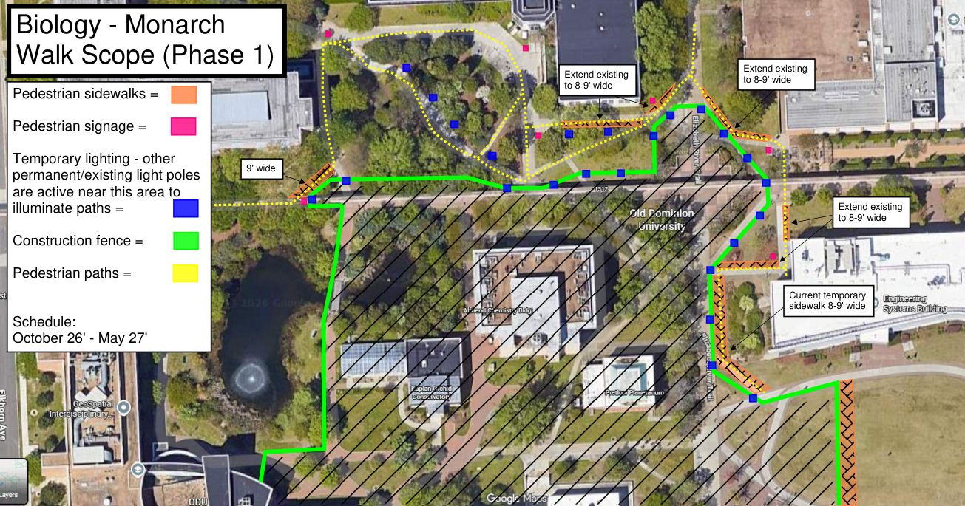
Map reproduced from the original project PDF. Refer to the text description and legend above; colored lines and symbols are not sufficient on their own to identify a safe accessible route.

Phase 2
Scheduled work: Intersection scope: May through July 2027

Text description of map
The second map shows the next stage of work around the intersection. Existing sidewalks are again marked for widening to 8–9 feet, and a current temporary sidewalk is labeled 8–9 feet wide. The diagram distinguishes pedestrian paths from construction fencing and identifies signage and lighting.

Map reference
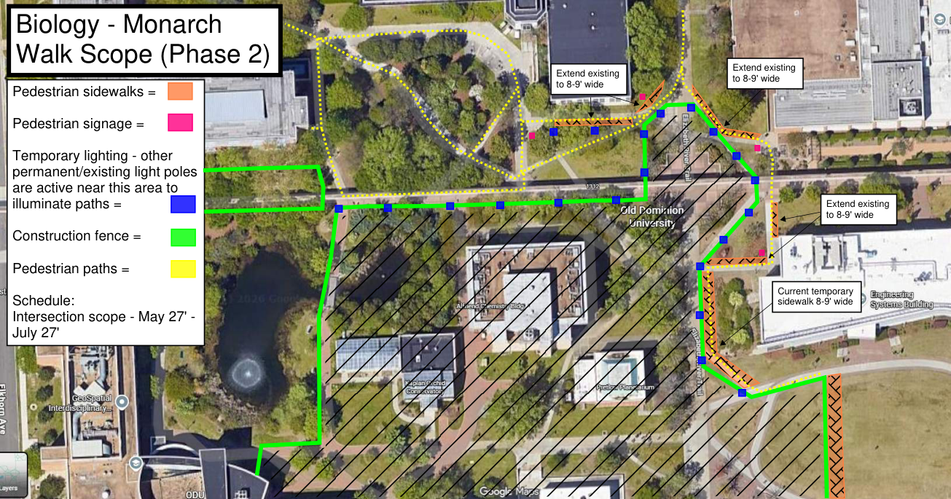
Map reproduced from the original project PDF. Refer to the text description and legend above; colored lines and symbols are not sufficient on their own to identify a safe accessible route.

Phase 2a
Scheduled work: Elkhorn Monarch Walk scope: May through fall 2027

Text description of map
The third map adds student blockades or barriers to discourage walking through grass and landscaped areas. The map states that OCNPS will be accessed from the side and rear during summer 2027. Sidewalk widening to 8–9 feet and the existing temporary sidewalk are also shown.

Map reference
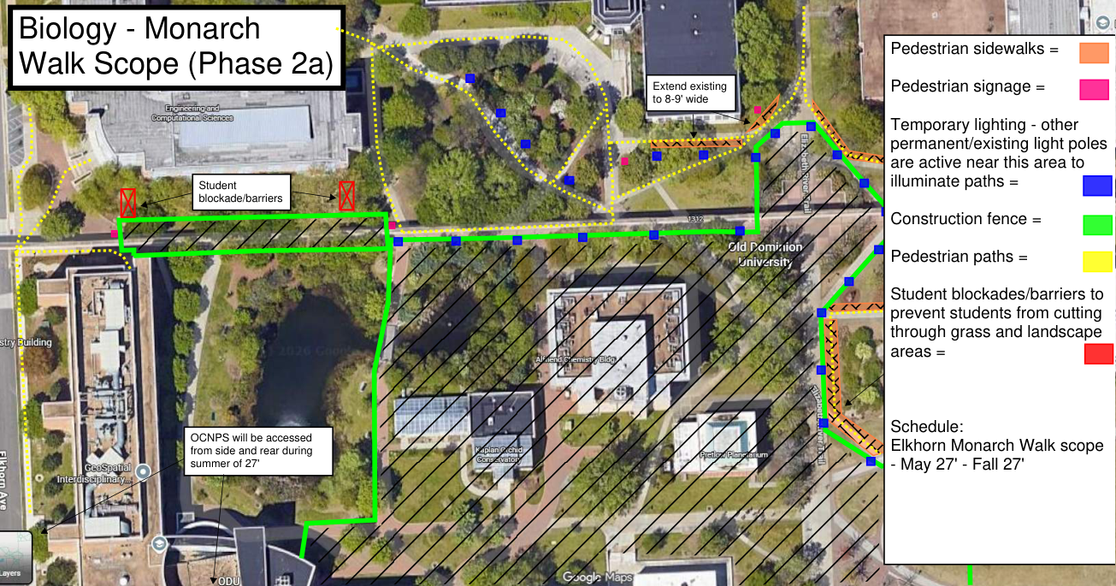
Map reproduced from the original project PDF. Refer to the text description and legend above; colored lines and symbols are not sufficient on their own to identify a safe accessible route.

