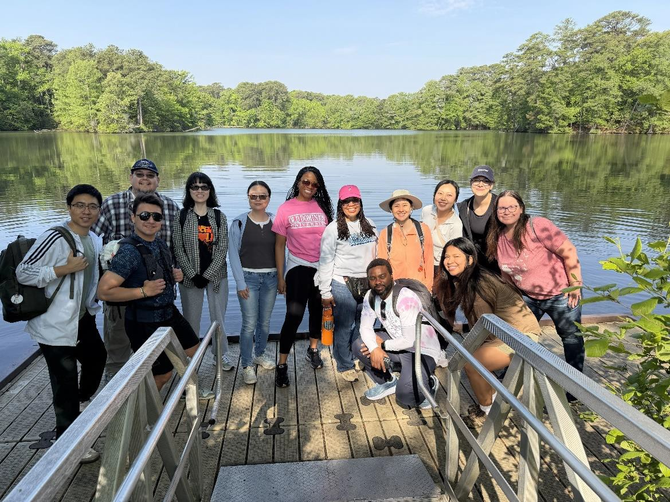

Office of Faculty Recruitment and Retention

IMPACT REPORT 2025 - 2026

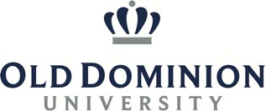


OUR TEAM 3

TABLE OF CONTENTS
SUPPORTING FACULTY 3
ABOUT US 4
OUR IMPACT 6
OUR EVENTS 8
FACULTY VOICES 15
OUR ACCOMPLISHMENTS 16
OUR PLANS FOR THE FUTURE 19
THANK YOU 20
CONTACT US 22

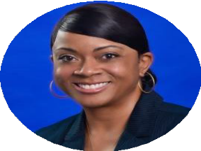
Dr. Shanda Jenkins

OUR TEAM
Director for Faculty Recruitment and Retention

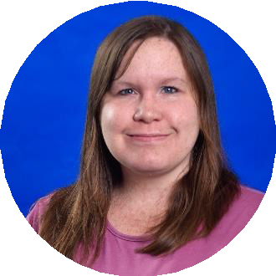
Allison Barber
Administrative Assistant

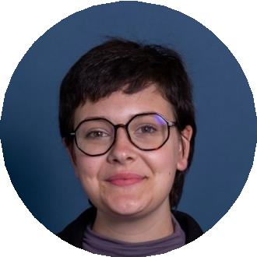
Sofia Calicchio
Graduate Assistant

SUPPORTING FACULTY

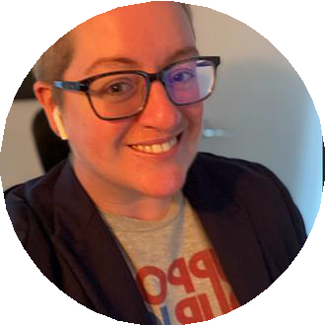
Alison Lietzenmayer
Master Lecturer, Department of Communication & Theatre Arts

ABOUT US

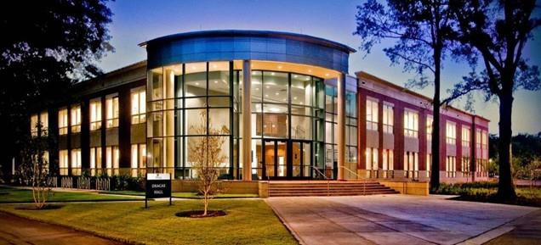
The Office of Faculty Recruitment and Retention has continued to build on its work over the past academic year by expanding efforts that support faculty recruitment, retention, and well-being. This year, particular emphasis has been placed on creating opportunities for connection, engagement, and community.
We are honored to join the new Center for Faculty Excellence (CFE) and contribute to the important work of holistically supporting our faculty. This moment represents an exciting step forward in how we cultivate faculty growth and development, not just in their professional roles, but as whole individuals. We are deeply committed to fostering an environment where faculty feel valued, supported, and empowered to thrive both personally and professionally, and we look forward to the meaningful impact we will create together.
This academic year has been like no other. We have faced tremendous tragedy together, and we are forever changed as an institution because of it. We have also witnessed the strength, compassion, and resilience of our Monarch community.
We are navigating significant changes across our institution and the broader landscape of higher education. We are evolving, and with that comes both challenges and opportunities. Through it all, we remain focused on promoting the well-being and success of our faculty.
The Office of Faculty Recruitment and Retention (OFRR) has offered a variety of initiatives, including workshops, virtual cafés, and expanded programming. We have worked to create meaningful opportunities for faculty to connect, learn, and engage beyond their everyday

responsibilities. Workshops addressed topics such as well-being, mental health, sleep, nutrition, and navigating challenging conversations. The virtual cafés created space for reflection, dialogue, and continued connection. Activities like Wednesday Walks, hikes, yoga sessions, and other physical experiences offered opportunities for faculty to step away from their desks, move, recharge, and build community.
The Faculty Talent Show created space to celebrate the creativity and talent of our faculty, while New Faculty Highlights introduced new faculty members to the Monarch community. Recruitment plan reviews, exit surveys, and exit interviews provided valuable insights to help strengthen hiring practices and better understand the faculty experience. Participation in conferences, collaboration with campus partners, and a growing presence across social platforms further enhanced our visibility and outreach efforts.
Together, these efforts reflect an ongoing commitment to strengthening faculty recruitment and well-being while fostering a campus environment where faculty feel connected, supported, and able to thrive.
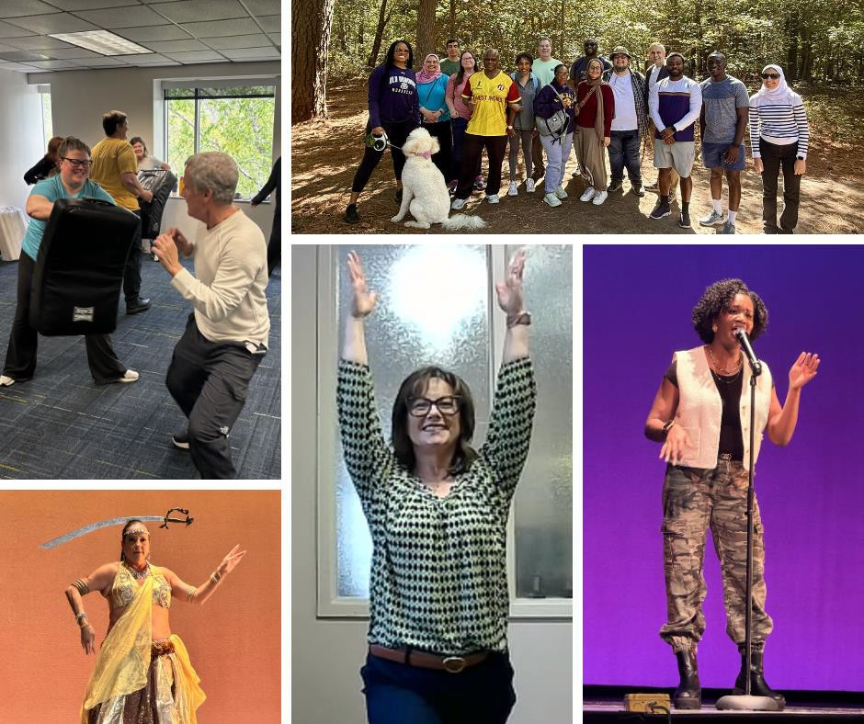

During the 2025–2026 academic year, the Office of Faculty Recruitment and Retention hosted 28 events with a total of 563 attendees. These activities reflected our continued commitment to supporting faculty through meaningful opportunities for connection, engagement, professional learning, and well-being.

OUR IMPACT
Programming this year expanded beyond traditional workshops and virtual cafés to include new initiatives featuring well-being focused and community centered experiences such as Wednesday Walks, hikes, yoga, cycling, and other opportunities for faculty to connect in new ways. The Faculty Talent Show also introduced creative and celebratory space to showcase talent and build community.
# of Attendees
350
300
250
200
150
100
50
0
Activities Workshops Virtual Cafés Faculty Talent Show
10, 35.71%
12, 42.86%
5, 17.86%
Number of Events
1, 3.57%

 | Workshops |  |  | Activities |  | Virtual Cafés |  | Faculty Talent Show
# of Attendees | 296 |  |  | 130 |  | 86 |  | 51

Post-event survey results reflect strong and consistent impact across all areas of programming. Compared to last academic year’s responses, increases in scores were seen in overall satisfaction, perceived value, and likelihood of future participation. Nearly all respondents said
they would recommend our events to others, indicating that attendees

Program Highlights
98% would Recommend Events to Others
4.74 out of 5 Satisfaction Rating
4.65 out of 5 Value Rating
4.68 out of 5 Likelihood of Future Participation
4.32 out of 5 Sense of Belong and Well-Being
found the events important and worthwhile. These results highlight the continued relevance of and quality of programming, as well as faculty interest in opportunities that support connection, engagement, and well-being.

Wellness Activities received the highest ratings for satisfaction, value, and recommendation. Workshops and Virtual Cafés also maintained high ratings, reinforcing the importance of offering a range of opportunities that support both professional learning and faculty well-being.
What Participants Gained from Events
80.00%
60.00%
40.00%
20.00%
0.00%
Post-Event Survey Results by Program Type 2025-2026

 | Wellness Activities | Workshops | Virtual Cafés | Overall
Satisfaction | 4.79 | 4.71 | 4.69 | 4.74
Value | 4.74 | 4.61 | 4.62 | 4.65
Belonging/Well-being | 4.65 | 4.28 | 3.85 | 4.32
Future Participation | 4.71 | 4.65 | 4.77 | 4.68
Recommend to Others | 100.00% | 98.04% | 92.31% | 97.96%
# of Responses | 34 | 51 | 13 | 98

 | Support for their Well-being | New Information/ Knowledge | A sense of community and belonging | New Connections with Colleagues | Inspiration or new ideas
% Gained | 71.13% | 70.10% | 48.45% | 35.05% | 34.02%

OUR EVENTS

Workshops
Our themed workshops and presentations covered a variety of topics that impact faculty in order to build awareness, share knowledge, and promote faculty well-being. Ten events happened over the 2025-2026 academic year with a total of 296 faculty participants.
 Thriving in Academic: Strengthening Faculty Well-Being – September 2025
Dr. Shanda Jenkins examined current research and shared evidence-based strategies to enhance well-being. The session underscored the vital connection between faculty's well-being and success throughout the academic year. Participants reflected on their own experiences, identified challenges, and discussed practical ways to strengthen personal and collective well-being. Faculty left with greater awareness and clear, actionable steps to support themselves and their colleagues.
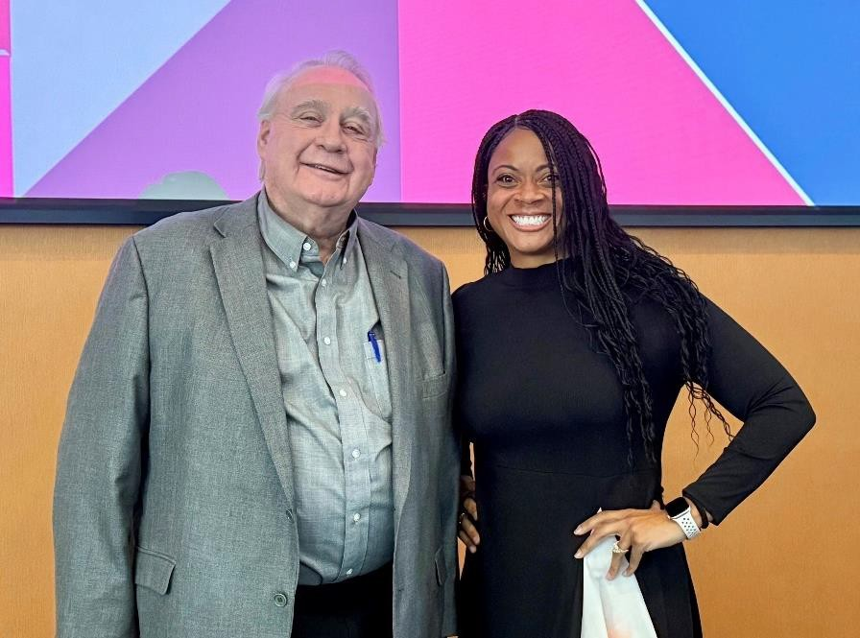
Shifting Ground: Navigating Policy Changes in Higher Education – October 2025
Dr. Dennis Gregory offered insight into how current and emerging policies are shaping higher education at the national, state, and university levels. Through his presentation and discussion, participants gained a deeper understanding of the ripple effects of policy changes and considered practical ways to prepare, adapt, and thrive in an evolving academic landscape.
Everyday Mental Health: A Rhythm of Refresh, Revive, and Renewal for Faculty –
November 2025
Facilitated by Dr. Brittany G. Suggs, a licensed professional counselor, clinical supervisor, and faculty member in the Department of Counseling and Human Services. Participants engaged in evidence-based activities, created personalized wellness plans, and explored

ways to foster balance, community, and renewal. Faculty left feeling refreshed and equipped with practical strategies to support their well-being throughout the year.
Rest to Rise: Understanding and Improving Your Sleep – December 2025
Dr. Shanda Jenkins, a licensed and registered Polysomnographic Technologist, shared key insights on the fundamentals of healthy sleep, common sleep disorders, and current approaches to diagnosis and treatment. Faculty left with a clearer understanding of their sleep needs and practical tools to enhance rest, boost energy, and support overall well-being.
Navigating Challenging Conversations, Dealing with Conflict, and/or Communication Across Differences – January 2026
Kristin A. Gansle (Faculty Ombuds) offered faculty an opportunity to reflect on how they approach difficult conversations. The session explored common sources of conflict and introduced practical strategies for difficult conversations, managing emotions, and communicating more effectively. Faculty left with a clearer understanding of how to approach these moments with intention and care.
Employee Resource Group Panel on Building Faculty Community – February 2026 A panel of Employee Resource Group leaders shared how their groups foster connection, support professional growth, and contribute to a strong sense of
community across campus. Panelists provided overviews of their missions, goals, and activities, while faculty in attendance engaged with thoughtful questions and discussion. The conversation also created space for ERG leaders to connect with one another, sparking ideas for future partnerships and shared initiatives.
A Century of Black History Month: What We’ve Done, What We Need to Do – February 2026
A Century of Black History Month: What We’ve Done, What We Need to Do, co-hosted with the Coalition of Black Faculty and Administrators, offered a meaningful opportunity to reflect during Black History Month. Dr. Marvin T. Chiles, Associate Professor of African American History, guided a conversation on the legacy and impact of Black History Month over the past century. The event created space for faculty to reflect on this milestone and consider its significance going forward.
Nutrition Made Doable: Practical Strategies for Busy Professionals – March 2026 Guest speaker Abby Lemmon (Certified Functional Nutrition-Informed Professional) encouraged faculty to rethink how nutrition fits into their daily routines. The session focused on simplifying nutrition by returning to foundational concepts and translating them into realistic, everyday actions. Faculty were invited to reflect on their current

habits, explore ways to build sustainable routines, and consider small, manageable changes, with a helpful reminder to slow down and be more intentional with everyday food choices.
Nutrition Considerations for a Physically Active Lifestyle – March 2026
Patrick B. Wilson (Registered Dietitian) provided faculty with a deeper understanding of how nutrition and physical activity work together. The session highlighted key areas such as energy balance, protein needs, and hydration, while emphasizing that responses can vary widely from person to person. Faculty also explored common misconceptions, including the role of sports drinks and electrolyte supplements, and were encouraged to prioritize whole foods and balanced, practical approaches to supporting long-term health and activity.
Grace in the Gaps: Healing While Holding Space for Our Students – April 2026
Dr. Brittany G. Suggs offered faculty a space to reflect on supporting students while also navigating their own experiences of tragedy. The session included grounding exercises and introduced the concepts of embrace, shelf, and release as ways to process what we are carrying. Faculty were reminded that experiences of stress and grief are deeply personal and should be approached without judgment. Faculty also shared their own experiences, creating a meaningful space for connection and support.
Virtual Cafés
In the 2025-2026 academic year, we hosted five Virtual Cafés. These events covered selected topics while remaining an informal space for faculty to connect and speak freely. In total, 86 faculty members attended Virtual Cafés.
Virtual Café: Welcoming Back Faculty – August 2025
Shanda Jenkins and Alison Lietzenmayer kicked off the semester focused on faculty well-being and connection. The session offered space for faculty to reconnect with colleagues, welcome new members of the community, and learn about upcoming opportunities and events throughout the semester.
Virtual Café: Shifting Ground – October 2025
Built on the discussion from Dr. Dennis Gregory’s earlier workshop on navigating policy changes in higher education. Dr. Gregory began with a brief overview of key points, then opened the floor for faculty to share questions, reflections, and ideas for moving

forward in a changing higher education landscape. The conversation fostered thoughtful dialogue and connection among faculty.
Virtual Café: Rest to Rise – December 2025
At this event, Dr. Shanda Jenkins (Registered Polysomnographic Technologist and Registered Sleep Technician) continued the conversation on healthy sleep and overall well-being. Building on themes from the Rest to Rise workshop, the session offered space to share insights, reflect on the semester’s highlights, and celebrate the connections formed through this semester’s focus on faculty well-being. The conversation closed the semester on a thoughtful and restorative note, encouraging faculty to carry forward the practices that support balance and renewal.
Virtual Café: Navigating Challenging Conversations – January 2026
This event welcomed faculty back for the semester while continuing the conversation from the workshop with Dr. Gansle. Participants revisited key ideas, learned more about the Ombuds and mediation process, and explored real-life scenarios related to conflict in academic settings. The session also created space for faculty to connect, share experiences, and reflect on how to apply these strategies in their own work.
Virtual Café: End of Year Wrap Up – May 2026
Led by Shanda Jenkins and Alison Lietzenmayer, this end-of-year gathering offered faculty an opportunity to reflect on the academic year and celebrate the many accomplishments of their colleagues. The session revisited memorable activities and milestones from the year, highlighted faculty success stories, and created space to appreciate all that had been achieved throughout the semester. Faculty also looked ahead to the summer months, discussing upcoming plans for the Fall Semester.
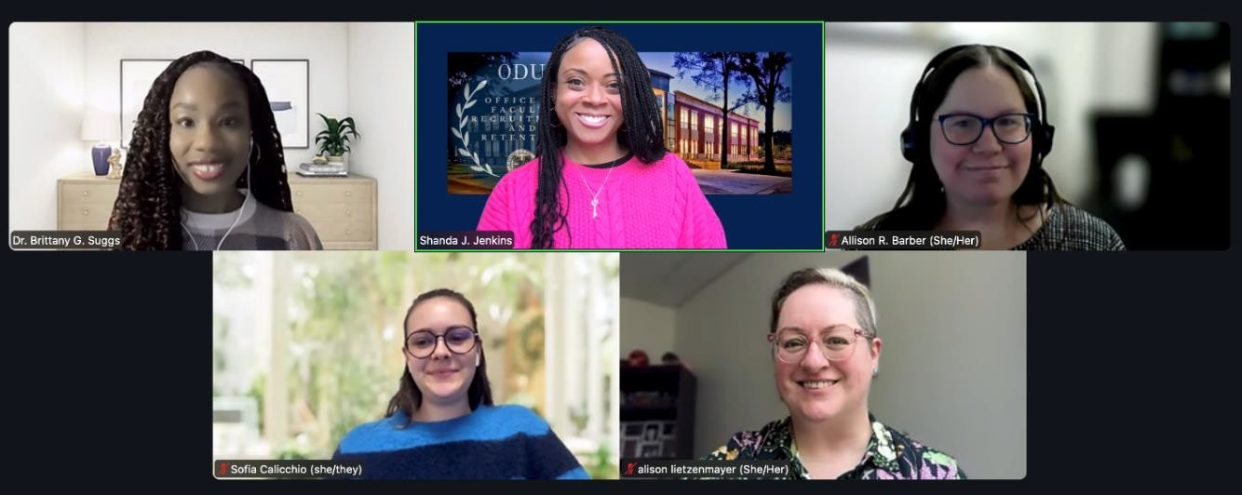

Stretch & Connect – September 2025

Wellness Activities
In the 2025–2026 academic year, Wellness Activities were introduced as a new area of programming. These events were designed to create space for faculty to take a break their desks, move, connect with colleagues, and engage in shared experiences across campus. Activities highlight a new approach to fostering connection and community. A total of 12 activities were hosted with 130 faculty participants.
The first wellness activity was led by Dr. Chrissy Blanchard-Alworth, a licensed yoga instructor and lecturer in Human Movement Sciences and Special Education. The session focused on gentle stretching, releasing tension, and fostering connection in a supportive and welcoming space. Faculty left feeling relaxed, refreshed, and renewed.
Fall Hike at First Landing State Park – October 2025
Led by a guide from the Outdoor Adventure Program at the Student Recreation and Well-Being Center, faculty enjoyed a refreshing morning hike along the three-mile trail at First Landing State Park. The experience was filled with laughter, conversation, and connection as participants took in the natural beauty of the park and strengthened their sense of community.
Restore & Recharge: Faculty Yoga – November 2025
Guided by a certified yoga instructor from the Student Recreation and Well-Being Center, this event offered faculty an opportunity to unwind with colleagues while focusing on balance, stress relief, and overall well-being. The session provided a calming space to relax, reconnect, and restore energy at the end of a busy day.
Mindful Momentum: Stretch & Connect for Faculty – February 2026
Chrissy Blanchard-Alworth offered faculty a chance to pause and recharge through guided deep breathing, gentle stretching, and accessible strengthening exercises designed to support posture and overall well-being. The virtual format allowed participants to join from their own spaces, creating an opportunity to practice movement and relaxation right at their desks.
Faculty Cycling Class – March 2026
Held in collaboration with the Student Recreation and Wellness Center, brought faculty together for an engaging and energizing workout led by a student instructor. Whether it was their first time on a bike or they were experienced riders, participants challenged

themselves through a dynamic session that simulated hills, intervals, and recovery. Along the way, faculty worked up a sweat, connected with colleagues, and had the opportunity to experience the Student Recreation and Well-Being Center in a new way.
Faculty Self-Defense Class – April 2026
Kru Bruce offered faculty a hands-on opportunity to learn practical techniques for personal safety. The session covered foundational skills, including maintaining a balanced stance, palm and elbow strikes, and basic kicks, before moving into strategies for breaking free from common holds. Faculty worked in small groups, building confidence through hands-on practice, with helpful reminders like pulling toward the thumb when escaping a grab and keeping hands open during elbow strikes. The room was active and engaged throughout, with great questions and a clear sense of excitement as participants leaned into the experience.
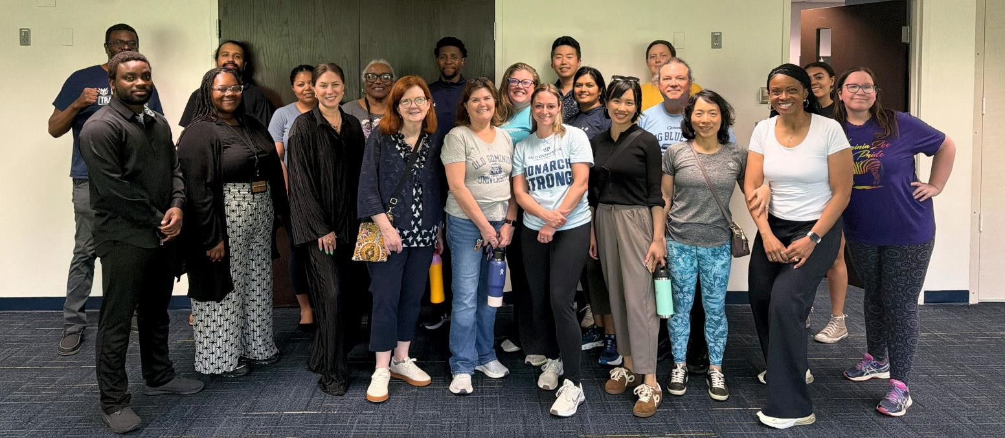

Spring Hike to Lake Lawson/Lake Smith – April 2026
The Spring Hike at Lake Lawson/Lake Smith Natural Area, held in collaboration with the Outdoor Adventure Program, brought faculty together for a beautiful morning of movement, conversation, and connection. Guided by Chris Lawson from the Outdoor Adventure Program, the group began with a lively name game using oinking toy pigs that quickly filled the morning with laughter and helped everyone get to know one another. Faculty then enjoyed a scenic walk through the natural area, stopping for photos between the lakes, admiring blooming flowers, and spotting wildlife along the trail. With great conversation throughout, the group chose to walk the trail twice, making the most of a memorable day together.

Wednesday Walks – April – May 2026
Wednesday Walks gave faculty a refreshing break in the middle of the day, bringing people together for time outdoors and easy conversation. Each week, we met in front of Dragas Hall at noon to set out on a walk around campus and the surrounding neighborhood. Walks offered opportunities for new connections with colleagues across ODU. Every Wednesday, we showed up for each other, creating a new routine of movement, conversation, and community building.

Faculty Talent Show
The Faculty Talent Show brought faculty and staff together for an evening of creativity, talent, connection, and celebration. Featuring performances in music, spoken word, and dance, the event provided colleagues with an opportunity to share talents and personal interests beyond their day-to-day roles. The program fostered a warm and engaging atmosphere that encouraged conversation, appreciation, and connection.
More than an evening of entertainment, the Faculty Talent Show strengthened community and generated strong enthusiasm for its continuation as an annual tradition. There were 51 attendees.

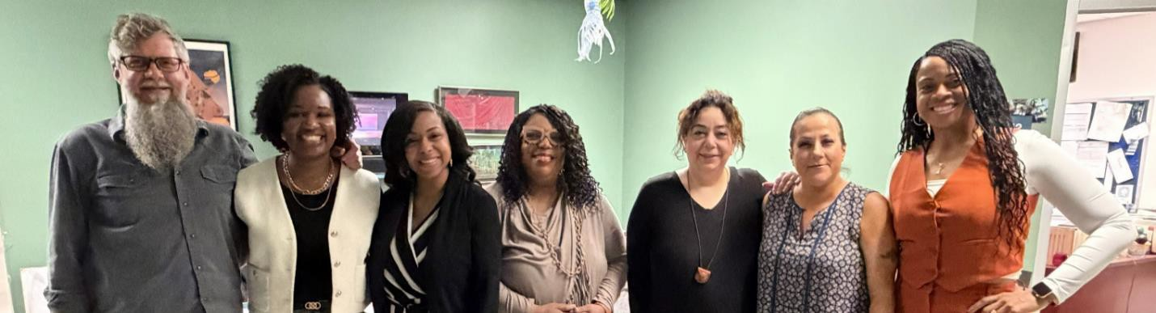
New Faculty Orientation and New Adjunct Faculty Orientation
At the start of the Fall and Spring semesters, we welcomed new faculty to ODU at the New Faculty Orientation which included our New Adjunct Faculty. At these events, new faculty were given several resources to help them succeed. In addition, they heard from key personnel on campus and learned information about a variety of useful topics and resources as they started their ODU journey.

Throughout the 2025–2026 academic year, faculty shared thoughtful and encouraging feedback

FACULTY VOICES
that reflected the meaningful impact of the office’s programming and support efforts. Responses frequently highlighted appreciation for opportunities that foster connection, promote well-being, and create welcoming spaces where colleagues could engage with one another in authentic and supportive ways. Faculty also valued programs that offer practical tools, timely information, and opportunities to build relationships across departments and disciplines.

“Thank you for making these sessions available. They are essential.”

Feedback from the inaugural Faculty Talent Show further reflected the value of creating spaces for celebration and community. Participants shared appreciation for the opportunity to discover the talents of colleagues, experience joy together, and connect with faculty and staff in new ways.

“I enjoyed the camaraderie of the audience supporting our fellow coworkers in their talent.”

Many comments spoke to the importance of feeling recognized, supported, and connected within the university community.

“Thank you. Truly. It meant so much to be seen.”

This feedback reflects the continued importance of creating spaces where faculty feel valued, encouraged, and connected to the broader Monarch community.
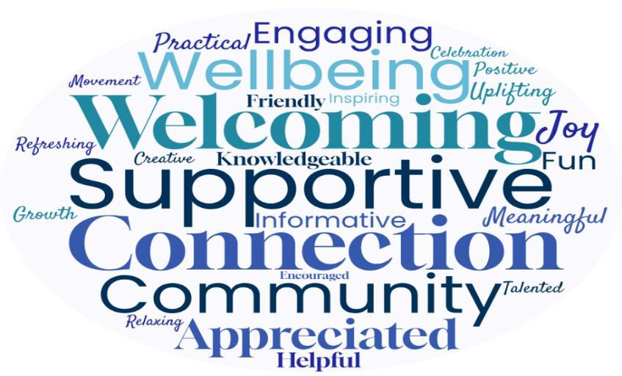

In 2025–2026, the Office of Faculty Recruitment and Retention continued to evolve in ways that reflect the changing needs of faculty and our university community. While recruitment, retention, and well-being remain central to the office’s mission, increased emphasis was placed on fostering connection, supporting faculty wellness, strengthening community, and creating meaningful opportunities for engagement across campus. Through strategic partnerships, responsive programming, and continued support efforts, the office expanded its impact throughout the academic year.

OUR ACCOMPLISHMENTS
Faculty Recruitment and Retention

Recruitment plans for faculty positions were reviewed, and the office collaborated with search committees to support effective hiring processes, broad candidate pools, and alignment with university goals.
Updated lists of institutions offering terminal degree and master’s degree programs to
support faculty recruitment outreach efforts.
Dr. Shanda Jenkins attended the Southern Regional Education Board’s Institute on Teaching and Mentoring, the nation’s largest gathering of underrepresented Ph.D. scholars.
New Faculty Orientations were facilitated to build early connections, provide valuable resources, and strengthen faculty networks across the university.
A new Faculty Exit Survey was developed to gather feedback and insight from faculty departing from the university.
Faculty Exit Interviews were conducted with faculty members who expressed interest in sharing their experiences.
Mentoring connections were also made across the institution.
Faculty Engagement and Community Building
Programming was expanded beyond traditional workshops to include 28 events consisting of virtual cafés, wellness initiatives, and community-centered experiences that supported faculty connection and well-being.

Wellness activities were introduced as a new programming area designed to create informal opportunities for faculty connection, engagement, and community-building.
Opportunities for movement, wellness, and collegial interaction were increased through recurring walks, hikes, and other initiatives.
New Faculty Highlights continued as a new initiative designed to welcome and introduce new faculty members to the Monarch community. Through interviews and feature stories shared through emails, social media, newsletters, and the office website, 27 new faculty members were highlighted during the Fall and Spring semesters.
The inaugural Faculty Talent Show was hosted to recognize faculty creativity and strengthen community through shared experiences.
New partnerships were established with the Outdoor Adventure Center and Student Recreation & Well-Being Center to expand faculty engagement opportunities.
Increased outreach and presence through Facebook (51 new, 233 total followers), Instagram (39 new, 178 total followers), and LinkedIn (43 new, 143 total followers) helped keep faculty and prospective hires informed and engaged.
Leadership and Professional Development

Dr. Shanda Jenkins attended and presented at the 2026 Annual Conference of the National Association of Diversity Officers in Higher Education (NADOHE).
Through the Virginia Division of NADOHE, monthly meetings with peers across the state were held to exchange ideas, build relationships, and strengthen a shared mission.
Dr. Shanda Jenkins joined and became involved with the American College Health Association (ACHA).
The Mid-Atlantic College Health Association (MACHA) 2026 Virtual Program was attended.
Dr. Shanda Jenkins participated in the Provost’s Leadership Academy.

Monthly meetings with the Joint Efforts for Dialogue and Innovation (JEDI) Council supported communication, shared best practices, and collaborative strategies to foster a welcoming and supportive environment.

Institutional Collaboration and Campus Impact
Institutional safety and awareness were supported through participation in the Sexual Assault Resource Team Committee (S.A.R.T.) and service as Title IX Deputy for Academic Affairs.
Supported the continued development of the Center for Faculty Excellence through collaborative discussions focused on shaping the center’s goals, priorities, and the future direction for faculty support and engagement across the university.
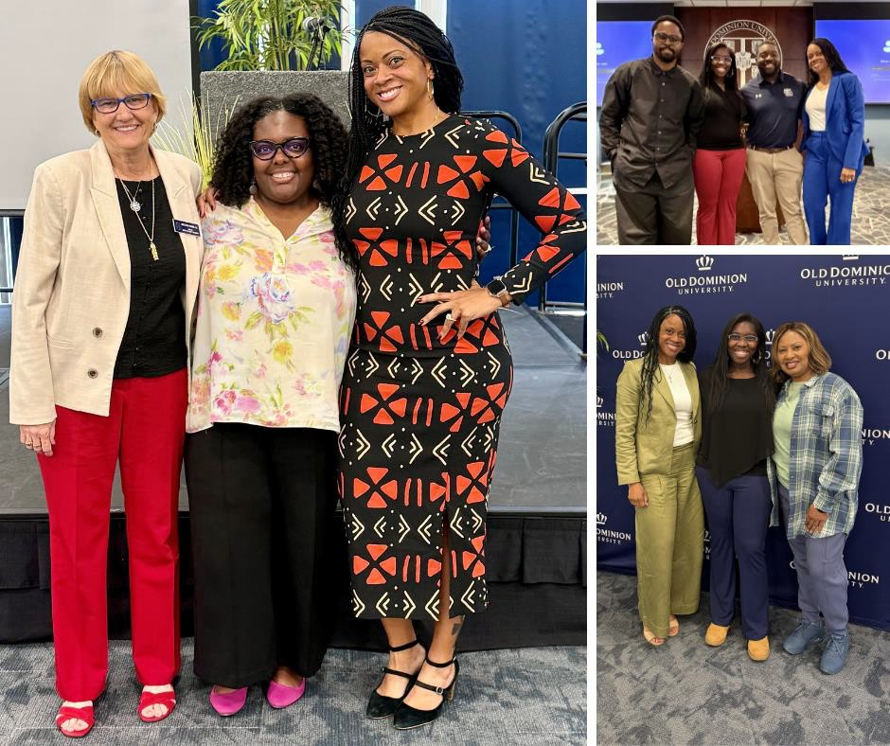

OUR PLANS FOR THE FUTURE
As we look ahead to 2026–2027, the work of the Office of Faculty Recruitment and Retention remains vital to the continued strength and success of Old Dominion University. Recruitment remains an essential priority, while increasing attention is being placed on faculty well-being, connection, and the overall faculty experience. Future efforts will build upon this year’s momentum through responsive programming, strategic partnerships, data-informed planning, and continued support for faculty at every stage of their careers.

Continue expanding innovative programming that supports faculty well-being, connection, and community through workshops, Virtual Cafés, activities, and shared experiences.
Build upon the success of Wellness Activities by expanding wellness-focused, restorative, and engagement opportunities that encourage movement and collegial interaction.
Continue to support and promote mentoring opportunities that encourage connection and professional growth across colleges and disciplines.
Expand initiatives that recognize faculty accomplishments, celebrate contributions, and highlight the impact faculty make across the university community.
Continue to support the planning and development of the Center for Faculty Excellence through efforts that strengthen faculty support, engagement, and success.
Maintain collaboration with departments and search committees to support effective hiring processes and strong candidate pools.
Expand partnerships with campus offices and community organizations to broaden faculty support efforts and shared initiatives.
Use survey feedback, participation trends, exit interviews, and faculty conversations to guide future programming and identify opportunities for improvement.
Maintain faculty data analysis with an emphasis on strengthening departmental and college climates that support faculty success and retention.
Continue providing meaningful support for faculty at every career stage through resources, guidance, and initiatives that promote success and well-being.
Expand collaboration with Macon & Joan Brock Virginia Health Sciences to enhance recruitment and retention efforts.

We would like to express our sincere gratitude to all those who supported us in achieving our goals and mission this year.

THANK YOU

- College of Arts and Letters
- Strome College of Business
- Darden College of Education and Professional Studies
- Batten College of Engineering and Technology
- Ellmer College of Health Sciences
- College of Sciences
- Ellmer School of Nursing
- Eastern Virginia Medical School
- EVMS School of Health Professions
- Joint School of Public Health
- Perry Honors College
- School of Cybersecurity
- School of Supply Chain, Logistics, & Maritime Operations
- School of Data Science
- The Graduate School
- University Libraries
- Office of the President
- Office of the Provost
- Division of Academic Affairs
- Center for Faculty Excellence
- Office of Talent Management and Culture
- Division of Student & Campus Life
- Outdoor Adventure Program
- Student Recreation & Well-Being Center

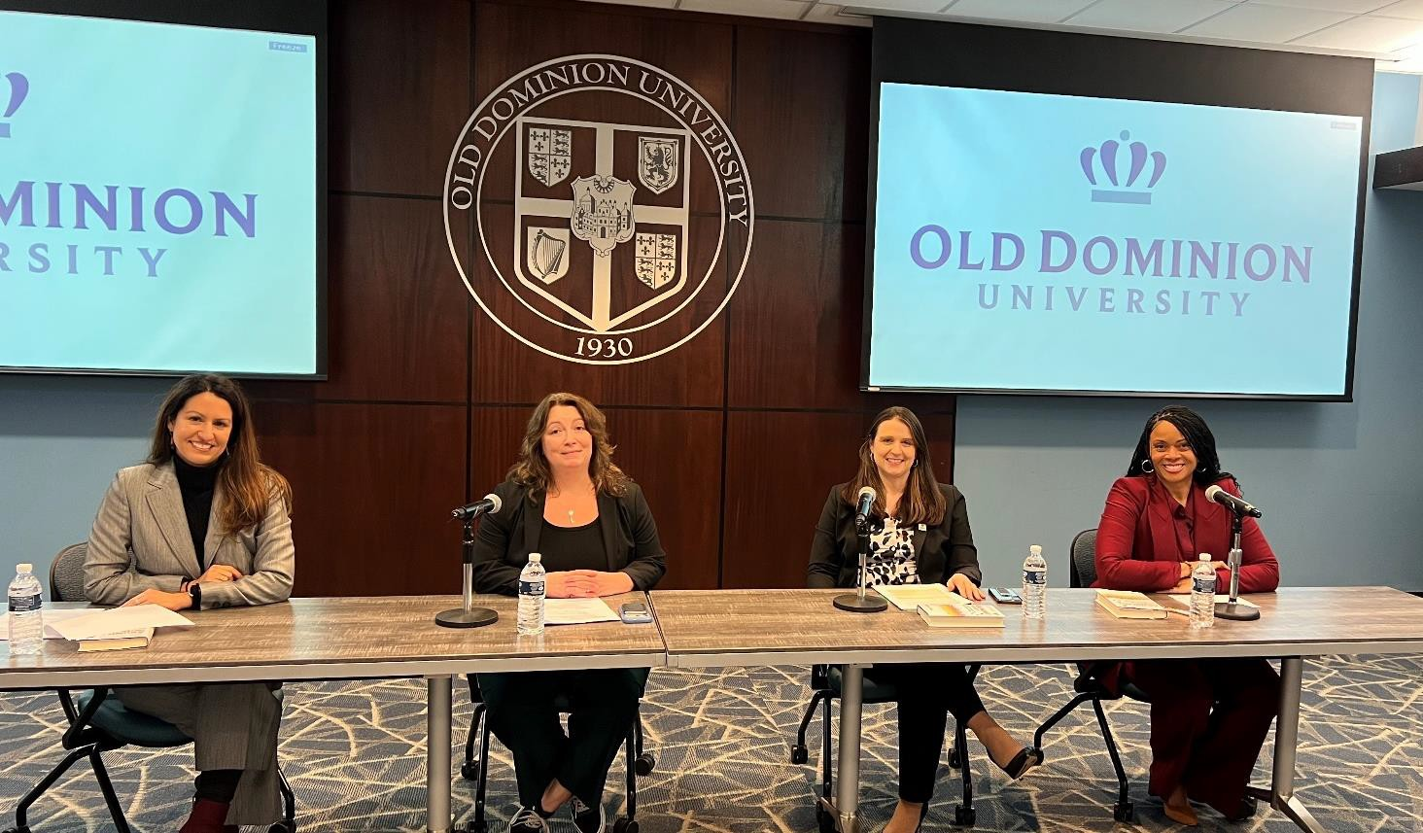

A special thank you to those who shared their knowledge with the ODU community through presentations, conversations, and panel discussions.

- Chrissy Blanchard-Alworth, Department of Human Movement Studies & Special Education
- Adrienne Brown, Student Health Services
- Kru Bruce, KBMT Training Center
- Rachel Childs, School of Medical Diagnostic & Translational Sciences
- Marvin Chiles, Department of History
- Madeline Dietrich, University Libraries
- Tracy Hongyun Fu, Pediatrics: Community Health Research
- Holly Gaff, Department of Biological Sciences
- Kristin Gansle, Department of STEM Education & Professional Studies
- Dennis Gregory, Department of Educational Leadership & Workforce Development
- Marissa Jimenez, Division of Academic Affairs
- Carla Knox, Department of Human Movement Studies & Special Education
- Chris Lawson, Recreation & Wellness

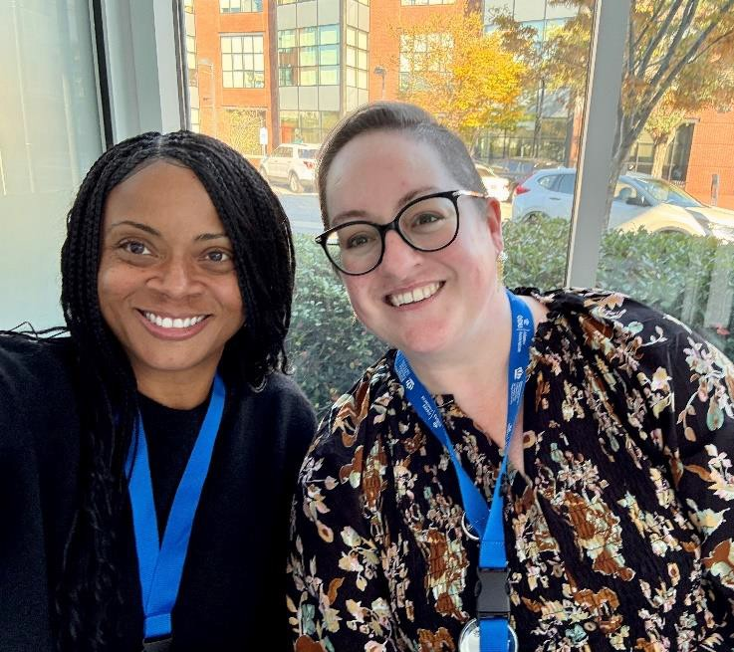
We would like to express our sincere gratitude to all the individuals who supported us this year.
We want to give a special thank you to Ms. Alison Lietzenmayer, for volunteering your time to help organize and facilitate this academic year’s events.
- Abby Lemmon, School of Rehabilitation Sciences
- Alison Lietzenmayer, Department of Communication & Theatre Arts
- Ruth Osorio, Department of English and Department of Women’s and Gender Studies
- Agatha Parks-Savage, Graduate Medical Education
- Tonya M. Shell, Department of Sociology & Criminal Justice and
Department of Women’s and Gender
Studies
- Cullen Strawn, College of Arts & Letters
- Brittany Suggs, Department of Counseling & Human Services
- Kendall Tate, Intercultural Relations
- Denisse Thillet-Tirado, Dean of Students Office
- Patrick Wilson, School of Exercise Science
- Shideh Yavary Mehr, School of Cybersecurity

Office of Faculty Recruitment and Retention 2102 Dragas Hall, Norfolk, VA 23529

CONTACT US

+1-757-683-5893


facultyforward@odu.edu



https://www.odu.edu/acadaffairs/faculty-recruitment https://www.facebook.com/ODUFacultyRecruitmentRetention/

https://www.instagram.com/odufacultyrecruitmentretention/


https://www.linkedin.com/company/odu-office-of-faculty-recruitment-and-retention/

