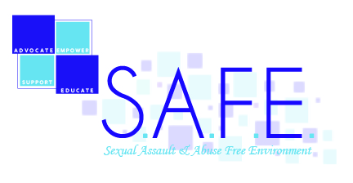
Support Services & Reporting Options
As an ODU student, you have many resources available to you.
Please identify which services would you like to receive right now:
Crisis and Support Service Options:
- YWCA Crisis Advocate (confidential service)
- Emergency room services (off campus)
- Physical Evidence Recovery Kit (Sexual Violence/Assault only – within 95 hours of the incident) Health Services (on campus) – for follow-up services
- ODU Counseling Services (confidential service)
- ODU SEES On Call /Women’s Center (For securing immediate accommodations)
- Other: __________________________________________________________

Reporting Options:
- Partial report to ODU Police Department (report incident without pressing charges)
- Full report ODU Police Department (which includes pressing charges)
- Full report to law enforcement Norfolk City Police Department
- Title IX complaint (on campus) with Office of Equity & Diversity
- Emergency or Preliminary Protective Order

Follow-Up Support Service Options:
- Women’s Center (confidential advocacy, support, assistance with class matters and housing accommodations)
- Student Outreach & Support (assistance regarding class matters, administrative and academic matters or personal road blocks)
- ODU Counseling Services (confidential counseling including assessment and referral)
- YWCA Counseling (confidential counseling)
- YWCA Legal Advocates
- Other: __________________________________________________________

YWCA is a confidential service provider. The YWCA advocate will only report to the college on what reporting options you have chosen to pursue. This document serves as a release of information. You have chosen the above options.

________________________________________ ______________________ Name Date

