Enterprise Risk Management (ERM)
Guide to Risk & Opportunity Assessment & Response

February 2017 (Revised 09/25/2017)

Adapted from The University of Vermont and The Citadel, Enterprise Risk Management Guide to Risk Assessment & Response.

Contents
Overview 1
Tools and Resources 3
Step 1- Establish the Context 4
Step 1 - Steps to Follow 4
Step 2- Risk & Opportunity Identification 5
Step 2 - Things to Keep in Mind 5
Step 2 - Questions to Spur Thinking & Discussion 5
Step 2 - Steps to Follow 5
Step 2 - Other Tools and Techniques 6
Step 2 - Key Terms 6
Step 3 - Risk & Opportunity Analysis 8
Step 3 - Things to Keep in Mind 8
Step 3 - Steps to Follow 8
Step 3 - Other Tools and Techniques 9
Step 3 - Key Terms 9
Step 3 – Table 1: Risk and Opportunity Classification 10
Step 3 – Figure 5: Risk Analysis Example 11
Step 3 – Figure 6: Opportunity Analysis Example 12
Step 3 – Table 2: Risk Impact Scale 13
Step 3 – Table 3: Opportunity Impact Scale 14
Steps 4 and 5 - Risk and Opportunity Evaluation & Response 15
Steps 4 and 5 - Things to Keep in Mind 15
Steps 4 and 5 - Steps to Follow 15
Steps 4 and 5 - Key Terms 15
Steps 4 and 5 – Risk and Opportunity Heat Map 17
References 18
Appendix A - Key ERM Terms and Definitions 19
General ERM Terms 19
Terms Related to ERM Program & Context 19
Terms Related to the Risk and Opportunity Assessment Process 20
Terms Related to ERM-Enabling Activities 22
Appendix B - Potential Risk Areas for Higher Education 23
Appendix C - ERM Steering Committee Charter, ERM Principles, & Institutional Risk Philosophy 26
ERM Steering Committee Charter 26
ERM Guiding Principles 29
Institutional Risk Philosophy 29

List of Figures & Tables

Figure 1: The Risk Assessment Process 1
Figure 2: The Opportunity Assessment Process 2
Figure 3: Step 1- Establish the Context Example 4
Figure 4: Step 2- Risk & Opportunity Identification Example 7
Table 1: Risk and Opportunity Categories 9
Figure 5: Step 3 - Risk & Opportunity Analysis Example 10
Table 2: Risk Impact Scale 11
Table 3: Opportunity Impact Scale 12
Figure 6: Risk & Opportunity Heat Map 15

“Enterprise risk management a strategic business decision that supports the achievement of an organization’s objectives by addressing the full spectrum of its risks and managing the combined impact of those risks as an interrelated risk portfolio” (Risk and Insurance Management Society (RIMS).

Overview
The risk management process—of identifying, analyzing, evaluating, and ultimately responding to and monitoring risk—is at the heart of enterprise risk management (ERM). Extending this process across an entire organization, looking at both “upside” opportunities and “downside” risks, and considering risks and opportunities in the context of strategy is what differentiates “ERM” from ‘traditional’ risk management.

This ERM Guide to Risk & Opportunity Assessment & Response deals with the steps 1 through 5 of the risk management process shown in Figures 1 and 2 establishing the context, and identifying, analyzing, evaluating, and responding to risks and opportunities that could affect the institution or a department’s ability to achieve its strategic goals and objectives. The context and assessment steps form the basis for decision-making about which risks or opportunities are priorities, what the appropriate response should be, and how resources should be allocated to manage the risk or opportunity in a way that best supports the organization’s strategy. The response step involves deciding on and planning for the best way to “treat” or modify the risk (mitigate) or opportunity (enhance), and implementing that plan.
Figure 1: The Risk Assessment Process
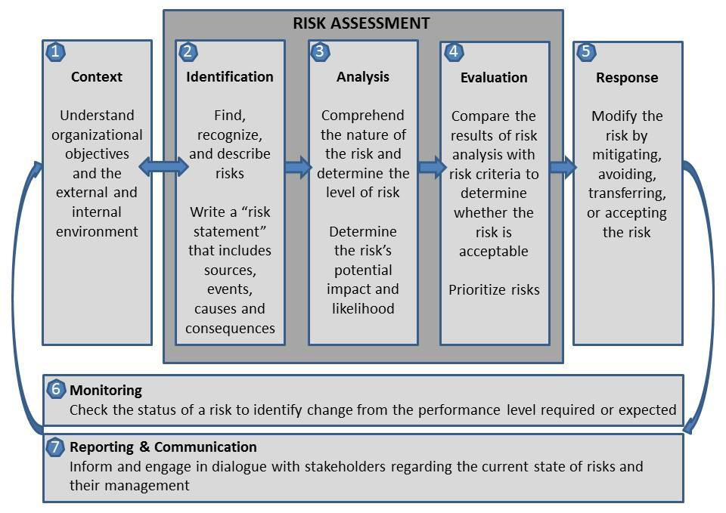

Figure 2: The Opportunity Assessment Process
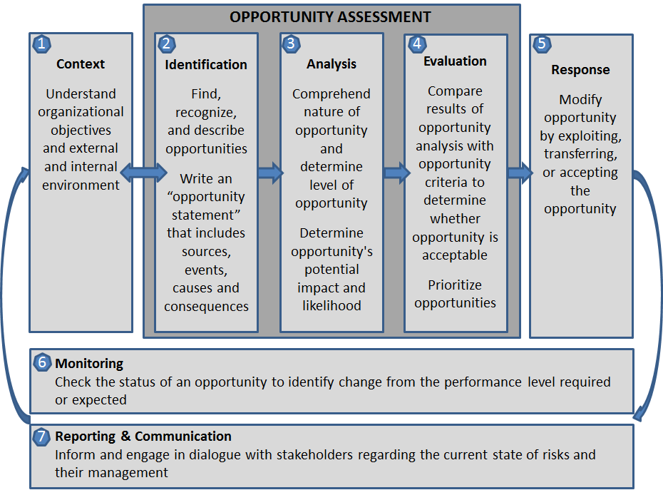
Any individual at any level of the institution may use this guide to assess and plan responses to risks and opportunities in their area. For the most part, however, risk assessments at ODU will be conducted along three primary pathways:

- As part of ODU’s annual ERM process, the ERM Steering Committee (SC) (deans, vice presidents, directors, or other senior officials designated as subject matters experts will be asked to identify and assess the institutional-level risks and opportunities for which they are responsible. The SC establishes working ERM Subcommittees to who will work with Risk Owners (typically cabinet level leadership responsible for the risk area) to further identify risks/opportunities, provide analysis, score risks, and develop mitigation/enhancement plans
- ODU’s senior management or the Board of Visitors may choose to have the Enterprise Risk Management (ERM) Steering Committee conduct a risk and opportunity assessment of a planned, institutional, strategic initiative to inform decision-making.
- Deans, directors, or other officials may, at their option, conduct a risk and opportunity assessment for their area that considers college-, school-, or department-level risks in addition to institutional-level issues.

The results of all risk and opportunity assessments and response plans are collected by the ERM Steering Committee and entered in the University’s risk and opportunity database (the OrigamiRisk RMIS) to facilitate monitoring and reporting.

Tools and Resources
As you follow this guide, you will capture the results of your risk and opportunity assessment and response planning in a Microsoft Excel workbook. The workbook has multiple worksheets that correspond to the steps of the risk management process, and allows the results to be entered into ODU’s risk database.

ODU’s Strategic Plan – ODU’s Strategic Plan should be considered as we look at risks and opportunities to our campus operations and community. Below are the 2014-2019 strategic Goals. The objectives listed under Figure 4 on page 7 or are explained in further detail in the Strategic Plan referenced at this here at this link, Strategic Plan 2014-19.

Goals:
Goal 1: Enhance the University’s Academic and Research Excellence
Goal 2: Support Student Success
Goal 3: Enrich the Quality of University Life
Goal 4: Engage with the Greater Community
Goal 5: Promote an Entrepreneurial Culture

Objectives:
Obj. 1: Develop principled leaders in a globalized environment.
Obj. 2: Enhance the learning environment.
Obj. 3: Strengthen the University through institutional advancement.
Obj. 4: Develop the student population.
Obj. 5: Enhance the facilities and technological support for the campus.
Obj. 6: Improve institutional effectiveness.

Additional resources are listed in Appendix A, B, and C of this guide:

- Appendix A: Key ERM Terms and Definitions
- Appendix B: Potential Risk Areas for Higher Education
- Appendix C: Proposed ERM Steering Committee Charter, ERM Principles, & Institutional Risk Philosophy

The ERM Steering Committee is a resource for responsible officials and their staff. ODU ERM Steering Committee will develop a capability to conduct facilitated risk assessment workshops and other educational/training sessions as well as to review and offer feedback on completed risk and opportunity assessments.

Step 1- Establish the Context (Tab 1 of the Assessment Workbook)
The purpose of establishing the context in the assessment is to set the stage for risk and opportunity identification. Since “risk” (opportunity) is defined as “the uncertainty about any issue (negative or positive) that may impact an organization’s ability to achieve its objectives,” defining the organization’s objectives is a prerequisite to identifying risks and opportunities.
Step 1 - Steps to follow (see Figure 3 for Example)
Open the Workbook in Microsoft Excel; you should be on the Step 1 Tab.
  - Save the Workbook with a unique name identifying your organization and risk/opportunity.
  - Use the drop-down menu to select your organization.
  - Enter the date.
  - Enter your name.
  - Use the drop-down menu to select which of the 8 Strategic Initiatives your organization best supports.
  - Enter your organization’s strategic goals of objectives.
  - Enter any key initiatives your organization has planned or has underway.
  - Enter the critical functions for your organization.
  - Go to Next Tab – Step 2: Risk and Opportunity Identification.

Figure 3: Step 1- Establish the Context Example

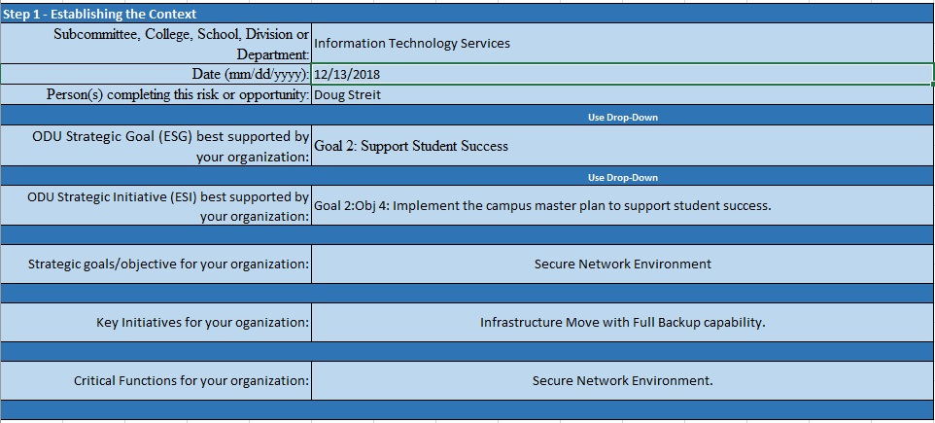

Step 2- Risk & Opportunity Identification (Tab 2 of the Assessment Workbook)
The purpose of the risk and opportunity identification step is to “generate a comprehensive list of risks [and opportunities] based on those events that might create, enhance, prevent, degrade, accelerate, or delay the achievement of objectives” (ISO 31000, 2009).

Step 2 - Things to Keep in Mind
- Be as comprehensive as possible at this stage – identify everything you can.
- Identify positive events that could advance strategic goals (opportunities) as well as negative events that could hinder attainment of those goals (risks).
- Include risks and opportunities regardless of whether or not they are “under your control.”
- Consider the risks associated with not pursuing an opportunity.
- Think about related risks and opportunities, and cascading or cumulative impacts.
- Involve the most knowledgeable people.
- Use the most relevant and up-to-date information you have.

Step 2 - Questions to Spur Thinking & Discussion
- What could affect the institution or your area’s ability to achieve or fulfill your strategic goals, initiatives, or key functions, either positively or negatively? What uncertainties do you face?
- What risks or opportunities could your area or the institution face in terms of:
  - Human Capital
  - Hazard, Safety, or Legal Liability
  - Financial
  - Operational
  - Compliance and Privacy
  - Strategic Issues
  - Reputational
  - Enrollment Management & Student Success
- What do you see as the strengths, weaknesses, threats, and opportunities facing your area?
- Have there been any recent major changes to your area of responsibility or control (new regulations, new programs/activities, organizational changes, etc.) that pose new risks or opportunities?
- Are there particular programs, activities, internal controls, or legal/regulatory issues, in your area that worry you or you think may pose significant risk to your unit or the institution?

Step 2 - Steps to Follow
Identify all the risks and opportunities you can that might affect your objectives (see Questions to Spur Thinking & Discussion, above).
- Enter the Risk / Opportunity Name in Column A (a short name or title). This is a free form field displaying up to 72 characters although you can enter more.
- Enter the Risk / Opportunity Statement in Column B that provides a little more detail about its sources and cause. Again, this is a free form field displaying up to 72 characters although you can enter more. Do not include potential impacts or consequences.
  - Aim for a “Goldilocks” risk/opportunity statement: not too short, not too long; not too vague, not too detailed; meaningful but not inflammatory.
  - Too vague: “IT infrastructure.”
  - Too specific/inflammatory: “IT network and hardware is obsolete, resulting in the potential for loss of institutional business continuity, loss of irreplaceable data, and privacy breaches.”
  - Just right: “IT infrastructure not maintained and/or upgraded to necessary standards.
- Choose Primary Enterprise Strategic Goal (ESG) Risk (if a risk) or Opportunity (if an Opportunity) category most closely related to from drop-down menu in Column C.
- Choose which Enterprise Strategic Initiative (ESI) area each risk or opportunity affects or is most closely related to from drop-down menu in Column D. If your ESG was Goal 3 then your ESI will come from Goal 3’s list of initiatives.
- Choose which, if any, secondary ESG each risk or opportunity affects or is closely aligned to (e.g. Goal 1; Goal 2; Goal 3 etc.) from drop-down menu in Column E.
- Indicate any other ESI for your Office, College, School, or department that this risk or opportunity affects in Column F.
- Enter the Responsible Office for each risk or opportunity in Column G.
- Enter the responsible official for each risk or opportunity in Column H. This is the individual at ODU with the accountability and authority to manage the issue.
- Go to Next Tab – Step 3: Risk and Opportunity Analysis.

Step 2 - Other Tools and Techniques
- Appendix B - Potential Risk Areas for Higher Education lists common risk areas by major University function that can be used to provide additional detail to the Risk / Opportunity Statement in Step 2.
- Other identification techniques or potential sources of risks and opportunities: Brainstorming, Questionnaires, Case Studies, Industry benchmarking, Scenario analysis, Incident investigation, or Audits or Inspections.

Step 2 - Key Terms
- Risk/Opportunity: Any issue (positive or negative) that may impact an organization’s ability to achieve its objectives; the effect of uncertainty on organizational objectives. Often characterized in reference to potential events, consequences, and the likelihood thereof.
- Identification: Process of finding, recognizing, and describing risks and opportunities.
- Risk/opportunity statement (description): Structured statement of risk or opportunity usually containing four elements: sources, events, causes, and impacts/consequences.
- Source (of risk or opportunity): Element or circumstance which alone or in combination has the intrinsic potential to give rise to risk or opportunity. Can be tangible or intangible.
- Event: Occurrence or change of a particular set of circumstances. Can be one or more occurrences, can have several causes, and can consist of something not happening.
- Cause: Something that provides an effect, result, or condition.
- Impact (consequences): Outcome of an event affecting objectives, either positively or negatively. Can be certain or uncertain; can be expressed qualitatively or quantitatively. An event can lead to a range of consequences, and initial consequences can escalate through knock- on effects.
- Responsible Office/Official (risk/opportunity owner): Person or entity with the accountability and authority to manage a risk or opportunity.

Figure 4: Step 2- Risk & Opportunity Identification Example

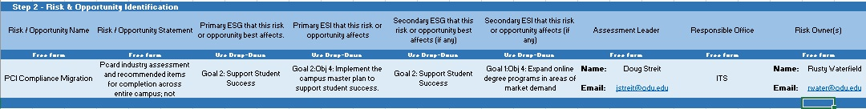

7

Step 3 - Risk & Opportunity Analysis (Tab 3 of the Assessment Workbook)
The purpose of the analysis step is to develop an understanding of the risk or opportunity in order to inform your evaluation and decision of whether a response is required. Here is where you will assess the potential impact and likelihood of the risks and opportunities.

Step 3 - Things to Keep in Mind
- Analysis can be qualitative, semi-qualitative, quantitative, or a combination thereof.
- Consider causes and sources, their positive and negative consequences, the likelihood that they can occur, and other attributes of the risk or opportunity.
- Consider interdependence of different risks or opportunities and their sources.
  - Remember the law of unintended consequences; that change does not occur in a vacuum. Be mindful of the impact change can make outside of the intended results.

Step 3 - Steps to Follow
- The Risk / Opportunity Name is carried forward from Step 2 for Column A.
- The Risk / Opportunity Statement is carried forward from Step 2 for Column B.
- Use the drop-down menu in Column C to pick which institutional risk or opportunity classification best fits each risk or opportunity (See Table 1, Primary Risk and Opportunity Classification below).
Note: If a Risk or Opportunity has more than one primary classification, as it may should there be related risks or sub-risk associated with it, you will then duplicate the Risk or Opportunity on a succeeding spreadsheet Tab and base the scoring as if it were a single record (the scores on each line should match).
- Use the drop-down menu in Column D to pick the Impact Analysis Score. See Tables 2 and 3 below for the detailed definitions. If more than one column of the scale relates to your risk, base your rating on the column that reflects the greatest impact. This will likely be the column that also corresponds to the classification of the risk or opportunity. (For example, if you categorized your risk as a “financial” issue, you will likely use the financial column of the impact scale to determine your impact rating.)
- Use the drop-down menu in Column E to pick the Risk/Opportunity Uncertainty Score. The definitions are listed beneath Figures 5 and 6 below.
- Use the drop-down menu in Column G to pick the Management Control score. In cases where multiple controls are to be implemented then a statistical regression model may be needed to account for the variations in the controls, the Office of Risk Management cab assist with these calculations. See Figures 5 and 6 below.
- Use the drop-down menu in Column H to select the Likelihood of management success. Typically this is a 2 for most organizations. Select 1 if response to management controls is poor. Select 3 if response to management controls has been historically high.
- The Risk Mitigation Score, for risks, and the Enhanced Opportunity score, for opportunities, is automatically calculated by the spreadsheet (Column I).
- Enter the recommended response (mitigation / exploitation) for each Risk/Opportunity (Column J).
- The Responsible Office is carried forward from Step 2 for Column I
- The Risk Owner is carried forward from Step 2 for Column J
- Save the file with a unique name and email to risk@odu.edu.

Note: If an issue presents both risk and opportunity (i.e., could have both positive and negative impacts), rate the positive/opportunity aspects of the issue using the opportunity impact and likelihood scale and enter the information on ERM-Opprt. Step 3 tab. The spreadsheet will automatically calculate the score based on impact, likelihood, and management control ratings to produce an opportunity score. For the risk side of the issue use ERM-Risks Step 3 tab to consider the negative/risk aspects of the issue and rate it using the risk impact, likelihood, and management control scales. The spreadsheet will automatically calculate the score. Compare your opportunity and risk scores: which is greater? Is there more upside or downside to this issue? The Steering Committee will consider both assessments and keep whichever opportunity or risk ratings produced the higher score.

Step 3 - Other Tools and Techniques
Other tools and techniques include but are not limited to: Business continuity planning; Business impact analysis; Political, economic, social, technological (PEST) analysis; Decision taken under risk and uncertainty; Dependency modeling; Event or Fault tree analysis; Failure mode and effect analysis (FMEA); Market surveys, prospecting; Measures of central tendency and dispersion; Political, economic, social, technical, legal and environmental (PESTLE) analysis; Real option modeling; Research and development; Statistical inference; SWOT (Strengths, Weaknesses, Opportunities, and Threats) analysis; Test marketing; or Threat analysis.

As we consider these other tools and techniques, bear in mind that within the University community we have undergrad and graduate students in our schools of business and mathematics. We can engage these students as interns and student workers to assist in performing many of these quantitative and qualitative analysis that may be required. This will lessen the time and costs components of ERM analysis and provide a valuable real world experience for some students.

Step 3 - Key Terms
  - Impact (consequences): Outcome of an event affecting objectives, either positively or negatively; can be certain or uncertain; can be expressed qualitatively or quantitatively. An event can lead to a range of consequences and initial consequences can escalate.
  - Likelihood: The chance that something will happen – whether defined, measured, or determined objectively or subjectively, qualitatively or quantitatively, and described using general terms or mathematically.
  - Management Control: Any process, policy, device, practice, or other action that modifies the risk or opportunity.
  - Risk/opportunity analysis: Process to comprehend the nature of risk or opportunity and to determine the level of a risk or opportunity; provides the basis for risk/opportunity evaluation and decisions about response.

Table 1: Risk and Opportunity Classification
Classification* | Description
Human Capital | Risks or opportunities related to investing in, maintaining, and supporting a quality workforce, such as: recruitment, retention, morale, compensation & benefits, change management, workforce knowledge, skills, and abilities, unionization, employment practices
Hazard, Safety, or Legal Liability | Risks related to legal liability (negligence), injury, damage, or health and safety of the campus population or the environment, including impacts caused by accidental or unintentional acts, errors or omissions, and external events such as natural disasters.
Financial | Risks or opportunities related to physical assets or financial resources, such as: tuition government support, gifts, research funding, endowment, budget, accounting and reporting, investments, credit rating, fraud, cash management, insurance, audit, financial exigency plan, long-term debt, deferred maintenance.
Operational | Risks or opportunities related to management of day-to-day University programs, processes, activities, and facilities, and the effective, efficient, and prudent use of the University’s resources.
Compliance & Privacy | Risks related to violations of federal, state or local law, regulation, or University policy, that creates exposure to fines, penalties, lawsuits, reduced future funding, imposed compliance settlements, agency scrutiny, injury, etc.
Strategic | Risks or opportunities related to ODU’s ability to achieve its strategic goals and objectives, including competitive market risks, and risks related to mission, values, strategic goals; diversity; academic quality; research; student experience; business model; market positioning; enrollment management; ethical conduct; accreditation, etc.
Reputational | Risks or opportunities where ODU could lose or gain business or market share based on its character or quality of services.
Enrollment Management and Student Success | Opportunities where ODU could increase overall student recruitment, retention, completion or student satisfaction with degree programs.

Figure 5: Step 3 - Risk & Opportunity Analysis Example

Tab-ERM Risks Step 3

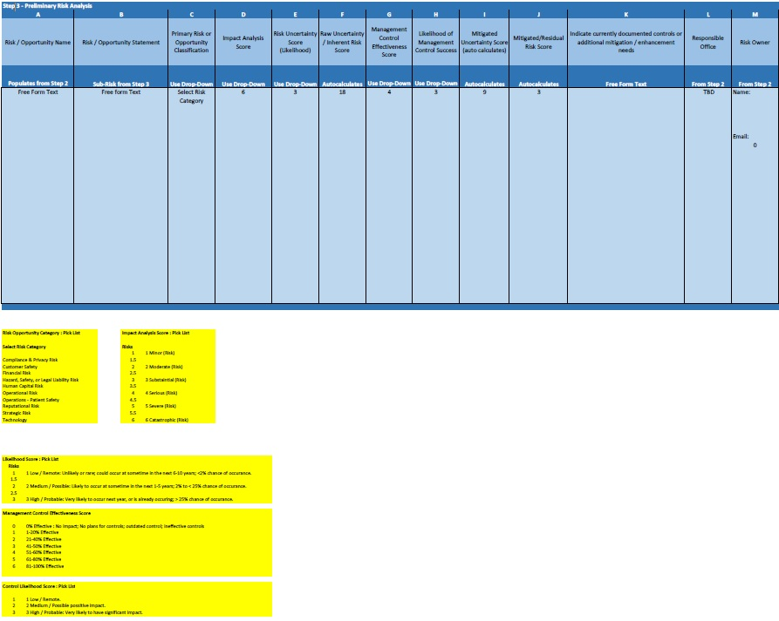

Tab-ERM Opprt. Step 3

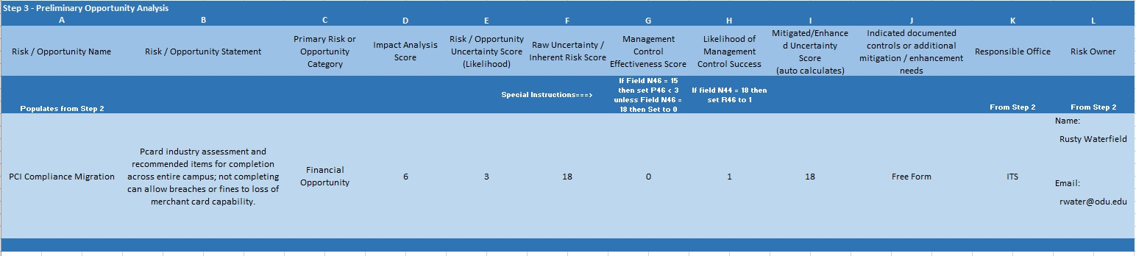

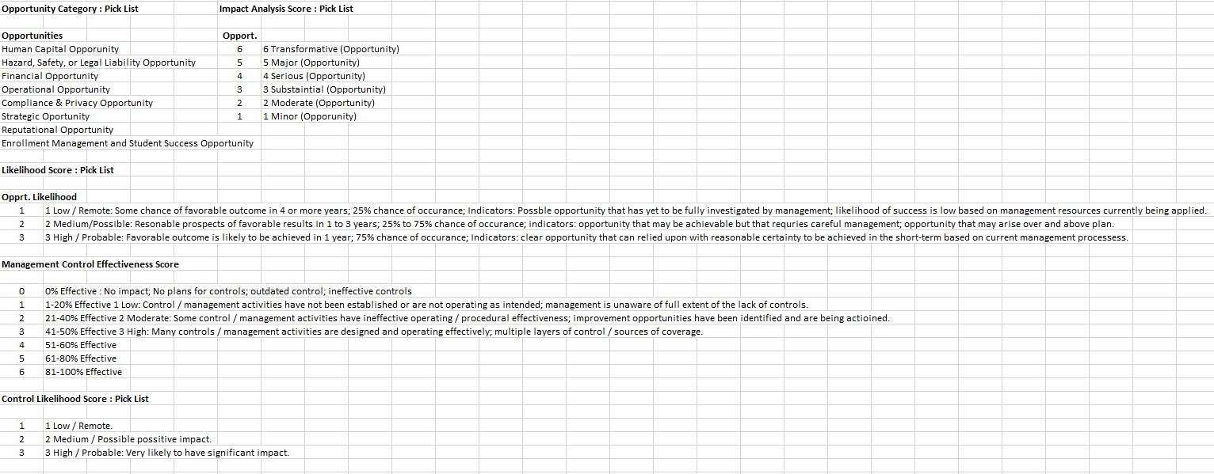

Table 2: Risk Impact Scale
Impact Score | Short Description | Human Capital | Hazard/Safety/Legal Liability | Financial | Operational | Compliance & Privacy | Strategic | Reputational
1 | Minor | - Affects <5% of employees  - No impact on recruitment or retention | - Minor injury  - Minor legal liability exposure  - Minor, reparable environmental damage | - Fiscal Year loss of $50K  - 5-Yr Cumulative Liability / Obligation $125K | - No disruption of critical operations and services  - 1-2 day disruption of a department  - Minor impact on efficiency, client/student programs and services, environmental sustainability, or infrastructure  - No effect on leadership effectiveness | - Minor audit findings  - Minor fines | - Slows  progress on one ODU strategic goal | - Limited negative publicity  - No effect on University reputation/image
2 | Moderate | - Affects 5-10% of employees  - <5% employee turnover | - Moderate injury  - Self-insured workers’ compensation injury/exposure possible  - Moderate legal liability exposure  - Moderate, reparable environmental damage | - Fiscal Year loss of $250K  - 5-Yr Cumulative Liability / Obligation $625K | - 3- to 5-day disruption of several departments or one critical service  - Moderate impact on efficiency, client/student programs and services, environmental sustainability, or infrastructure  - Moderate effect on leadership effectiveness | - Moderate audit findings  - Moderate fines  - Short-term agency scrutiny | - Slows  progress on more than one ODU strategic goal | - Local/regional negative publicity  - Minor, short-term effect on University reputation/image
3 | Substantial | - Affects 11-25% of employees  - 6-9% employee turnover | - Substantial injury  - Self-insured workers’ compensation injury/exposure possible  - Substantial legal liability exposure  - Substantial environmental damage requiring mitigation | - Fiscal Year loss of $500K  - 5-Yr Cumulative Liability / Obligation $1.25M | - 6- to 10-day disruption of a College, School, or Department or several critical services  - Substantial impact on efficiency, client/student programs and services, environmental sustainability, or infrastructure  - Substantial impact on leadership effectiveness | - Audit findings requiring programmatic changes  - Moderate-term agency scrutiny  - Enforcement action likely | - Stops  progress of one ODU strategic goal | - Local/regional negative publicity  - Pressure for the University to control the message  - Moderate damage to The University’s reputation/image
4 | Serious | - Affects 26-50% of employees  • 10-15%  employee turnover | - Serious injury  - Self-insured workers’ compensation injury/exposure  - Serious legal liability exposure  - Environmental damage eligible for EPA National Priorities List | - Fiscal Year loss of $1M  - 5-Yr Cumulative Liability / Obligation $2.5M | - 10- to 14-day disruption of 2 or more Colleges, Schools, or Department or three or more critical services  - Serious impact on efficiency, client/student programs and services, environmental sustainability, or infrastructure  - Serious effect on leadership effectiveness | - Principal investigator debarred  - Program funds rescinded  - Long-term agency scrutiny  - Enforcement action likely | - Stops  progress on more than one ODU strategic goal | - National negative publicity  - Intense pressure for the University to control the message  - Significant damage to the University’s reputation/image
5 | Severe | - Affects 51-75% of employees  • 16-24%  employee turnover | - Severe injury or death  - Self-insured workers’ compensation injury/exposure  - Severe legal liability exposure  - Severe environmental damage eligible for EPA National Priorities List | - Fiscal Year loss of $2.5M  - 5-Yr Cumulative Liability / Obligation $6.25M | - 14-day to 3-month disruption of 2 or more Colleges, Schools, or Departments or most critical services  - Severe impact on efficiency, client/student programs and services, environmental sustainability, or infrastructure  - Severe effect on leadership effectiveness | - Imposed settlement or corporate integrity agreement  - Organizational criminal prosecution  - Record financial judgment | - Reverses progress on one or more ODU strategic goals | - National negative publicity  - The University cannot control the message  - Severe, long-term damage to the University’s reputation/image
6 | Catastrophic | - Affects >75% of employees  - >25% employee turnover | - Business-critical injury or death  - Critical legal liability exposure  - Major, irreparable environmental damage | - Fiscal Year loss of $10M  - 5-Yr Cumulative Liability / Obligation $25M | - The University shutdown >3 months  - Insolvency  - Leadership failure results in long-term damage to the institution | - Threatens viability of the University or its research mission  - Loss of all federal research or Title IV funds | - College strategic plan failure | - Negative publicity could permanently impair The University’s image/reputation  - Significant decrease in enrollment or research funding

Table 3: Opportunity Impact Scale
Impact Score | Short Description | Strategic | Reputational | Enrollment Management  & Student Success | Financial | Operational
1 | Minor | - Minor alignment with The University vision and mission  - Minor contribution to competitive advantage or long-term viability  - Minor progress on one strategic goal | - Limited, local positive publicity  - No lasting effect on the University reputation/image | - Minor improvement in recruitment, retention, completion, or student satisfaction with The University experience | - Annual savings or new net revenue  $50K* | - Minor improvements in efficiency, client/student programs and services, environmental sustainability, or infrastructure
2 | Moderate | - Moderate alignment with The University vision and mission  - Moderate contribution to competitive advantage or long-term viability  - Minor progress on more than one strategic goal | - Positive local/regional publicity  - Minor, short-term effect on the University reputation/image | - Moderate improvement in recruitment, retention, completion, or student satisfaction with University experience | - Annual savings or new net revenue of  $250K* | - Moderate improvements in efficiency, client/student programs and services, environmental sustainability, or infrastructure
3 | Substantial | - Substantial alignment with The University vision and mission  - Substantial contribution to competitive advantage or long-term viability  - Major progress on one strategic goal | - Positive publicity and external recognition  - Moderate. short-term improvement to The University’s reputation/image  - Positive effect on the University’s academic, environmental, or research reputation | - Substantial improvement in recruitment, retention, completion, or student satisfaction with The University experience | - Annual savings or new net revenue of  $500K* | - Substantial improvements in efficiency, client/student programs and services, environmental sustainability, or infrastructure
4 | Serious | - Overall alignment with The University vision and mission  - Significant contribution to competitive advantage or long-term viability  - Major progress on more than one strategic goal | - Positive national publicity or external recognition  - Significant, lasting improvement of the University’s reputation/image  - Positive effect on the University’s academic, environmental, or research reputation | - Significant improvement in recruitment, retention, completion, or student satisfaction with The University experience | - Annual savings or new net revenue of  $1M* | - Serious improvements in efficiency, client/student programs and services, environmental sustainability, or infrastructure
5 | Major | - Complete alignment with The University vision and mission  - Major contribution to competitive advantage or long-term viability  - Accelerates progress on one or more strategic goals | - Positive national publicity or external recognition  - Long-term enhancement of the University’s academic, environmental, or research reputation | - Major improvement in recruitment, retention, completion, or student satisfaction with The University experience | - Annual savings or new net revenue of  $2.5M* | - Major improvements in efficiency, client/student programs and services, environmental sustainability, or infrastructure
6 | Transformative | - Complete alignment with The University vision and mission  - Definitively enhances competitive advantage or long-term viability  - Fulfills strategic plan | - Positive national publicity and external recognition  - Permanent enhancement of the University’s academic, environmental, or research reputation  - Results in a significant increase in enrollment, student academic quality,  and/or research funding | - Meets or exceeds recruitment, retention, completion, or student satisfaction with The University experience goals | - Annual savings or new net revenue of  $10M* | - Transformative improvements in efficiency, client/student programs and services, environmental sustainability, or infrastructure

*Based on final-year projected savings or net revenue projections for multi-year initiatives

Steps 4 and 5 - Risk and Opportunity Evaluation & Response
The purpose of the evaluation and response steps is to decide, based on the results of your analysis, which risks and opportunities require a response and what your recommended response will be.

Steps 4 and 5 - Things to Keep in Mind
  - Each risk or opportunity’s risk score (the product of impact x likelihood / management control) will determine where it falls on ODU’s risk and opportunity “Heat Map” ( Fi gur e 6 below) and what level of institutional review each risk or opportunity will receive.
  - Risk/opportunity response is a cyclical process of assessing the response, determining whether residual risk levels (after response) are acceptable, developing a new response if necessary, and assessing the response again.
  - There are several standard options for risk/opportunity response, but they are not mutually exclusive; they can be used in combination.
  - A decision can be to not respond to the risk or opportunity other than maintaining existing management or control activities.
  - Consider the values of expectations of stakeholders in developing a response.
  - Consider whether some responses are not economically justifiable (e.g., an expensive response for a high impact but low likelihood risk).
  - Responding to risks or opportunities can itself introduce risks. Consider how your response plan will deal with any secondary risks.

Steps 4 and 5 - Steps to Follow
- Consider the overall results of your risk/opportunity analysis, especially your rating of the risk or opportunity’s impact and likelihood and the resulting risk score.
- Consult the “Heat Map ” shown in Fi gure 6 to see where your risks and opportunities will fall and what level of institutional review they will require based on their risk score.
- Consider which risk or opportunity response options you will use to manage this risk: accept/ignore, avoid/exploit, mitigate/enhance, or share.
- Consider what steps you will take to respond to each risk or opportunity.
- Consider any costs or special resource needs associated with your response.
- Consider how long it would take to fully implement your response.

Steps 4 and 5 - Key Terms
- Risk response (treatment): Process to modify or respond to a risk. Risk response can involve one or a combination of: acceptance, avoidance, mitigation, or sharing.
  - Accept: Form of risk response, an informed decision to tolerate or take on a particular risk
  - Avoid: Form of risk response, an informed decision not to be involved in, or to withdraw from, an activity, in order not to be exposed to a particular risk.
  - Mitigate: Form of risk response involving actions designed to reduce a risk or its consequences.
  - Sharing (transfer), risk: Form of risk response, involving contractual risk transfer to other parties, including insurance. Risk financing: Form of risk sharing, involving contingent arrangements for the provision of funds to meet or modify the financial consequences should they occur

  - Opportunity response (treatment): Process to modify or respond to an opportunity. Opportunity response can involve one or a combination of: enhancement, exploitation, ignoring, or sharing.
    - Ignore: Just as the “acceptance” strategy takes no active measures to deal with a residual risk, opportunities can be ignored, adopting a reactive approach without taking explicit actions.
    - Exploit: Parallels the “avoid” response, where the general approach is to eliminate uncertainty. For opportunities, the “exploit” strategy seeks to make the opportunity definitely happen (i.e. increase probability to 100%). Aggressive measures are taken which seek to ensure that the benefits from this opportunity are realized by the project.
    - Enhance: The opportunity equivalent of “mitigating” a risk is to enhance the opportunity. Enhancing seeks to increase the probability and/or the impact of the opportunity in order to maximize the benefit to the project.
O Sharing (transfer), opportunity: The “share” strategy for opportunities seeks a partner able to manage the opportunity who can maximize the chance of it happening and/or increase the potential benefits. This will involve sharing any upside in the same way as risk transfer involves passing penalties.

- Risk/opportunity response plan: Plan to implement chosen risk or opportunity response.
- Risk/opportunity criteria: Terms of reference against which the significance of a risk or opportunity is evaluated.
- Risk/opportunity evaluation: Process of comparing the results of risk/opportunity analysis with criteria to determine whether the risk/opportunity and/or its magnitude is acceptable. Use of a tool/system to rate and/or prioritize a series of risks or opportunities.

Figure 6: Risk & Opportunity Heat Map
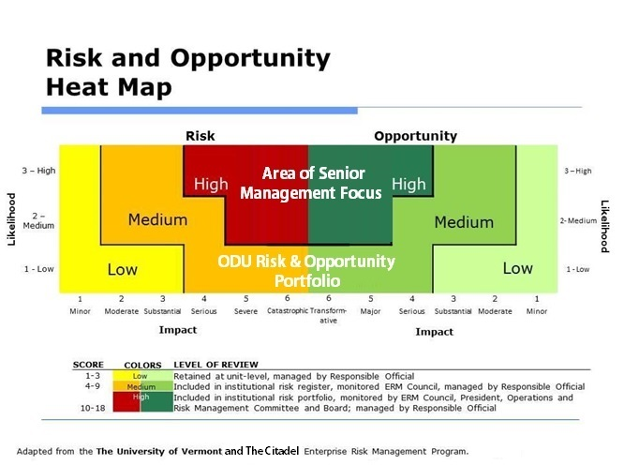

References
Institute of Internal Auditors (2009). IIA Position Paper: The Role of Internal Auditing in Enterprise- wide Risk Management. Issued January 2009.
ISO 31000. International Standard: Risk management – Principles and guidelines. First edition, 2009- 11-15.
ISO Guide 73. Risk management – Vocabulary. First edition, 2009.
Risk and Insurance Management Society, Inc. (RIMS): Enterprise Risk Management, 1st Edition, 2013, page 1.5.
The University of Vermont, Enterprise Risk Management Guide to Risk Assessment & Response.

Appendix A - Key ERM Terms and Definitions

General ERM Terms
Enterprise risk management (ERM): A strategic business decision that supports the achievement of an organization’s objectives by addressing the full spectrum of its risks and managing the combined impact of those risks as an interrelated risk portfolio (Risk and Insurance Management Society (RIMS)).
ERM framework: Set of components that provide the foundations and organizational arrangements for designing, implementing, monitoring, reviewing, and continually improving risk management throughout the organization at all levels. Ensures that information about risk derived from the risk management process is adequately reported and used as basis for decision-making and accountability at all relevant organizational levels.
Risk: The uncertainty around any issue (positive or negative) that may impact an organization’s ability to achieve its objectives; the effect of uncertainty on organizational objectives. Often characterized in reference to potential events, consequences, and the likelihood thereof.

Terms Related to ERM Program & Context
Context, external: External environment in which the organization seeks to achieve its objectives, including cultural, social, political, legal, regulatory, financial, technological, economic, natural, and competitive environments, whether international, national, regional, or local; key drivers and trends; and relationships with, perceptions, and values of external stakeholders.
Context, internal: Internal environment in which the organization seeks to achieve its objectives, which can include governance, organizational structure, policies, resource and knowledge capabilities, information systems and flows, decision-making processes, culture, form and extent of contractual relationships, and relationships with, perceptions, and values of internal stakeholders.
ERM goals (objectives): Goals and objectives that ERM activities are seeking to achieve; what the ERM program and process should accomplish for the institution.
ERM guiding principles (cultural expectations): Description of the risk-aware culture or control environment; expectations regarding behaviors, communication, information-sharing, reporting, etc.
ESG (Enterprise Strategic Goal): As used in this guide identifies the University strategic goal

ERM Steering Committee Charter: ODU’s Enterprise Risk Management Council (the “ERM Steering Committee”) provides campus-wide oversight in achieving the University’s Enterprise Risk Management (“ERM”) vision and mission. The vision is to expand the University’s ability to achieve its mission objectives by managing risks and maximizing opportunities. ERM creates a comprehensive approach to anticipate, identify, prioritize, and manage risks to daily operations and mission objectives. Enterprise risk is any significant event or circumstance that could affect or impact the achievement of mission objectives, including strategic, operational, reporting, and compliance risks.
Risk philosophy: Statement of the overall intentions, direction, and attitude of the institution related to risk; reflected in the ways risks are considered in both strategy development and day-to-day operations. The organization's approach to assess and eventually pursue, retain, take, or turn away from risk.

Terms Related to the Risk and Opportunity Assessment Process
Acceptance: Form of risk response, an informed decision to tolerate or take on a particular risk.
Avoidance: Form of risk response, an informed decision not to be involved in, or to withdraw from, an activity, in order not to be exposed to a particular risk.
Enhance: The opportunity equivalent of “mitigating” a risk is to enhance the opportunity. Mitigation modifies the degree of exposure by reducing probability and/or impact, whereas enhancing seeks to increase the probability and/or the impact of the opportunity in order to maximize the benefit to the project.
Event: Occurrence or change of a particular set of circumstances. Can be one or more occurrences, can have several causes, and can consist of something not happening.
Exploit: Parallels the “avoid” response, where the general approach is to eliminate uncertainty. For opportunities, the “exploit” strategy seeks to make the opportunity definitely happen (i.e. increase probability to 100%). Aggressive measures are taken which seek to ensure that the benefits from this opportunity are realized by the project.
Ignore: Just as the “acceptance” strategy takes no active measures to deal with a residual risk, opportunities can be ignored, adopting a reactive approach without taking explicit actions.
Impact (consequences): Outcome of an event affecting objectives, either positively or negatively. Can be certain or uncertain; can be expressed qualitatively or quantitatively. An event can lead to a range of consequences, and initial consequences can escalate through knock-on effects.
Inherent Risk: The uncertainty that as activity would pose if no controls or other mitigating factors were in place (the gross risk or raw risk before controls.
Likelihood: The chance that something will happen – whether defined, measured, or determined objectively or subjectively, qualitatively or quantitatively, and described using general terms or mathematically.
Mitigation: Form of risk response involving actions designed to reduce a risk or its consequences.
Opportunity response (treatment): Process to modify or respond to an opportunity. Opportunity response can involve one or a combination of: exploitation, ignoring, enhancement, or sharing.
Probability: Measure of the chance of occurrence expressed as a number between 0 and 1.
Residual Risk: The uncertainty that remains after controls are taken into account (the net risk or mitigated risk after controls.
Risk analysis: Process to comprehend the nature of risk and to determine the level of a risk; provides the basis for risk evaluation and decisions about risk response.
Risk assessment: Overall process of identifying, analyzing, and evaluating risk.
Risk control: Any process, policy, device, practice, or other action that modifies risk.
Risk criteria: Terms of reference against which the significance of a risk is evaluated.
Risk evaluation: Process of comparing the results of risk analysis with risk criteria to determine whether the risk and/or its magnitude is acceptable or tolerable. Use of a tool/system to rate and/or prioritize a series of risks.
Risk financing: Form of risk response, involving contingent arrangements for the provision of funds to meet or modify the financial consequences should they occur.
Risk identification: Process of finding, recognizing, and describing risks.
Risk inventory, preliminary: Preliminary list of potential risks identified for further assessment and analysis.
Risk/Opportunity Owners: Those members of the President’s Cabinet with responsibility over an identified risk or opportunity. May or may not be the process owner.
Risk portfolio (profile): A composite view of highest-level institutional risk exposures for presentation by management and discussion with the Board; provides information regarding relationships, concentrations, and/or overlaps of risk as they relate to strategic objectives. Description of any set of risks.
Risk/Opportunity Process Owner: Member of the University community responsible for the processes involving an identified risk or opportunity.
Risk register (log, repository): Record of information about identified risks; the complete list of all risks identified in the ERM process.
Risk response (treatment): Process to modify or respond to a risk. Risk response can involve one or a combination of: avoidance, acceptance, mitigation, or transfer.
Risk response plan: Plan to implement chosen risk response.
Risk statement (description): Structured statement of risk usually containing four elements: sources, events, causes, and impacts/consequences.
Sharing (transfer), opportunity: The “transfer” response allocates ownership to a third party best able to deal with the threat. Similarly, a “share” strategy for opportunities seeks a partner able to manage the opportunity, who can maximize the chance of it happening and/or increase the potential benefits. This will involve sharing any upside in the same way as risk transfer involves passing penalties.
Sharing (transfer), risk: Form of risk response, involving contractual risk transfer to other parties, including insurance.
Source (of risk): Element or circumstance which alone or in combination has the intrinsic potential to give risk to risk. Can be tangible or intangible.

Terms Related to ERM-Enabling Activities
Communication & consultation: Continual and iterative processes that an organization conducts to provide, share, or obtain information, and to engage in dialogue with stakeholders regarding the management of risk.
Monitoring: Continual checking, supervising, critically observing, or determining the status in order to identify change from the performance level required or expected. Can be applied to an ERM framework, ERM process, risk, or control.
Reporting: Form of communication intended to inform particular internal and external stakeholders by providing information regarding the current state of risk and its management.

Appendix B - Potential Risk Areas for Higher Education

ACADEMIC AFFAIRS
- Academic freedom
- Academic quality and standards
- Accreditation
- Collective bargaining
- Computer security, back-up systems
- Contractual relationships/dependencies
- Distance learning
- Educational technology
- Facilities quality
- Faculty diversity
- Faculty employment-operational
- Faculty recruitment and retention
- Grievance procedures
- Health & safety of students, faculty, staff- operational
- International students-operational
- International travel, global activities
- Joint programs
- Libraries
- Reappointment, promotion and tenure
- Student experiential learning
- Student learning outcomes
- Transportation risks
- See also compliance and privacy risks

BOARD GOVERNANCE
- Board member independence
- Board performance assessment
- Administration compensation & assessment
- Governance policies
- Officer codes of conduct
- See also compliance and privacy risks

COMPLIANCE AND PRIVACY
- Accounting – GASB/GAAP
- Affirmative action
- Alcohol and drugs- drug free workplace, drug free schools and community act
- Animal research
- Athletics – NCAA/Title IX
- Background checks
- Biosafety
- Bond compliance
- Information security breach response
- Clinical research – human subjects
- Code of business conduct
- Code of ethics
- Conflicts of interest – inclusive of research
- Copyright and "fair use"
Compliance & Privacy, continued
- Credit card privacy regulations – PCI-DSS
- Environmental health & safety
- Export controls
- Federal sentencing guidelines – organizations
- Foreign nationals - SEVIS
- Gramm-Leach-Bliley
- Government grants – grant restrictions
- Grant accounting – reporting and cost accounting, A-133/A-110/ARRA
- Harassment prevention
- Hazardous materials
- Health and safety compliance
- Higher education act
- HIPAA
- HR/employment – affirmative action/FLSA/FMLA
- Intellectual property rights – Baye-Dole Act
- Laboratory safety - compliance
- Lobbying
- Policy/procedure - institutional
- Privacy
- Record retention/destruction
- Red flags rules
- Select agents
- Sexual molestation prevention
- Student financial aid – Title IV, HEOA, program integrity
- Student records - FERPA
- Tax compliance
- Whistleblower policy
- Vermont security breach notification act

DEVELOPMENT & ALUMNI RELATIONS
- Alumni relations
- Capital campaigns - reduced donor support
- Compliance with donor intent
- Computer security, back-up systems
- Endowment – loss of income/investment
- Gift acceptance policies
- Health & safety of employees, visitors- operational
- High-risk investments
- Investment oversight
- Naming policies
- Sale of donated property
- Special event risks
- Transportation risks
- See also compliance and privacy risks

ENROLLMENT MANAGEMENT
- Admissions
- Diversity
- Enrollment trends
- Financial aid - operational
- Graduation rates
- Retention
- Student and family demographics
- Student debt
- Study abroad
- Transportation risks
- See also compliance and privacy risks

FACILITIES & OTHER OPERATIONS
- Accessibility
- Auto/Fleet
- Business continuity
- Capital planning and projects
- Contract Services
- Emergency planning, response, operations, and recovery
- Energy consumption/efficiency
- Facilities maintenance/operation
- Outsourcing/privatization
- Police operations
- Property disposal
- Regulatory Compliance
- Safety – operational, personnel, and environmental
- Transportation and parking
- Waste disposal, recycling, and reuse
- See also compliance and privacy risks

FEDERAL, STATE & COMMUNITY RELATIONS
- City relations
- Neighborhood relations
- Regulatory concerns
- State relations
- See also compliance and privacy risks

FINANCE
- Auditor independence
- Budget challenges, allocations, carryovers
- Cash management
- Contracting & purchasing
- Cost management
- Depletion of endowment principal
- Endowment - loss of income/investment
- Financial aid
- Financial exigency plan
- Financial reporting
- Fundraising
- High-risk investments
- Insurance

Finance, continued
- Internal controls
- Investment oversight
- Investment performance
- Liquidity
- Long-term debt
- Reserve fund
- Revenue risks - tuition dependency
- See also compliance and privacy risks

HUMAN RESOURCES
- Background checks - operational
- Benefits
- Code of conduct
- Collective bargaining
- Computer security, back-ups
- Diversity
- Employee handbook
- Employee retention
- Employee succession planning
- Employment
- Employment - affirmative action
- Grievance procedure
- Labor relations
- Non-discrimination
- Performance evaluation
- Termination procedures
- Unionization
- Workplace safety – operational
- See also compliance and privacy risks

INFORMATION TECHNOLOGY
- Back-up procedures
- Communications systems
- Cyber liability
- Data integrity and protection
- End-user training
- Incident response – continuity and security
- Network integrity
- Security
- Staffing & support
- System capacity
- System maintenance and upgrades
- See also compliance and privacy risks

RESEARCH
- Animal research – operational
- Biosafety
- Clinical research - operational
- Competition for grants

- Data security and back-up
- Environmental & laboratory safety - operational
- Facilities quality
- Funding
- Grant administration, accounting, and reporting - operational
- Hazardous materials-operational
- Human subjects - operational
- Patenting
- Security
- Technology transfer
- See also compliance and privacy risks

STUDENT AND CAMPUS LIFE
- Academic support
- Alcohol & drugs
- Athletics-operational
- Barracks Operations
- Career services
- Code of conduct
- Communications, public relations, and marketing
- Crime on campus
- Diversity
- Experiential programs
- Food services
- Fraternities & sororities
- Free speech
- International students
- Police operations
- Privacy
- Safety, health, and wellness
- SGA activities
- Study abroad
- Transportation risks
- See also compliance and privacy risks

Appendix C - ERM Steering Committee Charter, ERM Principles, & Institutional Risk Philosophy

ODU Proposed ERM Steering Committee Charter
Once approved by the Board of Visitor to be posted on the ERM website.
- PURPOSE.
ODU’s Enterprise Risk Management Council (the “ERM Steering Committee”) provides campus-wide oversight in achieving the University’s Enterprise Risk Management (“ERM”) vision and mission. The vision is to expand the University’s ability to achieve its mission objectives by managing risks and maximizing opportunities. ERM creates a comprehensive approach to anticipate, identify, prioritize, and manage risks to daily operations and mission objectives. Enterprise risk is any significant event or circumstance that could affect or impact the achievement of mission objectives, including strategic, operational, reporting, and compliance risks.
- ERM STEERING COMMITTEE.
The ERM Steering Committee is an initiative aimed at assessing and managing risks and opportunities. The ERM Steering Committee’s goal is to embed risk assessment and management into the University’s daily operations to minimize risks and surprises, to maximize opportunities, and to be more responsive to the ever-changing needs of the campus (students, faculty, and staff) and communities we serve and support. The ERM Steering Committee’s success depends on the coordinated and cooperative response from employees at every level.
- BACKGROUND.
Risk has historically been viewed as something to be avoided or eliminated with only a negative outcome on an organization. However, there is increasing awareness that successful risk taking (opportunity) leads to a competitive advantage and can maximize value. In addition to this risk/return equation, it is more evident now that risks are interconnected across an organization and traditional silo approaches to managing these risks are becoming less effective. Organizations must systematically share risk and internal control knowledge across their functions and departments to obtain best practices.
For ODU to optimize the benefits of risk and minimize their costs, we must embed an ERM culture into all our activities. This embedded framework causes decisions that trade value and risk to be made on an informed basis and aligned with risk tolerance and strategy. With ERM, greater transparency to the Board of Visitors and other stakeholders will be realized.
Central to this ERM framework is the ERM Steering Committee. This committee is represented by delegates of the operational functions of the University and assures that risk management decisions are aligned with our strategies, made on an informed basis, and shared across our organization.
- ERM STEERING COMMITTEE GOALS.
  - Increased overall effectiveness and accountability for managing risk and maximizing opportunities.

  - Sound operations and business processes; greater assurance of operations and business continuity.
  - Demonstrated compliance with applicable laws, regulations, policies, and procedures.
  - Enhanced employee empowerment and pride.
  - Reinforcement of strong cultural identity and core values of honor, duty and respect.
  - Enhanced brand and competitive advantage in our unique mission space.
- COUNCIL COMPOSITION, MEETINGS, AND REPORTS.
The ERM Steering Committee shall consist of the senior member of the Office of Risk Management, V.P. for Administration and Financial Services, Senior officer of the Office of Internal Audit, Assistant V.P. for Public Safety, and senior leadership from the offices of the Provost and Dean of the University, Athletic Department, V.P. for the Office of Strategic Communications and Marketing, Institutional Advancement, the Institutional Review Board, University Council, leadership from Student Engagement & Enrollment Services and other representation deemed necessary by the University senior Administration or the Chairperson. University Counsel will be consulted on applicable risk management efforts. The senior risk management official shall serve as the Chairperson. The Vice President for Operations shall serve as an advisor to the ERM Steering Committee.
The ERM Steering Committee shall meet as frequently as deemed necessary to carry out its duties and responsibilities, but it shall meet at least four times each year. Meetings of the ERM Steering Committee may be called by the Chairperson.
The ERM Steering Committee shall establish sub committees of its members or elect subject matter experts from within the University community to serve in order to best identify and analyze risk and opportunities and to then development mitigation plans for risk and enhancement plans for opportunities.
The ERM Steering Committee shall maintain minutes of all its meetings and shall report no less than quarterly to the President of ODU regarding the Council’s activities, findings, conclusions, and recommendations. The ERM Steering Committee shall also report to the Operations and Risk Management Committee of ODU Board of Visitors, coordinated through the Vice President for Operations.
- RESPONSIBILITIES.
The primary responsibility of the Steering Committee (SC) is to oversee that sound policies, procedures, and practices are in place for the enterprise-wide risk management of the University’s operational risks and to report the results of the SC its various operational risk sub committees’ activities to the senior Administration of the University. The senior administration and management of the University is responsible for satisfactorily mitigating risks.
The Council shall:
  - Promote and advance risk awareness and understanding through discussions with risk SC members and other employee groups.
  - Provide leadership for the identification, resolution, and monitoring of cross- organizational issues related to risk.
  - Assist in the elimination of functional, cultural, and department barriers in dealing with risks and opportunities.
  - Design, implement, and monitor risk management practices and risk assessment methodology for continuously identifying risks, both internal and external for the University:
    - Provide ongoing guidance and support for the refinement of the overall risk management framework using best practices.
    - Facilitate University senior administration and personnel understanding and accepting responsibility for identifying, assessing, and managing risk.
    - Require that risk assessments are performed periodically and completely.
    - Determine the University’s most significant enterprise risks and coordinate with appropriate individuals, officials, or organizations for resource allocation, monitoring, and mitigation. If appropriate, submit requisite paperwork necessary for budgeting and resource allocation consideration.
    - Assign risk owners (typically the cabinet level official responsible for the risk area) and approve action plans.
    - Assist in the development of mitigation strategies.
    - Periodically review and monitor risk mitigation progress.
  - Interface and cross flow with other campus groups (e.g., Institutional Planning Council, Planning Budgeting, and Review Council, Enrollment Management Council, Leadership Development Council, Financial Review Board) on any University ERM issues.
  - Serve as advisors to the University administration by contributing ideas and feedback on risk management activities.
  - Periodically review and report to the University President’s Cabinet and committees of the Board of Visitors as requested: (a) the magnitude of significant operational risks; (b) the processes, procedures and controls in place to manage risks; and (c) the overall effectiveness of the risk management process.
  - Authority to create or establish subcommittees as needed.
- ODU’S RISK ENVIRONMENT, CULTURE, AND APPETITE.
ODU encourages risk assessment and management while maximizing opportunities as an integral process for carrying out our mission to promote and enhance employee success and student learning and success. It is the responsibility of every employee to identify, assess, and manage risks and opportunities individually throughout our organization and to collectively strive for continuous quality improvement and the efficient and effective use of our resources.
- ANNUAL EVALUATION.
The ERM Steering Committee evaluates its performance on an annual basis. The evaluation shall be conducted in such a manner as the Council deems appropriate and in accordance with best practices. The evaluation shall compare the performance of the Council with the requirements of this Charter. The evaluation shall recommend improvements to the Council’s Charter deemed necessary.

ERM Guiding Principles
ODU seeks to establish a risk-aware institutional culture where consideration of both upside and downside risk is integrated into decision-making at all levels of the organization. The purpose of these guiding principles is to support that culture and set expectations for the behavior of University employees and administrators regarding risks and opportunities.
- All individuals, regardless of their role at the University, are empowered and expected to report early on to senior management any perceived risks or opportunities and any near misses or failures of existing control measures, without fear of retribution.
- Risk management is integral to the management and future direction of the University and is a shared responsibility at all levels of the University.
- Ownership and management of risk will be retained within the University function, department, or unit that creates the risk or is best capable of responding to it.
- The University’s risk philosophy will guide strategic and operational decisions at all levels.
- ODU encourages an open and honest discussion of the institution’s environment, strategy, risks, opportunities, and actions taken in pursuit of its objectives.
- All credible reports of risks or opportunities are responded to promptly, incomplete reports are investigated with integrity by the responsible University official, and information about risks or opportunities is shared promptly with senior management and other key stakeholders.

Institutional Risk Philosophy
The University takes a broad view of risk as any event—positive or negative—that could affect the University’s competitive position or ability to achieve its mission, vision, and strategic objectives.
The University acknowledges that risk, in one form or another, is present in virtually all its endeavors, and that successful risk-taking will often be necessary to achieve its aims.
We therefore do not seek to eliminate all risk; rather, we seek to be risk-aware but not risk- averse, and to effectively manage the uncertainty inherent in our environment.
To this end, we seek to identify, understand, assess, and respond to the risks and opportunities we face, taking into account their impact on ODU’s people, standing, reputation, financial position, and performance. We further seek to pursue prudent risks or opportunities that we believe will generate sufficient and sustainable performance and value, avoid intolerable risks, manage residual risk within defined levels, and be prepared to respond to risks or appropriate opportunities when necessary.

