This guide provides step by step instructions for submitting Google forms, such as the Temporary Account Maintenance Request and Account Cancellation Request.

- Please make sure you are not signed into a personal Google account.

- From the Procurement Services Pcard web page, click the link to desired form. For this example, the Pcard Temporary Account Maintenance Form is used.

- Sign in using ODU email address. This will trigger sign on using MIDAS.
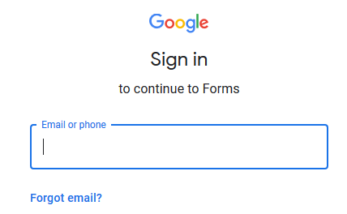

- Log in with MIDAS ID and password.
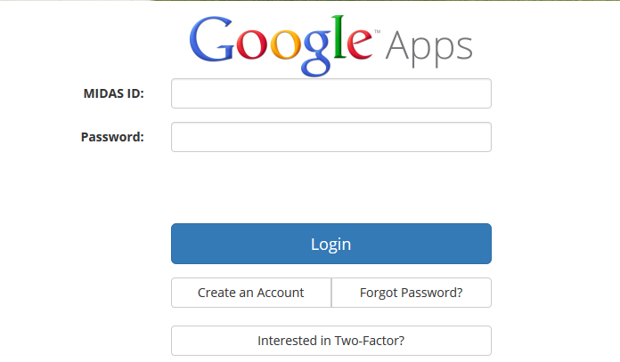
- Use the faculty/staff email if more than one option is available.
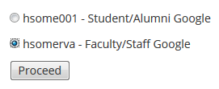

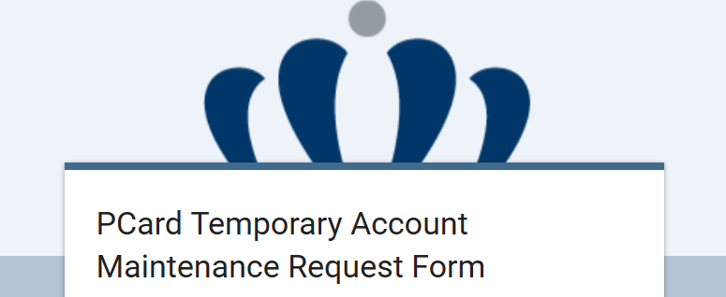
- Google form opens as in the screenshot below.

- Enter required information. Pcard Temporary Account Maintenance Form contains four section.
- Maintenance Request Form
- Temporary Protective Suspension Request
  - Leave blank and click Next for temporary MCC adjustment request.
- Request to unblock merchant category code
  - Leave blank and click Next for suspension requests.
- Include detailed description in Good/Service Being Purchased area.
- Finalize Submission
  - Any documents that need to be uploaded can be uploaded in this section.
