Introduction: Global Goals but National Implementation

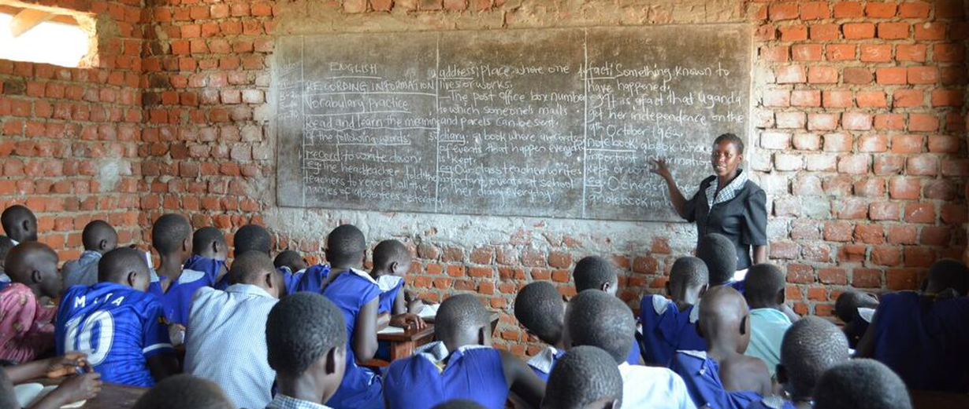
Few issues are more fundamental to global development and more controversial than promoting primary and secondary (high school) education. All countries want effective and universal education systems. But most expect education to serve their own national goals. How to balance universal ambitions with distinct national expectations is a difficult riddle for all United Nations (UN) bodies. For the United Nations Educational, Scientific and Cultural Organization (UNESCO), where cultural issues often are foremost, it is especially tricky.
Ensuring the success of developing and rural areas of the world is an essential mission of the UN. Emphasizing global agreement on its importance, quality primary and secondary education is the United Nations’ Sustainable Development Goal (SDG) Number Four. As a prominent part of the SDGs—which coordinate all global development assistance—quality education has been made a prominent problem for global resolution. Agreed by the UN General Assembly in 2015, the SDG’s will guide all development assistance for the years 2016-2030. They replace the Millennium Development Goals (MDGs) of 2001-2015.

Photo source: UNESCO
Research has proved that education is a key element in removing poverty and increasing productivity in all parts of the world. These findings prove that education also improves health through vaccine usage, proper sanitation awareness, and reductions in deaths related to childbirth by up to two-thirds. Health factors aside, education fosters gender equality. The Global Partnership for Education finds that those who attend secondary schooling are less likely to be married as a child, and that women’s incomes increase 10-20 percent for each additional year of schooling.
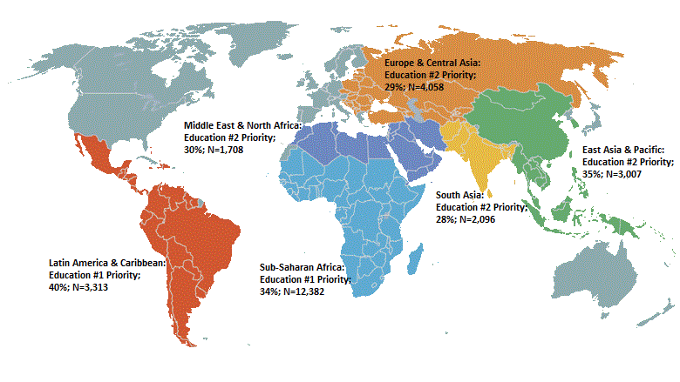
Not all regions of the world have access to educational opportunities, for many various reasons. One of the most detrimental factors contributing to the lack of children attending school is war and civil unrest. The effects of war on children are disheartening and astonishing. An article from the Croatian Medical Journal cites that children are killed, injured, or permanently disabled as a result of war in their region. Some children are sold into prostitution in order for their families to have a survivable income, and an estimated tens of thousands are forced into becoming child soldiers. All of these factors render children unable to attend school, running under the assumption that schools in these regions are still open and operational. These factors also have a wide variety of lasting social, cultural, emotional, and physical effects on the children themselves, in addition to losing their educational opportunities.

Figure source:
Other major issues affecting education in developing countries are economic struggle and government corruption. There have been several examples of major discrepancies in funding allocations for schools and how much money is actually invested in education. A dated but still relevant report from Uganda shows that of all the grants and funds reserved for educational purposes, only 13 percent of the available funds were put towards their designated purpose in the state.

Background
Worldwide education has steadily improved throughout the last fifty years. According to data from the World Bank Group, the highest level of primary school-age (generally 6-15 years old) girls who were not attending school reached 81.61 million worldwide in 1971. Since then, that number dropped to its lowest point in 2012 with 31.95 million, and the most recent number as of 2016 shows a slightly larger number 34.29 million primary school-age girls that are out of school. The male counterpart of this statistic has seen a change as well.
The number of primary school-age boys around the world who are not attending school dropped from a high in 1997 at 49.15 million to an all-time low of 28.69 million in 2012. As of 2016, the number had grown by about half a million to 29.05 million boys out of school, due in part to dislocations caused by armed conflict in Syria and elsewhere. Literacy in men and women older than age fifteen has seen steady improvements in the same timeframe as well. Globally, women’s literacy has grown from 61.0 percent in 1976 to 82.1 percent in 2014, and men’s literacy has grown from 76.8 percent to 89.6 percent in the same years.
While improvements in education have been seen in the last few decades, these numbers still prove that the world has a long way to go to ensure every child in the world has access to free, quality education. Literacy rates have greatly improved form where they were in 1976, but the data also shows that around the world, in forty years men and women saw 12.8 and 21.1 percent improvement, respectively. This is a major step forward in the education of women in particular, but leaves a lot to be done to increase adult literacy rates worldwide.
The UN set Sustainable Development Goals on 1 January 2016. These 17 goals are a subset of the 2030 Agenda for Sustainable Development. These Sustainable Goals (SDG’s) have been defined as “development that meets the needs of the present without compromising the ability of future generations to meet their own needs” by the UN. These goals are different from the previous Millennium Development Goals because they apply to poverty and development in the entire world, not just developing countries. The fourth SDG is quality education. The major targets of the fourth SDG include ensuring all children in the world have access to free, quality education, improving practical skills in all people, establishing functional educational buildings and schools, providing scholarships to developing regions, and closing the gender gap in global education.

Current Situation
There are several worrisome concerns in the current state of global primary and secondary education. First to be addressed is the leading factor contributing to lack of education: wars and civil unrest. This factor only adds to the already staggering number of school-age children that are unable to attend or are barred from school.
Current numbers by the Global Partnership for Education push the out-of-school children total up to 262 million worldwide as of the conclusion of the 2016-2017 school year. Of that number, 54 percent of the primary school-age children reside in Sub-Saharan Africa. Sub-Saharan Africa also makes up the largest category of developing countries according to the United Nations Human Development Reports. Nearly all of these states also rank at the bottom of the list of GDP per capita, making the Sub-Saharan states some of the poorest in the world. It is in these regions and regions with similar economic standings that governments have the most difficulty attaining and allocating funds towards education. And it is also in these regions where the most government leaders ranked education as a number one priority (see Figure 2).
War and political and civil unrest play a detrimental role in the lack of public education. Students who cannot safely attend school will not do so. West Africa in particular has seen the most violence in years past, due mostly to the activity of Islamic extremist group Boko Haram. In January and February of 2015 (see Figure 3), there were about 8300 deaths, concentrated largely in Nigeria, as a result of wars and political unrest in the region. Most of these deaths have been attributed to the activity of Boko Haram. Since 2009, when Boko Haram began its disruptions, there have been more than 37,000 deaths associated with the organization, and just under half of those (15,500 deaths) were that of civilians.
Sub-Saharan Africa is not the only region in the world to be faced with violence. The Middle East, with especially high concentrations in Syria, Afghanistan, Pakistan, Israel, Yemen, and Iraq, have been ravaged in recent years by riots, protests, battles, and other forms of violence in the last ten years. The Islamic State extremist group, ISIS, has wreaked havoc across the Middle East in recent years. In 2017 alone, ISIS was associated with 11,939 events, 48,885 fatalities, and 9409 civilian deaths. Yemen has seen more than 63,000 deaths since their political and military crisis began in 2014. Syria, the focus of the media in the last few years due to their horrific civil war and exodus of refugees, has witnessed the deaths of more than 80,000 people in 2017 and data shows that rates of “daily violence {are} very high”.
Results of these incidents include millions of displaced people and refugees. Estimates of Syria claim that more than 13.2 million people are in desperate need of humanitarian aid, and more than 5 million refugees have fled the state. Many of these people, if not most of them and their children, will have no access to education unless perhaps they were able to reach secure stable countries. Refugee children are “five times less likely to attend school than other students”, and that statistic is not necessarily for lack of trying, but rather there are little to no opportunities for refugee children to access a free, safe, and quality education.
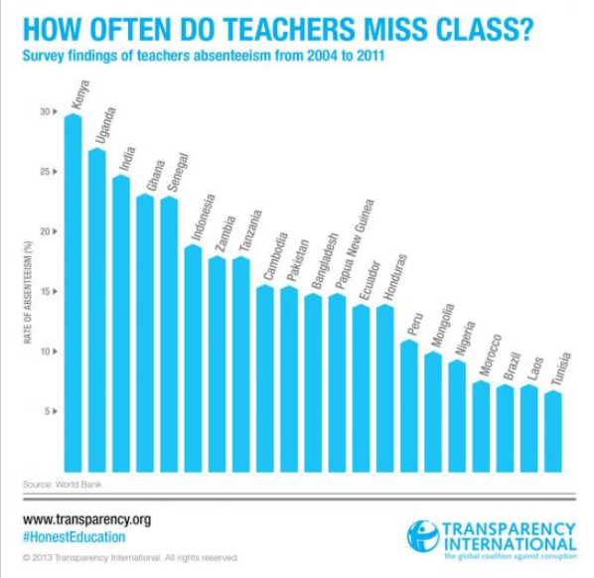
In other regions of the world, educator absenteeism is becoming a critical problem. This issue is not one as simple as work leave or illness, teacher absenteeism refers to deliberately skipping class with illegitimate reasoning. In India, only 10 percent of teacher leave and absences were legitimate (annual, medical, emergency leave) leaving a 90 percent gap of illegitimate absences. These absences account for a loss of nearly 25 percent of India’s education budget, as those teachers still get paid even when they do not show up, though there is no real productivity. Much of this absenteeism is blamed on corruption (taking the money and running) and “moonlighting”, referencing teachers who are working other jobs when they should be in class.
Uganda, mentioned earlier for their likely financial corruption in relation to education, sees 27 percent of their educators cutting class on a regular or permanent basis (see figure 5). While still not the official highest percent absenteeism (Kenya holds that title at 30 percent), there is an epidemic of teachers showing up for work but not working. These flighty educators are not contributing to students’ education and are reaping the salary benefits of an educator for the job of a babysitter. It is educators like these who drive down productivity and progress within states’ educational programs, and render funds allocated to the school systems practically useless.
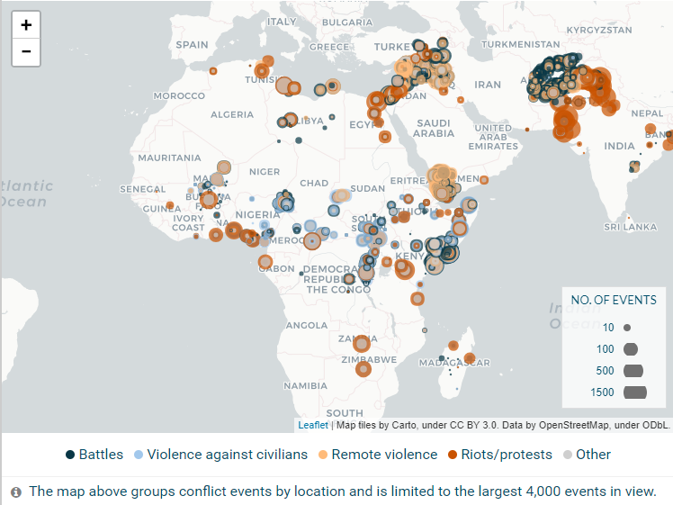
War-torn and violence-ridden areas are not suitable to promote safe and accessible education, but these regions are there areas where quality education is most needed. Research proves that the more educated a population is, the less impoverished its. One study of a population in Pakistan shows a direct negative relationship between education and the likelihood of living in poverty; that is, as level of education increases, poverty levels decrease. But this same study also shows that women are still held much farther back than men in that even though women can become more educated, they are still often shut out from pursuing their education and have far fewer employment opportunities once they finish their education. Though this study was isolated to Pakistan, it would not be unreasonable to expand this study further into other Middle Eastern states where the culture, economy, and social structure is very similar.

Role of the UN system
UN Secretary General, António Guterres helped set the agenda for the entire international community in an address on 27 April 2018, when he said that:
The world cannot afford a generation of children and young people who lack the basic skills they need to compete in the 21st century economy. Nor can we afford to leave behind an entire gender – half of humanity – as a matter of their rights, and our best interests. Nor can we afford to sacrifice these young lives to disillusionment… despair… and even extremist thought. For the peace of our world… the prosperity of our world… the future of our world… there is no better investment than in education.
Guterres stated that though he is proud of the work done by UNESCO and its partners, there is still much work to be done and called upon the entire UN system and its partners to continue to strive to better education for the world.
UNESCO works to promote peace and cultural acceptance through accessible education for all. Since the 1950’s UNESCO has placed an emphasis on lowering poverty, raising literacy rates, and improving conditions in underdeveloped and developing nations. While several UN bodies can formulate and pass resolutions that will impact and improve educational conditions around the world, generally this responsibility would be left up to UNESCO.
The World Bank is an important supporter of UNESCO mandates. The World Bank provides low-interest loans, credits, and grants to developing and impoverished states. It also provides financial services to these states through financial advisors and technological services. The World Bank focuses on improving four major aspects of education, first, teachers. The World Bank acknowledges teachers as the driving and most important force behind the quality of education each child receives. The World Bank Group (WBG) works with governments and schools to attract quality teachers, motivating them, providing them with the materials they need to do their best, improve curriculums, and invest in the professional development of teachers.

Country and Bloc Positions

African Union (AU): promoting quality education in rural and developing communities is important for all African countries. There is growing recognition that only through wider access to quality education can rural development slow migration to the cities or emigration out of their home country.

African Member States welcome coordinated assistance for education, but they are divided on how to channel it. Some welcome aid and donor government oversight to ensure the highest possible effectiveness. Others demand that aid first be coordinated with their domestic policies and goals; they want to maintain their own national oversight. And a few African Union states face difficult domestic political problems, and face pressure to allocate foreign aid through supportive individuals and groups, even at the risk of corrupt activity, or giving unfair advantages to privileged groups.

China: has expanded its foreign educational aid program and welcomes opportunities to invest in promotion of quality education in rural and developing communities, as well as projects that support rural women and children. Most Chinese foreign assistance takes the form of long-term loans, not grants. It’s foreign aid loaning appears to be roughly equal to the United States. While China sees itself as a developing country—with hundreds of millions of people still in rural poverty—and prefers that other countries show more generosity, it is willing to act globally, under some circumstances. China often expects commercial advantages for its development assistance, which some accuse of viewing aid as an investment tool above all. But China is willing to invest and accepts some degree of international coordination and supervision.

European Union (EU): the 28 Member States of the EU are supportive of the SGD process and coordination of development assistance. With an annual aid budget of EUR 75 billion (USD 86 billion), it is by far the largest single donor of direct assistance (not counting loans). They are especially sensitive to the need to promote quality education in rural and developing communities. Generous with their development budgets, with strong public support at home, they also demand high standards of accountability, making sure that programs in recipient states are effective and that benefits reach their intended targets. They are willing to sacrifice control to assure results, but insist on careful oversight and careful measures of effective implementation. They are less enthusiastic about new funding, however, and may insist that new programs be funded by cutting old ones.

Latin America: receives less foreign assistance than it used to, as its economies have developed. In Central America, a special problem is promoting security, so that investment will be effective. This means first finding way to reduce crime and corruption. Other parts of Latin America are highly supportive of coordinated assistance, including help to promote quality education in rural and developing communities. But politically these areas and groups are weaker and less likely to get the help they need. Overcoming those hurdles remains a widespread regional issue.

The Non-Aligned Movement (NAM): the 120 Member States of UN’s largest voting bloc, which includes most countries of Africa and Latin America, as well as Asia, expect the world’s richer countries to contribute to global development goals, including promotion of quality education in rural and developing communities. They welcome foreign assistance, but ask that new projects not endanger old ones. They often resist foreign oversight over the way aid is spent, preferring to maximize their national control—ostensibly in defense of sovereignty—when possible. There is disagreement among the NAM member states on these important issues.

Russia: fully accepts the SDGs in its domestic planning and foreign assistance. But Russia stresses that education is a domestic issue, and each country is its own ultimate sovereign authority, with unique sovereign responsibility and freedom from foreign interference. Russia, like many Non-Aligned Movement countries and some other major donors including China, is suspicious of UN efforts to promote education that can be used to promote democratic values or criticism of the state and government.

The United States: is reducing its foreign aid investments, dealing with global inequality by strengthening its borders and military action abroad. It still invests in development assistance and supports quality education in rural and developing communities, so long as assistance does not increase spending. In UNESCO, where it is an active non-voting participant, the United States is especially concerned that any resolution not criticize Israel, that other countries pay their fair share, that no resolution can be interpreted to encourage radical Islam, and that no country is forced to sacrifice national sovereign freedom.

Regarding the United States, most assistance is in the form of long-term loans. Grants are channeled through the Millennium Challenge Corporation (MCC), the most prominent instrument for development policy. Established by President George W. Bush in 2004, it works under State Department and USAID to help achieve the SDGs. The MCC annual budget, which reached USD 3 billion in 2007, currently is down to USD 800 million. By selecting country partners who perform well and leveraging continued domestic policy reform to support growth, good governance, and an enabling environment for trade and investment, MCC aims to create incentives to improve performance on the SDGs, including girls’ primary school completion.

Proposals for further action

For UNESCO Member States, it is easiest to agree on principles, especially if they are diluted to permit each country to interpret and apply them as they will. Stressing principles is a natural path. What is tougher is finding agreement for more binding commitments. Active measures are the great untried area for rural primary and secondary educational reform. Possibilities include:
- Create financial rewards for countries that prioritize rural education.
- Establish a global testing system to evaluate and compare primary and secondary education in all countries and regions of the world.
- Establish aid programs to fund equal levels of primary and secondary education in developing countries, or all countries.
- Require uniform standards for primary and secondary education in all countries. To be effective, such a mandate would have to include plans for funding.
- Encourage political centralization, running rural education everywhere through each country’s central governments, to better assure effective educational programing and proper use of educational assistance funding.
- Encourage political devolution, such as regional self-rule, for rural areas to permit local groups and leaders to channel educational assistance funding as they see fit.
- Israel: For many UNESCO Member States, an easy course of action is to focus not on general issues of education and development, but the specific issues of Israeli treatment of its Arab residents and the rights of people of the Israeli Occupied Palestinian Territories. Criticizing Israel is one area where most Member States often find cooperation and agreement easiest, in this case for failing to elevate Arabic education to equal status as Hebrew in its governance. Support is strongest among the Member States of the NAM and especially its Arab Member States. Aggressive support for global assistance to the 1.4 million Arab residents of Israel (20 percent of the country’s population) or the 4.4 million residents of the Occupied Palestinian Territories, demanding they receive equal or preferential educational support, is something many NAM Member States can agree on.
Opposition is extreme from the United States, which makes support for Israeli policy the center of its foreign policy under President Trump. Opposition also comes from the Member States of the European Union, who regard the focus on Israel as a distraction from more ambitious work.
There is a cost to such priorities, since it appears to confirm a bias in UNESCO that its critics—led by the United States—use to criticize the organization and its work. The preoccupation with Israel was President Trump’s justification for withdrawing the United States from UNESCO in 2018. The United States indicated to the Director General its desire to remain engaged with UNESCO as a non-member observer state ‘in order to contribute U.S. views, perspectives and expertise on some of the important issues undertaken by the organization, including the protection of world heritage, advocating for press freedoms, and promoting scientific collaboration and education.’

Bibliography
EU, 2018. ‘EU remains the world's leading donor of development assistance: €75.7 billion in 2017’, European Commission, 4 October 2018, https://ec.europa.eu/europeaid/news-and-events/eu-remains-worlds-leading-donor-development-assistance-eu757-billion-2017_en
Harris, Gardiner and Steven Erlanger, 2018. ‘U.S. will withdraw from UNESCO, Citing Its ‘Anti-Israel Bias’, New York Times, 12 October 2018, https://www.nytimes.com/2017/10/12/us/politics/trump-unesco-withdrawal.html
IMEMC, 2018. UNESCO Adopts New Resolutions on Palestine’, IMEMC News, 11 October 2018, http://imemc.org/article/unesco-adopts-new-resolutions-on-palestine/ ;
Markova, Svetlana, 2017. ‘Education as a development priority at the global, regional, and country levels’, World Bank Group, 24 January 2017 https://blogs.worldbank.org/opendata/education-development-priority-global-regional-and-country-levels
Murphy, Tom, 2017. ‘Find Out Some (But Not All) The Secrets Of China's Foreign Aid’, NPR, 31 October 2017, https://www.npr.org/sections/goatsandsoda/2017/10/31/560278615/find-out-some-but-not-all-the-secrets-of-chinas-foreign-aid
Texas Instruments, n.d. ‘TIer, Texas Tech professors use technology to illuminate education in developing countries’, Texas Instruments, n.d. [2016], https://e2e.ti.com/blogs_/b/thinkinnovate/archive/2016/02/25/tier-texas-tech-professors-use-technology-to-illuminate-education-in-developing-countries
UN, 2015. Resolution adopted by the General Assembly on 25 September 2015, 70/1, Transforming our world: the 2013 Agenda for Sustainable Development, A/Res/70/1, New York: United Nations, 21 October 2015, http://www.un.org/en/development/desa/population/migration/generalassembly/docs/globalcompact/A_RES_70_1_E.pdf
US State Department, 2018. FY 2019 Congressional Budget Justification - Department of State, Foreign Operations, and Related Programs, Washington, D.C.: U.S. Department of State, 12 February 2018, https://www.state.gov/documents/organization/277155.pdf
US State Department, 2017. ‘The United States withdraws from UNESCO’, U.S. Department of State, 12 October 2017, https://www.state.gov/r/pa/prs/ps/2017/10/274748.htm
WAFA, 2018. ‘Newspapers review: UNESCO’s resolutions on Occupied Palestine focus of dailies’, WAFA, 11 October 2018, http://english.wafa.ps/page.aspx?id=80FFQ0a105071627694a80FFQ0

https://www.un.org/sustainabledevelopment/education/
Resolution adopted by the General Assembly on 25 September 2015, 70/1, Transforming our world: the 2013 Agenda for Sustainable Development, A/Res/70/1, New York: United Nations, 21 October 2015, http://www.un.org/en/development/desa/population/migration/generalassembly/docs/globalcompact/A_RES_70_1_E.pdf
https://www.globalpartnership.org/education/the-benefits-of-education
https://www.ncbi.nlm.nih.gov/pmc/articles/PMC2080482/
Svetlana Markova, ‘Education as a development priority at the global, regional, and country levels’, World Bank Group, 24 January 2017 https://blogs.worldbank.org/opendata/education-development-priority-global-regional-and-country-levels
https://www.isid.ac.in/~tridip/Teaching/DevelopmentMicroeconomics/Spring2012/Readings/04Education/04Glewwe&Kremer-HandbookOfEconomicsOfEducation-2006.pdf
According to UNISEF website pages, most countries start primary school between ages 5-7, and UNICEF categorize those 15 years old and older as adults. I have taken this separate evidence and generalized primary school age worldwide to mean ages 6-15. https://data.unicef.org/topic/education/primary-education/
https://data.worldbank.org/topic/education
https://www.un.org/sustainabledevelopment/development-agenda/
https://www.un.org/sustainabledevelopment/education/
https://www.globalpartnership.org/education/education-challenges
http://hdr.undp.org/en/content/developing-regions
https://www.cia.gov/library/publications/the-world-factbook/rankorder/2004rank.html
https://blogs.worldbank.org/opendata/education-development-priority-global-regional-and-country-levels
https://africacheck.org/factsheets/conflict-related-deaths-in-sub-saharan-africa/
https://www.acleddata.com/dashboard/#
Ibid.
Ibid.
https://www.worldvision.org/refugees-news-stories/syrian-refugee-crisis-facts
https://www.globalpartnership.org/education/education-challenges
http://blogs.worldbank.org/education/hidden-cost-corruption-teacher-absenteeism-and-loss-schools
http://blogs.worldbank.org/education/hidden-cost-corruption-teacher-absenteeism-and-loss-schools
https://www.researchgate.net/publication/215442733_Impact_of_education_on_poverty_reduction
http://www.worldbank.org/en/about/what-we-do
http://www.worldbank.org/en/topic/teachers#2
Tom Murphy, ‘Find Out Some (But Not All) The Secrets Of China's Foreign Aid’, NPR, 31 October 2017, https://www.npr.org/sections/goatsandsoda/2017/10/31/560278615/find-out-some-but-not-all-the-secrets-of-chinas-foreign-aid
‘EU remains the world's leading donor of development assistance: €75.7 billion in 2017’, European Commission, 4 October 2018, https://ec.europa.eu/europeaid/news-and-events/eu-remains-worlds-leading-donor-development-assistance-eu757-billion-2017_en
FY 2019 Congressional Budget Justification - Department of State, Foreign Operations, and Related Programs, Washington, D.C.: U.S. Department of State, 12 February 2018, https://www.state.gov/documents/organization/277155.pdf
UNESCO Adopts New Resolutions on Palestine’, IMEMC News, 11 October 2018, http://imemc.org/article/unesco-adopts-new-resolutions-on-palestine/ ; ‘Newspapers review: UNESCO’s resolutions on Occupied Palestine focus of dailies’, WAFA, 11 October 2018, http://english.wafa.ps/page.aspx?id=80FFQ0a105071627694a80FFQ0
Gardiner Harris and Steven Erlanger, ‘U.S. will withdraw from UNESCO, Citing Its ‘Anti-Israel Bias’, New York Times, 12 October 2018, https://www.nytimes.com/2017/10/12/us/politics/trump-unesco-withdrawal.html
‘The United States withdraws from UNESCO’, U.S. Department of State, 12 October 2017, https://www.state.gov/r/pa/prs/ps/2017/10/274748.htm

