U.S. Navy

Pre-Entry Physical Training Plan

“Fit Today for Tomorrow’s Challenges”

D. M. Settles & T.P. Brown

Navy Environmental Health Center
Naval Aviation Schools Command

U.S Navy


Pre-Entry Physical Training Plan

Introduction:

The Navy Pre-Entry Physical Training Plan assists recruits in preparing for the physical demands a prospective Sailor experiences during Navy basic training programs. This plan provides guidelines for the three primary elements of a physical fitness program: aerobic activity, muscular strength and endurance exercises, and flexibility exercises. Research supports that participation in these activities will decrease one’s injury risk during Navy basic training programs; the Navy Pre- Entry Physical Training Plan will prepare the prospective Sailor for the physical challenges of basic training and throughout one’s Navy career.

Physical Fitness Overview:

Physical fitness is an essential and critical component of readiness. Fitness is much more than the absence of disease. It is a state of being that includes strong, flexible muscles and an efficient system for getting oxygen and nutrients to the body. Physical fitness is a state of being that must be maintained. You have to specifically exercise the muscles and joints where you want improvement. It is also achievable by everyone, despite body type, family health history, and past habits. A physical activity program includes 3 primary components:

Aerobic (Cardiovascular): Aerobic activities, such as running and swimming, help the heart, lungs and blood vessels become more effective at delivering to the muscles what they need to function - oxygen and glucose.

Muscular Strength and Endurance: These activities include exercises such as push- ups, curl-ups, or weight training. Muscular strength and endurance activities help your muscles become stronger, giving them both the raw strength and ability to work repeatedly without undue fatigue.

Flexibility: Flexibility or stretching exercises are necessary to prevent injury to the muscles and joints, and to allow the muscles to work efficiently through a full range of motion.

1
Recommended Exercise Sequence

Recommended Exercise Sequence:
Diagram 1 outlines the recommended exercise sequence to improve performance and to reduce risk of injury; this exercise sequence should be conducted between 3 to 6 days per week. If you feel any unusual pain or discomfort during your physical activity session or if you answer “yes” to any questions listed in the Physical Readiness Questionnaire (Appendix 2), contact your allied health professional prior to beginning an exercise program. There is some risk of injury
associated with physical activity. To prevent injury, remember to pace yourself, especially if you
have not participated regularly in an exercise program. * Review the injury prevention section of this booklet prior to beginning a personal exercise program (pp. 11 - 13).

(1) Warm-Up

(2) Stretching

(3) Physical Activity Session
(Aerobic, Muscular Strength and Endurance Exe rcise, Sporting Event)

(4) Cool Down

(5) Stretching Diagram 1

Warm-Up
A warm- up prior to exercise is recommended to prepare the muscles and heart for the workout. Participation in a 3 to 5 minute warm- up during the first portion of your exercise
session will assist you in decreasing your chances of getting injured. Examples of warm- up exercises include walking, slow jogging, or any nonvigorous, low intensity activity.

Stretching
Page 3 will outline a safe and effective stretching program for your body’s major muscle groups. Stretching exercises should be conducted after the warm- up and cool-down exercise sequence.

Physical Activity Session
Pages 4 and 5 will outline guidelines for preparing for aerobic demands that you will incur during basic training. Page 6 and 7 will assist you in preparing for the the muscular exercise demands that you will experience during basic training.

Cool-Down:
A cool-down consists of 3 to 5 minutes of light to moderate slow activity after vigorous exercise. Stopping exercise abruptly can result in lightheadedness and can cause excessive stress on your heart.
2
Stretching/Injury Prevention

After your warm- up, you should always begin with a period of stretching. Stretching makes the muscles, ligaments, and tendons more flexible and elastic- like. Rather than tearing or breaking when under strain, a flexible muscle is more likely to stretch and give. Flexibility prevents injuries, like back injuries and sprained ankles, and helps you perform everyday task with greater ease. Stretching is joint specific - you have to target each muscle group and
joint separately. Diagram 2 provides 10 stretches to include in your daily exercise program;
these stretches will improve the flexibility of your body’s major muscle groups. It is important to also include stretching exercises during the cool-down portion of your exercise sequence.

Safe and Effective Stretching Guidelines:
* Stretch at least 5 times a week (every day is better) * Stretch to a point of mild tension
* Warm- up 3 to 5 minutes before stretching * Hold each stretch for 10 to 30 sec.
* Prevent bouncing movement when stretching * Repeat each stretch 3 to 5 times

Diagram 2

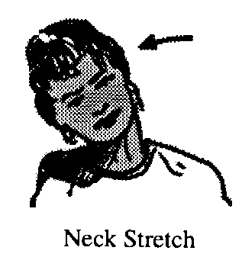
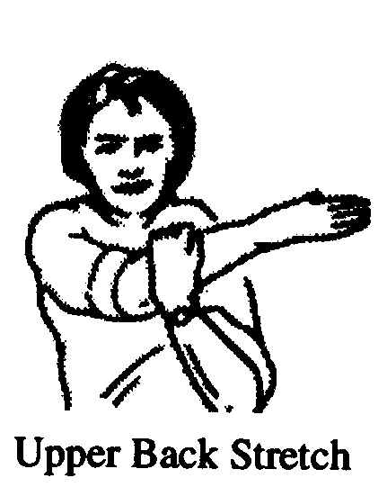

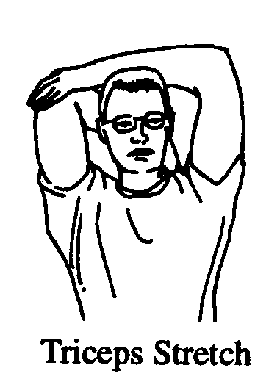

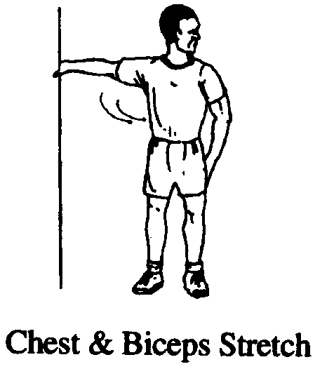

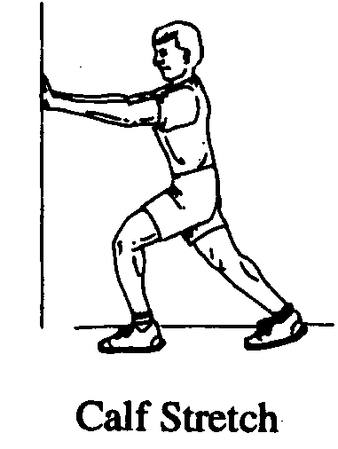
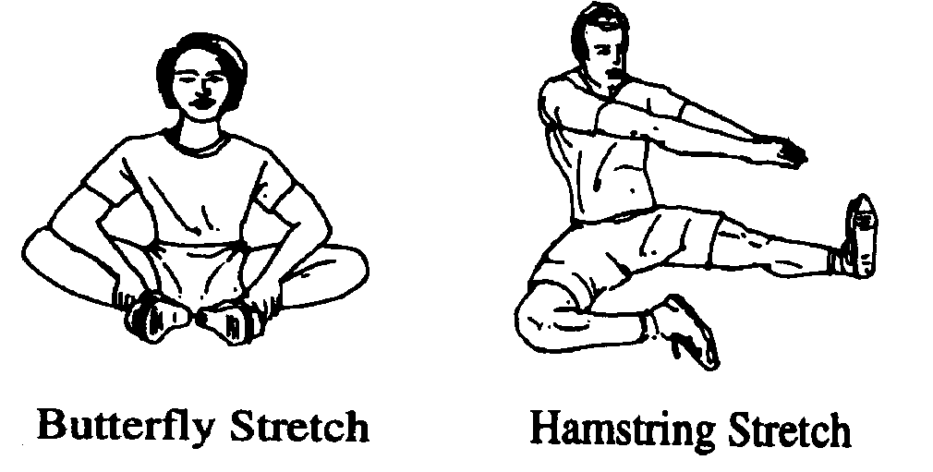

PRT Flexibility Test: Although no flexibility test measures the flexibility of all joints, the sit and reach test serves as an important functional measure of hip and back flexibility. To perform the sit and reach test, sit with legs straight, feet together, with shoes off and toes pointed up. Slowly reach forward and attempt to touch the tips of the toes with fingertips of both hands. Hold the reach for one second; DO NOT BOUNCE OR LUNGE. The Navy PRT Score Categories for the sit and reach test are included in Appendix 1. * The sit and reach exercise should only be used for testing
purposes; it should NOT be included in your daily exercise program due to the excessive stress
the stretch places on the low back. The Hamstring Stretch shown in Diagram 2 is a safe and effective stretch for the hamstring muscle group.
3

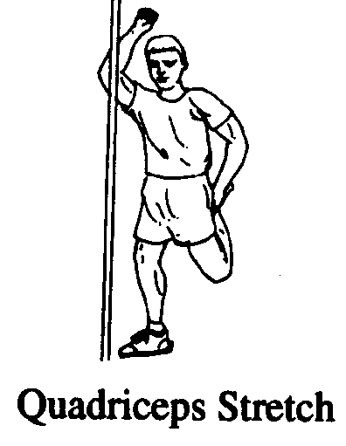

Running

The one physical fitness component that stands out in virtually all studies for the prevention of injuries is aerobic fitness. Studies show that being aerobically conditioned prior to entering basic training will greatly decrease your chances of ge tting injured. The lower the initial level of fitness when starting basic training, the greater the risk of experiencing a training related injury. Though running is a primary component of basic training exercise sessions, you may choose to participate in a wide variety of aerobic activities prior to beginning basic training. Other types of aerobic activity include, but are not limited to, the following exercises: cycling, swimming, aerobics classes, hiking, rowing, and stairclimbing.

Running Program: Running will be one of the more strenuous tasks you will perform during basic training programs. The following regimen should help you best prepare for the rigorous demands of basic training.

Use the program as follows: Locate the run stage placement chart (Diagram 3). On the left side locate where you fall on the total miles you have run over the last 4 weeks. Then move to the running program chart (Diagram 4). Enter at your starting stage level. Now follow
the distance, time goal and frequency as noted. If you are an experienced runner, start at the stage and distance you normally run and progress from there. The Navy PRT Score Categories for Running are included in Appendix 1. You will be expected to score a “good” score for your age group during enlisted basic training and Officer Indoctrination School (OIC), between a “good” and “excellent” score at the U.S. Naval Academy, and an “excellent” score at Officer Candidate School (OCS).

Run Stage Placement Chart
Total Miles Run During  The Last 4 Weeks | 1.5 Miles  Mile Run  Time | 1 Mile  Female  Run Time | Starting  Stage
Less than 9 |  |  | 1
9.1 - 12 |  |  | 2
12.1 - 15 |  |  | 3
15.1 - 18 |  |  | 4
18.1 - 21 |  |  | 5
21.1 - 24 |  |  | 6
24.1 - 27 |  |  | 7
27.1 - 30 |  |  | 8
30.1 - 36 |  |  | 9
36.0 - + |  |  | 10

(Diagram 3)

4

Basic Training Pre -Entry
Running Program

Stage / Week | Activity | Distance  Miles | Time Goal  (minutes) | Times Per  Week
1 | Walk | 2 | 32 | 3
2 | Walk | 3 | 48 | 3
3 | Run 2 Min./Walk 3 Min.  Repeat 5 times |  | 25 |  | 3
4 | Run 3 Min./Walk 2 Min.  Repeat 5 Times |  | 25 |  | 3
5 | Run 4 Min./Walk 1 Min.  Repeat 5 Times |  | 25 |  | 3
 |  |  | Male Female
6 | Run | 2 | 22 24 | 3
7 | Run | 2 | 20 22 | 3
8 | Run | 2 ½ | 25 27 | 3
9 | Run | 2 ½ | 23 25 | 3
10 | Run | 3 | 30 33 | 3
11 | Run | 3 | 27 30 | 3
12 | Run | 3 | 24 27 | 3
13 | Run | 3 | 24 27 | 3
14 | Run | 3 | 24 27 | 3
15 | Run | 3 | 24 27 | 3
16 | Run | 3 | 23 26 | 3
17 | Run | 3 | 23 26 | 3
18 | Run | 3 | 22 25 | 3
19 | Run | 3 | 22 25 | 3
20 | Run | 3 | 21 24 | 3
21 | Run | 3 | 21 24 | 3
22 | Run | 3 ½ | 25 28 | 3
23 | Run | 3 ½ | 24 27 | 3
24 | Run | 4 | 28 32 | 3

(Diagram 4)

5
Curl-Ups

Abdominal curl-ups are an indicator of abdominal muscle group endurance which has been identified as an important predictor in low back injury. This exercise, along with running and push-ups, will be tested many times throughout your career in the Navy.

Safe and Effective Abdominal Curl-Ups : Abdominal curl- ups are an important component of your pre-entry training program. Curl- ups are the best exercise for strengthening the abdominal muscles. Curl- ups must be done with the knees flexed to 90 degrees to eliminate the curve in the low back. The abdominal muscles should be contracted. The head should be lifted off the floor, and the trunk should curl into the sit- up position. Alteration of this technique may cause additional strain to the low back. It is necessary only to do a partial curl- up to provide maximal benefit to the abdominal muscles. A full sit-up may place additional stress on the low back. Your shoulders
should come above the ground only 30 degrees to performing a safe and effective curl- up.
(diagram 5).

Curl-Ups During Basic Training and Physical Readiness Testing: During the basic training physical regimen and during the Navy’s semi-annual Physical Readiness Testing, curl- ups will be performed similarly, but your arms will be folded across the chest, and your feet will be held to the floor by a partner. You will curl- up touching elbows to
thighs and will then lie back touching shoulder blades to deck. (diagram 6). You will be expected to score a “good” score for your age group during enlisted basic training and Officer Indoctrination School (OIC), between a “good” and “excellent” score at the U.S. Naval Academy, and an “excellent” score at Officer Candidate School (OCS).
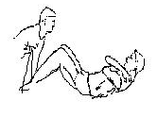

Abdominal Curl Up
Diagram 5
Full-Sit Up
Diagram 6

To Prepare: If you have not been performing curl- ups prior to this program it is
re. commended that you allow yourself a week of gradual increase in intensity. Each week for the first 4 weeks, do 2 sets of sit-ups stopping at the first sign of abdominal fatigue, allowing 2
minutes of rest between each set. It is recommended to perform the back extension stretch between sets (diagram 2, page 3). After 4 weeks (8 sessions) of abdominal exercises, you should do as many curl- ups as you can in two minutes. Rest for two minutes, do another set of as many as you can. These 2 sets of maximum effort sit- ups should be done no more than 2 times per week . Perform no more than 4 sessions of sit-ups each week.
6

Push-Ups

Push-ups are a measure of your upper body strength (chest, shoulders, and triceps). Always use correct form to prevent injury and to improve physical performance.

1: Start in the rest position (diagram 7). Assume the front leaning position with hands approximately shoulder width apart and feet together. The arms, back, buttocks and legs must be straight from head to heels and must remain so throughout the push-up. Shoes may/may not be worn.

2: Begin the push-up by bending the elbow and lowering the entire body until the top of the upper arms are parallel to the deck (diagram 8) and the elbows are bent at a 90 degree angle. Remember to keep the arms, back, buttocks, and legs aligned throughout the push- up motion.

3: Return to the starting position by extending the elbows until the arms are almost straight. Do not lock your elbows (diagram 7).
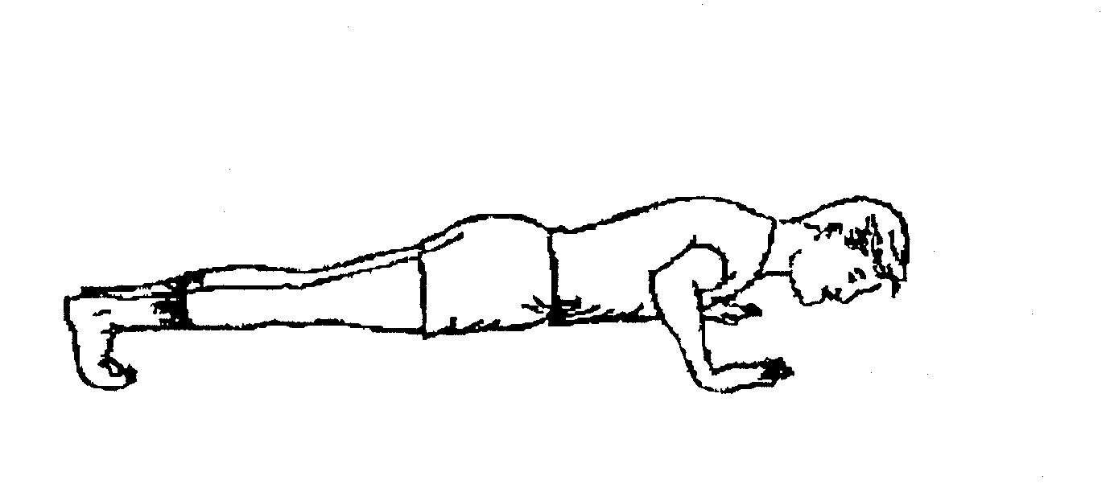

Diagram 7 Diagram 8
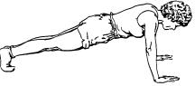

To Prepare : If you have not been doing push-ups prior to this program it is recommended that you perform a modified push-up. Fold a towel, and place it under your knees. Then perform the push-up as described above, keeping your knees on the towel. Allow yourself 4 weeks of gradual increase in intensity. For the first 4 weeks, you should do 3 sets of push- ups, each 2 minutes apart, stopping at the first sign of arm or shoulder fatigue. It is recommended to perform the chest and biceps stretch (diagram 2, page 3) between sets. After 4 weeks (12
sessions) you should do a regimen of 4 sets. The first 2 sets would be to perform as many push-
ups as you can in 30 seconds with your knees down. Then 2 sets of as many as you can for 20 seconds with your knees up. Remember to first warm- up and stretch prior to any physical training, and always use proper form. Approximately every two weeks attempt a single maximum set for two minutes and record your progress. Perform no more than 5 sessions of push-ups each week.

Physical Readiness Test: The Navy PRT Score Categories for push-ups are included in Appendix 1. You will be expected to score a “good” score for your age group during enlisted basic training and Officer Indoctrination School (OIC), between a “good” and “excellent” score at the U.S. Naval Academy, and an “excellent” score at Officer Candidate School (OCS).

7
Lower Body
Strengthening Exercises

The following 2 lower body muscle strength and conditioning exercises are not components of the Navy Physical Readiness Test, but they are important for preparing for the physical training portion of basic training. In addition, weak muscle groups are more susceptible to strains or sprains. The squat and the lunge exercises will deve lop balanced, proportional strength in the quadriceps and hamstring muscle groups. If injury does occur, it may be less severe and may heal more quickly if the muscle is well- conditioned.

SQUAT: Quadriceps and Hamstring Strengthening Exercise (Diagram 9 & 10)

Starting Position: Stand tall with head up, back flat, and feet shoulder-width apart. Place hands on front of thighs.

Action: Lower body by bending knees until hands touch knees. Lower to approximately 90 degrees of knee flexion. Hold squat position for 8 to 10 seconds. Return to starting position.

Diagram 9 Diagram 10

LUNGE: Quadriceps and Hamstring Strengthening Exercise (Diagram 11)

Starting Position: Stand tall with feet together.

Action: Take a long step forward with one foot and bend back knee. Forward knee should not pass over forward foot. Return to starting position. Repeat on opposite side.

Diagram 11

8
Injury Prevention

Injury Prevention During Pre -Entry Physical Training

Navy Basic Training Schools experience a 20% injury rate which is largely due to recruits coming in poor physical condition. The goal of the Navy Pre-Entry Physical Training Program
is to provide you with guidelines for exercise so that you improve but not so much that you cause overuse, excessive overload leading to injury or illness. Overuse problems commonly occur at the beginning of a new exercise program and account for the majority of injuries. The body and muscles must be given time to gradually adapt to the new demands of a physical activity
program. The first few months of a new physical conditioning program are the most critical.

Injury Prevention Overview:

Participation in physical exercise offers many benefits; these benefits far exceed the risk of injury. When you exercise, you intentionally use certain muscles to increase their strength and endurance. It is common to feel minor aches and soreness as your body adapts to these efforts. While injury is possible in any exercise program, following safety guidelines to prevent injuries and participating in a sensible strengthening and stretching program generally decrease risk of injury for those who participate in physical fitness programs. When beginning a physical training program, IT IS IMPORTANT TO GRADUALLY INCREASE YOUR EXERCISE INTENSITY AND DURATION. When in doubt about your physical activity program, it is better to cut back and take it easy rather than to do too much too soon.

* The one physical fitness component that stands out in virtually all studies for the prevention of injuries is aerobic fitness. Studies show that being aerobically conditioned prior to entering basic training will greatly decrease your chances of getting injured. The lower the initial level of
fitness when starting basic training, the greater the risk of experiencing a training related injury.

* Though being aerobically conditioned is important for the prevention of injury, aerobic exercises such as running have the potential to cause injury through repetitive, forceful impact against hard surfaces. During your aerobic conditioning efforts, it is recommended to participate in many different types of aerobic activities to prevent injury occurrence. Remember to
gradually increase your exercise intensity and duration.

* When ligaments, tendons, muscle, and bone are strengthened through muscular exercise, risk of injury is decreased. Strong, flexible muscles and ligaments can better withstand the stress of
many forceful landings during a workout. Many aerobic activities tend to develop strength in
only a few groups of muscles, leaving others weak. For example, running strengthens quadriceps but leaves the hamstrings weak. Flexibility programs may decrease risk of injury. When tight muscles restrict the natural range of motion of a joint , the slightest unusual twist can cause a strain or pull, such as a strained hamstring. Inflexibility may also cause overuse injuries because inelastic muscles transfer excessive stress to even less flexible areas of the body.

9
Avoiding Common
Basic Training Injuries

Common Injuries During Basic Training: The 5 primary injuries most commonly incurred by recruits during Navy basic training schools include the following: ligament sprains, muscle strains, shin splints, stress fractures, and Runner’s Knee, also known as Iliotibial Band Friction Syndrome (ITBS). Approximately 20% of recruits participating in basic training will obtain
these types of injuries, which could affect their successful completion of basic training. To best
prepare you in preventing these injuries from occurring to you during basic training, this section will define each injury, will explain what are the primary causes of each injury, and will provide you with injury prevention guidelines, including muscle strengthening and stretching exercises.

Sprains: A sprain is a partial or complete tear of a ligament, thetissue that binds bones together to form a joint. A sprain is most often a result of a sudden force, typically a twisting motion that surrounding muscles are not strong enough to control. Both ankles and knees are vulnerable to sprains during basic training. Strong, flexible muscles help protect against sprains. For example, to prevent ankle sprain, strengthen ankles with flexion, extension, inversion, and eversion exercises shown in diagrams 9 - 12. Exercise tubing or bicycle tubing is needed during this exercise. Recommended exercise sequence is 3 sets of 10 repetitions / 3 times per week.
Diagram 12: Plantar flexion: Band around forefoot, point toe as far as possible.
Diagram 13: Dorsiflexion - Attach band to stationary object opposite of foot.
Position band on top of foot and pull foot toward you.
Diagram 14: Inversion - Attach band to inside of foot and a stationary object opposite it. Pull foot inwards.
Diagram 15: Eversion - Attach band to inside of foot and a stationary object
opposite it. Pull foot outwards.

Diagram 12 Diagram 13 Diagram 14 Diagram 15

Strains: A muscle strain is a partial or complete tear of muscle fibers or a tendon and is sometimes referred to as a muscle “pull”. There are many different causes, but it most often results from a violent contraction of the muscle. A strain may be caused by fatigue, overexertion, muscle imbalance or weakness, or electrolyte or water imbalance. To prevent strains, complete a full-body warm-up before working out, take precautions not to overdo, and work toward
balancing the strength and flexibility in opposing muscles.

10
Avoiding Common
Basic Training Injuries

Shin Splints:

A shin splint refers to any pain in the front of the lower leg (shin). Early signs are acute burning pain or irritation in the lower third front of the leg. This ma y progress to slight swelling, redness, warmth, and inflammation. Shin splints may come early in an exercise program and are particularly common in those who are out of shape, overweight, or who have anatomical / mechanical
problems. Working out on very hard or very soft surfaces can cause shin splints, even if a person is in good physical condition. Switching from hard to a soft surface or vice versa, excessive mileage, improper footwear, poor foot mechanics, running on a road slope, and running the same direction
all the time may cause shin splints. To prevent shin splints, you should avoid the identified causes
of this injury. In addition, you may participate in strengthening exercises for the shin. Diagram 13.
(Diagrams 12,14, and 15 are also beneficial exercises for the prevention of shin splints.)

Stress Fracture:

A stress fracture is a very small, microscopic break in a bone caused by overuse. Unlike a broken bone, which occurs with a distinct traumatic event, a stress fracture is the result of cumulative overload that occurs over many days or weeks. Doing too much too soon (overuse) is the major cause. Bone is living tissue that adjusts to exercise force demands placed on it. As force is applied, bone will remodel itself to better handle the force. If too muc h force is applied, the bone may fracture before it can successfully remodel. Running extreme mileage, doing impact activities such as running, wearing worn-out shoes, exercising on hard surfaces such as asphalt or concrete, and having poor foot mechanics may cause a stress fracture. Because they have smaller, lighter bones, women are more prone to stress fractures than are men. To preve nt stress fractures, gradually work into a physical training program, and avoid the identified causes of stress fractures.

Runner’s Knee (Iliotibial Band Friction Syndrome):

Diagram 16

Runner’s Knee (Iliotibial Band Friction Syndrome) is an overuse condition commonly occurring in runners, in individuals who are out of shape or who do too much physical activity too soon (overuse). Running repetitively along the outside slope found on many paved streets may also cause Runner’s Knee. The iliotibial band is located on the outside part of the thigh and connects at the knee. Irritation usually develops at the outside thigh and knee area where friction is created. Stretching the iliotibial band (Diagram 16) and gradually working into
a physical conditioning program will assist you in preventing this overuse injury.
Iliotibial band stretch (Diagram 16): Cross left foot over right, press hips to left. Repeat with other side.
11

Caution About Ergogenic Aids

So what about the use of drugs and dietary supplements, often referred to as ergogenic aids, by both men and women? Some athletes try to gain an advantage by using these substances to enhance performance and accelerate muscle growth.
The distinction between a drug and a dietary supplement may not be obvious, but it is important. Drugs must meet Food and Drug Administration (FDA) approval for safety and effectiveness. If the substance is not classified as a drug nor promoted as having therapeutic or healing value,the FDA generally does not regulate its sale. Tha t means anyone can produce a new dietary supplement without any special approval and without being investigated for safety and effectiveness, unless a health risk is brought to the FDA’s attention. Athletes who use dietary supplements often serve as guinea pigs for substances that have not been tested.
One myth is that consuming amino acids and protein supplements will improve performance.
However, muscle growth cannot be increased by consuming excess protein. Only exercise can increase muscle mass. Intake of protein that exceeds the athlete’s caloric requirement will only be stored as fat. High intake of protein can lead to ketosis, dehydration, gouty arthritis, and
loss of calcium. A Sailor or Marine who takes even a single amino acid supplement daily may actually be causing problems with the absorption of other essent ial amino acids.
The bottom line is that extreme dietary supplements do not work at all, and that no ergogenic
aids are worth the risk to your reputation and health. Every substance with a potential ergogenic benefit carries some disadvantages and dangers. Eating a well b alanced diet can provide you with all the nutrients you need, even for a very vigorous training program.

Appendix 3 provides guidelines that may help you make decisions about ergogenic aids.

Get in Shape!

This physical fitness program overview is intended to give you a basic guideline to help prepare you for the rigors of basic training. Certainly, if you are already involved in a more intensive, safe and effective program, we urge you to continue.

Arriving at basic training does not guarantee that you will become a Sailor. It takes a great deal of motivation and sacrifice. That motivation begins today.

The U.S. Navy Exercise Planner Booklet provides additional exercise program guidelines for aerobic conditioning, muscular strength and endurance, and flexibility. This booklet and daily exercise log sheets can be viewed and downloaded from the Navy Environmental Health Center Physical Fitness Program Homepage:

http://www/nehc-med.navy.mil/hp.\

Physical Fitness Testing Goals for MIDN. You want to score at a minimum Good Low in all categories. Source: OPNAVINST 6110.1H

12

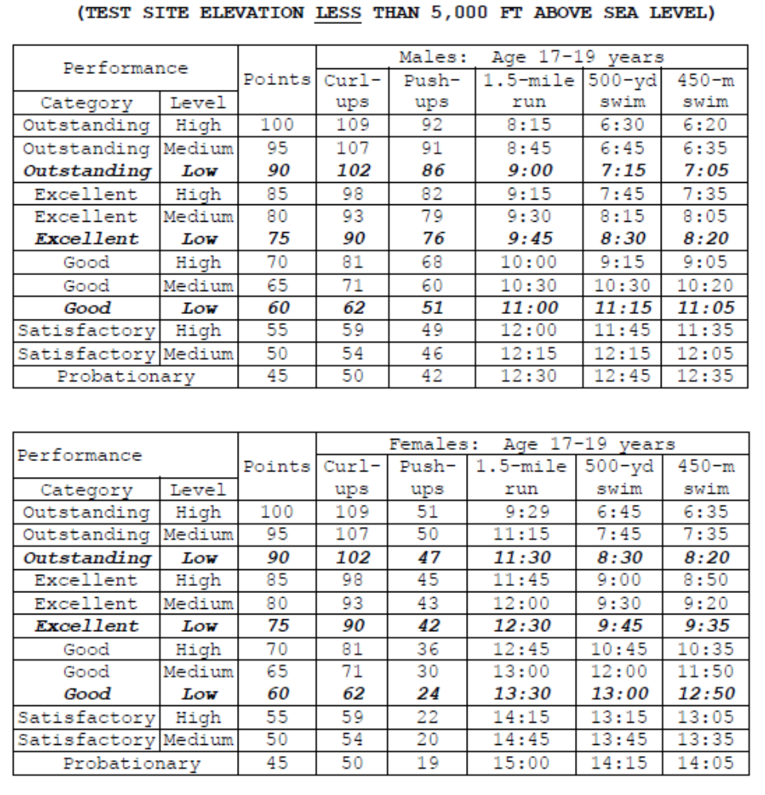
Physical Activity Readiness Questionnaire (PAR-Q)

1. Has your doctor ever said that you have a heart condition and that you should only do physical activity recommended by a doctor?

2. Do you feel pain in your chest when you do physical activity?

3. In the past month, have you had chest pain when you were not doing physical activity?

4. Do you lose your balance because of dizziness or do you ever lose consciousness?
5. Do you have a bone or joint problem that could be made worse by a change in your physical activity?

6. Is your doctor currently prescribing drugs (for example, water pills) for your blood pressure or heart condition?

7. Do you know of any other reason why you should not do physical activity?

American College of Sports Medicine. (1998). ACSM’s Resource Manual for
Guidelines for Exercise Testing and Prescription. (3rd ed.). Williams and Wilkins.

Appendix 2

Ergogenic Aids

Appendix 3

Authors

Diana Settles, M.A.T., A.T.,C.
Manager, Physical Fitness and Injury Prevention Programs Health Promotion and Medical Management Directorate Navy Environmental Health Center, Norfolk, VA

CDR Thomas Brown, MC, USN
Head Flight Surgeon
Officer Candidate School, Pensacola, FL

Bibliography

American College of Sports Medicine. (1995). ACSM’s Guidelines for Exercise Testing and
Prescription, (5th ed.). Baltimore: Williams and Wilkins.

American College of Sports Medicine. (1998). ACSM’s Resource Manual for Guidelines for Exercise
Testing and Prescription. (3rd ed.). Williams and Wilkins.

American College of Sports Medicine. (1990). The Recommended Quantity and Quality for Developing and Maintaining Cardiorespiratory and Muscular Fitness in Healthy Adults. Med Sci Sports Exerc , 22,
265 - 274.

Blackburn , T. A. (13 September 1997). Personal Interview.

Bockelman, T. & Long, K. (October 1996). United States Marine Corps Poolee Conditioning Program. Marine Corps Base, Parris Island Sports Medicine Department.

Chief of Naval Operations. (1998). OPNAVINST 6110.1E. Navy Physical Readiness Program. Washington, DC: Department of the Navy, Office of the Chief of Naval Operations, 23 March 1998.

Cooper Institute for Aerobics Research (October 1998). U.S. Navy Personal Training Plan, NEHC Technical Manual 6100.98-4). Norfolk, VA: Navy Environmental Health Center.

Corbin , C. & Lindsey, R. (1997). Concepts of Fitness and Wellness with Laboratories , Boston: McGraw- Hill.

Deuster,P. Jones, B., & Moore, J. (1997). Patterns and Risk Factors for Exercise-Related Injuries in
Women: A Military Perspective, Military Medicine, (162) 649 - 655.

Robins,G. Powers, D. & Burgess, Sharon (1997). A Wellness Way of Life , (3rd Edition) Boston, McGraw-Hill

Settles, D. & Cooper Institute for Aerobics Research (April 1999). Aerobic Fitness for Readiness, (NEHC Technical Manual 6100.99-4). Norfolk, VA: Navy Environmental Health Center.

Settles, D. & Cooper Institute for Aerobics Research (April 1999). Muscular Fitness for Readiness, NEHC Technical Manual 6100.99-3). Norfolk, VA: Navy Environmental Health Center.

Settles, D. & Cooper Institute for Aerobics Research (April 199 9). Stretching and Injury Prevention for
Readiness, (NEHC Technical Manual 6100.99-2). Norfolk, VA: Navy Environmental Health Center.

Trone, D.W., Hagan, R.D., Shaffer, R.A. (1999). Physical Training Guidelines for U.S. Navy Recruits: Preparing for Battlestations (NHRC Tech. Doc. No. 99-1A). San Diego, CA: Naval Health Research Center.
15
DRAFT

U.S. Navy Pre-Entry Physical Training
Waiver of Liability

This is only a draft form.
This Waiver of Liability may be provided to prospective Sailors entering the
United States Navy (signed during the Navy recruitment process).

“ I, , have enrolled in a program of physical activity including, but not limited to, aerobic exercise, muscular strength and endurance, and flexibility. I hereby affirm that I am in good physical condition and do not suffer from any disability that would prevent or limit my participation in this exercise program.”

“In consideration of my participation in the US Navy Pre-Entry Exercise Program, I,
, for myself, my heirs and assigns, hereby release the United States Navy, from any claims, demands and causes of action arising from my participation in the exercise program.”

“I fully understand that I may injure myself as a result of my participation in the U.S. Navy Pre-Entry Exercise Program and I, , hereby release the United States Navy from any liability now or in the future including, but not limited to , heart attacks, muscle strains, pulls or tears, broken bones, shin splints, heat injuries, knee/lower back / foot injur ies, and any other
illness, soreness, or injury, however caused, occurring during or after my participation in the exercise program.”

Signature

Date

I hereby affirm that I have read and fully understand the above.

Signature

United States Navy

