This is an op-ed piece by Dr. Enrique Figueroa, written after the shootings in Uvalde, Texas and expressing his perspective on growing up Mexican American in Texas. Dr. Figueroa has a PhD in Economics from the University of California, Davis, taught at Cornell University, was an Undersecretary of U.S. Department of Agriculture and UW Milwaukee.

I was born in Uvalde, Texas. I have serious doubts that justice will be done on behalf of the community's Mexican Americans.
Enrique E. Figueroa
View Comments
I was born in Uvalde, Texas, and we lived there until I was 11, when we moved to California's Central Valley.
The horrific murders in Uvalde shock the conscience of virtually everyone. But, trust me, for an Uvalde native steeped in the inequities of this community’s history, it was a gut punch. But it also prompted much internal inquiry and remembrance.
Over the past 60 years, how have Mexican Americans (Chicanos) in Uvalde experienced justice? If past is prologue, what justice will be for parents and family members of the dead and wounded should cause concern.
During the Eisenhower Administration’s “Operation Wetback,” Mexican nationals were deported, some of whom lived in Uvalde.
My father was born Enrique Terrazas in Mexico, but when World War II broke out, a man named Lorenzo B. Figueroa was drafted, but chose not to go.
My dad assumed his name and honorably served (as did many Mexican Americans from Uvalde) in the U.S. Army. In the mid-1950s, he was charged with being in our country fraudulently. After much family anguish and litigation, my dad, by this time working as a farmworker, was granted a “green card” and became a naturalized citizen.
Was my dad and my family granted justice? Some would say yes: After all, he wasn’t deported. But he had to defend his right to be here even though he had put his life on the line for his country and even though he was a hard-working man who paid taxes —he was someone who was contributing.
If this is justice, it was justice deferred and only grudgingly granted, to say nothing of the impact on my mother and brother who were Mexican citizens.
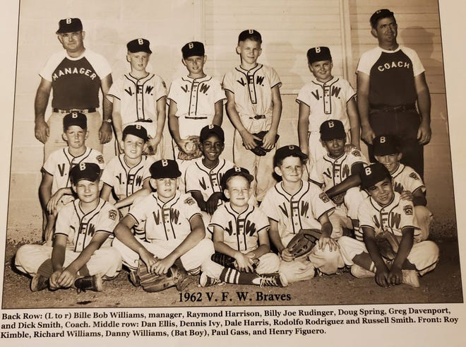
The photo with this article is of my VFW Little League team, taken in 1962, which is when I first interacted with White kids in Uvalde. How could that be?
Well, the Lasso movie house was for whites, while the Texas was for Mexicans.
El Parque de Abajo (lower park) was for Mexicans, while the whites’ park was up north.
The camposanto (cemetery) was for Mexicans, while the one up north was for whites.
I attended Sacred Heart Elementary, and it was all Mexican Americans, while the public schools catered to whites.
The Kinkaid Hotel and restaurant was the best in town, but service was refused to my family.
Was this justice for Mexican Americans at the time?
In 1970, Mexican American/Chicano students walked out of Uvalde High School to protest discrimination of Mexican Americans by an all-white School Board. The walkout lasted nearly six weeks, and the seniors that participated did not receive their high school diplomas.
Armed Texas Rangers were called into Uvalde. Texas Department of Public Safety helicopters flew over the city. The Uvalde Draft Board obtained a list of students who walked out; they were re-classified 1A and drafted.
Ten servicemen from Uvalde were killed in Vietnam and all 10 were Mexican Americans.
The Mexican American Legal Defense & Education Fund eventually filed suit against the Uvalde School District, and after decades of litigation, the district was ordered to comply with many of the issues raised in the walkout and MALDEF’s lawsuit.
Was justice served to the Mexican American community that suffered the consequences of discrimination? Eventually, grudgingly and, yet, not fully, with inequities still existing.
I returned to Uvalde in 2014 to do research on a book about what happened to the 13 kids in the picture of my 1962 Little League team in the ensuing half century.
I spoke to five of the now adult kids; and I obtained leads for another three.
I was only able to talk to one kid’s brother, which I arranged through his Mexican American secretary. Upon departing his brothers’ office, his secretary told me, “He doesn’t talk to Mexicans.”
I was grateful for the connection, but, even if I was the exception, is justice administered to Mexican Americans if they are not talked to because they are Mexican Americans?
Most people in Uvalde refer to themselves as Mexican Americans or Mexicans. The news media covering the massacre keep referring to them/us as Latinos. Why?
In a previous mass shooting, a shooter in El Paso specifically said he was out, “to kill Mexicans,” yet the media again referred to Latinos.
The media should honor and respect how people identify themselves. That’s called accuracy, which is allegedly a value journalist hold dear. Even in the media, when will Mexican Americans in our country obtain just treatment?
This is the context Uvalde provides.
It does not augur well.
There has been an accumulation of injustice towards Mexican Americans in Uvalde, followed by a determination by Mexican Americans that enough is enough. Or as we say, “Ya basta.”
Will there be justice for the Uvalde parents and family members of the massacred?
History dictates that, if it comes, it will be unjustly deferred and grudgingly parceled out so it does not resemble full justice.
Enrique E. Figueroa, Ph.D. is an emeritus associate professor in the Department of Urban Planning at the University of Wisconsin-Milwaukee.

