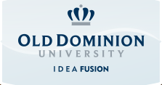

25 Years after the Fall of the Wall
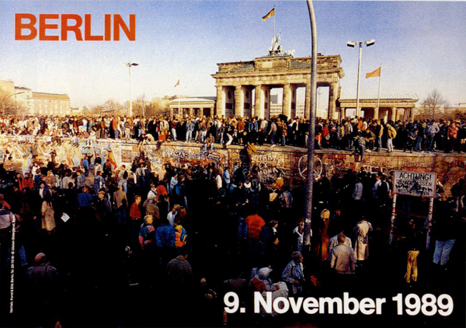
A screening of a documentary on the rise and fall of the Berlin Wall (50 min.)

Friday, November 7, 2014
3:00 to 5:00 pm
BAL 9024

Followed by a panel discussion among faculty members in the Department of Foreign
Languages & Literatures and the Graduate Program in International Studies. Audience participation welcome.

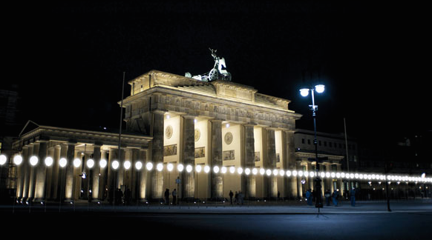
“Lichtgrenze” -- light installation “Border of Light” at the Berlin Brandenburg Gate, Oct. – Nov. 9, 2014

This event is free and open to the public and includes light refreshments.
For further information: Profs. Regina Karp (rkarp@odu.edu) and Kerstin Steitz (ksteitz@odu.edu).

