Dental Research Study
FREE DENTAL CLEANNG

EARN $100.00

We are looking for people who want to participate in a study testing a new oral HERBAL patch to help heal dental diseases.
YOU must:
- Be in general good health
- Be 18 years or older
- Have moderate to severe gum disease in at least 2 areas of your mouth

IRB Approval # 12-023

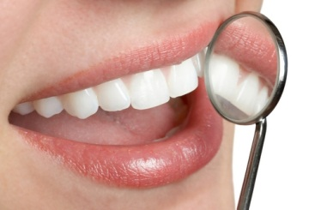

Old Dominion University
Dental Hygiene Research Center,
Health Sciences Building # 1103
Requires 5 visits over 3 months
Call 757-683-4719
For a screening Appointment

