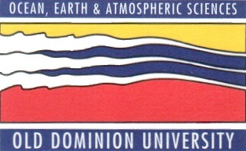

SPRING 2013 SEMINAR SERIES
DEPARTMENT OF OCEAN, EARTH, AND ATMOSPHERIC SCIENCES
3PM – ROOM 200 IN THE OCEANOGRAPHY/PHYSICS BUILDING
THURSDAY MARCH 21ST, 2013

“Karlodinium veneficum—The little dinoflagellate with a big bite”

Dr. Allen Place
University of Maryland

ABSTRACT

For decades, high densities of the dinoflagellate Karlodinium veneficum have been associated with aquatic faunal mortalities worldwide. This small (<8–12 mm) athecate phytoplankton, common in coastal aquatic ecosystems, has a mixed nutritional mode, relying on both photosynthesis and phagotrophy for growth (mixotrophy). It is frequently present in relatively low cell abundance (102–103 cells mL1), but is capable of forming intense blooms of 104–105 cells mL1 that are often associated with fish kills. A suite of toxic compounds (karlotoxins) have been characterized, both in the laboratory and in the field, with hemolytic, ichthyotoxic, and cytotoxic properties. These toxins have been shown to generate pores in membranes with desmethyl sterols and increase the ionic permeability resulting in membrane depolarization, disruption of motor functions, osmotic cell swelling and lysis. The biological raison d’etre
for karlotoxin production appears to be prey capture but grazing deterrence is an additional advantage. Strain variation in types of karlotoxins and toxin cell quotas is extensive. Since its initial description in 1956 by Dorothy Ballentine toxic and nontoxic strains are common. Despite numerous name changes it is now clearly recognized as a cosmopolitan species with extensive ecosystem impacts.

After the seminar, please join us in room 404, the Zaneveld Conference Room, for coffee and cookies, and to meet with the seminar speaker.

