REVISED PROPOSAL DEADLINE: DATE EXTENDED TO

JANUARY 18, 2013

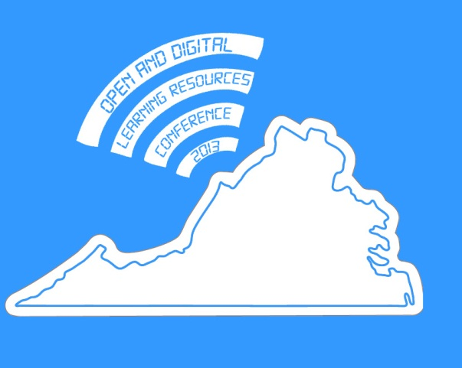

Virginia’s First Annual Open and Digital Learning Resources Conference

Mission
The Office of Governor of the Commonwealth of Virginia, State Council of Higher Education for Virginia, and Virginia Community College System invite submissions to its inaugural Open and Digital Learning Resources Conference to be held at the University of Mary Washington in Fredericksburg, Virginia on March 7th, 2013.

This is a watershed moment for open and digital learning resources, with a number of well-publicized initiatives bringing new energy and attention to this topic. In May 2012, Harvard and MIT announced a partnership to create EdX and host free courses to anyone, anywhere. In July 2012 the online course platform Coursera announced it had established new partnerships with 12 universities to offer free online courses. The State Board of Career and Technical Colleges in Washington state is offering open access to 81 of its most highly-enrolled courses through the Open Course Library. And OpenStax College, a project out of Rice University, has released the first of a series of free, open textbooks for core college courses like Physics and Biology.

Clearly, open and digital learning resources have the potential to have a significant and perhaps lasting impact on our educational institutions, and it is vitally important to begin to build an understanding of the challenges and opportunities they offer for teaching and learning across the Commonwealth.

The Open and Digital Learning Resources Conference will bring together teams of higher education stakeholders from across Virginia to collectively investigate the exciting topic of open and digital learning resources (ODLR) in education. ODLRs are a fairly broad categorization of educational technologies and practices that include the use and integration of in-class and online digital media, hardware, and software, a variety of openly licensed and freely available open educational resources (open textbooks, open courses, open content, etc.), augmented reality, and other tools used to deliver or enhance instruction in postsecondary settings. The conference organizers are particularly interested in examining ways these resources can be created and shared effectively and efficiently among college campuses across the Commonwealth in order to build a shared repository of openly licensed content.

This conference will tap into the a wide-range of expertise, innovation, and transformative ideas from across the Commonwealth of Virginia not only to showcase current ODLR projects and practices, but also actively link higher educational institutions together in order to develop and support a vibrant community of practice around the use of ODLR. This conference is an exciting opportunity to systematically explore how digital learning resources and networked educational experiences can lower costs, create new collaborative partnerships, and positively impact student outcomes, as well as establish a community of postsecondary institutions interested in continuing to explore this issue.

Topics
The scope of this conference includes, but is not limited to, the following topics as they relate to open and digital learning resources:

- strategies to reduce costs of instructional materials | - open policies, including open government, open assessment, and open data
- flipping the classroom | - alternate & augmented reality
- serious games/gamification | - team-based, collaborative, or cooperative online learning
- mobile learning | - open educational resources, including open textbooks, open content, open courses (MOOCs), and open teaching

Proposals
Institutions are encouraged to submit multiple proposals that meet the criteria of this RFP. Proposal submissions can be in two distinct categories, outlined below:
- Digital Carnival Showcase
- Presentation format, including:
  - formal presentation
  - panel discussion
  - interview
  - debate

The Digital Carnival Showcase
Why a carnival? Because a carnival typically involves a public celebration or parade combining elements of a circus, mask, and public street party. In other words, we want this part of the conference to be fun and engaging!

The ODLR Conference Committee invites submissions to the Digital Carnival Showcase to demonstrate and promote innovative technology projects happening at colleges and universities across Virginia. This is not a poster session; rather it is intended to be a fun, loud, colorful, and interactive morning session in which students, faculty, and administrators can engage participants in digital demonstrations of projects happening on their respective campuses. The “big top” of the Digital Carnival Showcase will be a large, open space that encourages interaction and the co-mingling of ideas across institutions in order to get a broader sense of the vast landscape of innovation and technology happening in higher education in Virginia.

For these proposals we encourage interactive “booths” where a team of presenters, like carnival barkers, demonstrates their innovative digital work to curious conference participants. These demonstrations can focus on faculty, student, and/or administrative innovations around digital learning resources, and can be as specific as localized classroom experiments or as broad as curricular innovations. Some examples: course sites, open textbooks, 3D Printing, e-books, internet radio, streaming video, campus-wide blogging, wikis, etc.. Ideally, submitted projects should be able to be effectively demonstrated and discussed in a physical space.

Presentations
The Call for Presentations invites individual or group submissions. As part of your submission please describe the format you plan to use for your paper (presentation, panel, interview, debate). Creative formats that actively engage the audience are encouraged. Specify whether you prefer a time slot of 20 minute or 45 minute duration. Identify which conference topic your paper fits with (see list above)

Go to http://openva.org to submit a proposal. The deadline for submissions is January 18th, 2013.

Who Will Be Attending?
The ODLR Conference Committee invites six member teams from each public two- and four-year institution in the Commonwealth to attend this conference. It is recommended these teams include a college or university president (or other senior administrative leader), a fiscal officer, a library representative, an instructional designer or technologist, and two faculty members.

Postsecondary faculty throughout Virginia are doing some amazing work with digital learning resources. The goal of this conference is to feature this work as well as create a network of postsecondary administrators, staff, and faculty interested in building an educational culture around open and digital learning resources. ODLR 2013 is your opportunity to share and promote the innovative work happening at your college or university and introduce it into Virginia’s public education learning ecosystem.

About
The Open and Digital Learning Resources Conference is an initiative of the Office of Governor of the Commonwealth of Virginia, the State Council of Higher Education for Virginia (SCHEV), the Virginia Community College System, and the following partner institutions:
- Christopher Newport University
- College of William & Mary
- George Mason University
- James Madison University
- Old Dominion University
- Radford University
- Tidewater Community College
- University of Mary Washington
- University of Virginia
- Virginia Commonwealth University
- Virginia Military Institute
- Virginia State University
- Virginia Tech

